






Operate a cellar system
D1.HBS.CL5.05
Trainer Guide

Operate a cellar system

D1.HBS.CL5.05

Trainer Guide




Project Base
William Angliss Institute of TAFE
555 La Trobe Street
Melbourne 3000 Victoria
Telephone: | (03) 9606 2111
Facsimile: | (03) 9670 1330
Acknowledgements
Project Director: | Wayne Crosbie
Chief Writer: | Alan Hickman
Subject Writer: | Nick Hyland
Project Manager: | Alan Maguire
Editor: | Jim Irwin
DTP/Production: | Daniel Chee, Mai Vu, Riny Yasin, Kaly Quach

The Association of Southeast Asian Nations (ASEAN) was established on 8 August 1967. The Member States of the Association are Brunei Darussalam, Cambodia, Indonesia, Lao PDR, Malaysia, Myanmar, Philippines, Singapore, Thailand and Viet Nam.
The ASEAN Secretariat is based in Jakarta, Indonesia.
General Information on ASEAN appears online at the ASEAN Website: www.asean.org.
All text is produced by William Angliss Institute of TAFE for the ASEAN Project on “Toolbox Development for Front Office, Food and Beverage Services and Food Production Divisions”.
This publication is supported by the Australian Government’s aid program through the ASEAN-Australia Development Cooperation Program Phase II (AADCP II).
Copyright: Association of Southeast Asian Nations (ASEAN) 2013.
All rights reserved.
Disclaimer
Every effort has been made to ensure that this publication is free from errors or omissions. However, you should conduct your own enquiries and seek professional advice before relying on any fact, statement or matter contained in this book. The ASEAN Secretariat and William Angliss Institute of TAFE are not responsible for any injury, loss or damage as a result of material included or omitted from this course. Information in this module is current at the time of publication. Time of publication is indicated in the date stamp at the bottom of each page.
Some images appearing in this resource have been purchased from stock photography suppliers Shutterstock and iStockphoto and other third party copyright owners and as such are non-transferable and non-exclusive. Clip arts, font images and illustrations used are from the Microsoft Office Clip Art and Media Library. Some images have been provided by and are the property of William Angliss Institute.
Additional images have been sourced from Flickr and SXC and are used under Creative Commons licence: http://creativecommons.org/licenses/by/2.0/deed.en

File name: TG_Operate a cellar system_refined





Table of contents
Competency Based Training (CBT) and assessment - An introduction for trainers 1
Competency standard 11
Notes and PowerPoint slides 17
Recommended training equipment 121
Instructions for Trainers for using PowerPoint – Presenter View 123
Appendix – ASEAN acronyms 125

Competency Based Training (CBT) and assessment - An introduction for trainers

Competency
Competency refers to the ability to perform particular tasks and duties to the standard of performance expected in the workplace.
Competency requires the application of specified knowledge, skills and attitudes relevant to effective participation, consistently over time and in the workplace environment.
The essential skills and knowledge are either identified separately or combined.
Knowledge identifies what a person needs to know to perform the work in an informed and effective manner.
Skills describe the application of knowledge to situations where understanding is converted into a workplace outcome.
Attitude describes the founding reasons behind the need for certain knowledge or why skills are performed in a specified manner.
Competency covers all aspects of workplace performance and involves:
- Performing individual tasks
- Managing a range of different tasks
- Responding to contingencies or breakdowns
- Dealing with the responsibilities of the workplace
- Working with others.

Unit of Competency
Like with any training qualification or program, a range of subject topics are identified that focus on the ability in a certain work area, responsibility or function.
Each manual focuses on a specific unit of competency that applies in the hospitality workplace.
In this manual a unit of competency is identified as a ‘unit’.
Each unit of competency identifies a discrete workplace requirement and includes:
- Knowledge and skills that underpin competency
- Language, literacy and numeracy
- Occupational safety and health requirements.
Each unit of competency must be adhered to in training and assessment to ensure consistency of outcomes.

Element of Competency
An element of competency describes the essential outcomes within a unit of competency.
The elements of competency are the basic building blocks of the unit of competency. They describe in terms of outcomes the significant functions and tasks that make up the competency.
In this manual elements of competency are identified as an ‘element’.

Performance criteria
Performance criteria indicate the standard of performance that is required to demonstrate achievement within an element of competency. The standards reflect identified industry skill needs.
Performance criteria will be made up of certain specified skills, knowledge and attitudes.

Learning
For the purpose of this manual learning incorporates two key activities:
- Training
- Assessment.
Both of these activities will be discussed in detail in this introduction.
Today training and assessment can be delivered in a variety of ways. It may be provided to participants:
- On-the-job – in the workplace
- Off-the-job – at an educational institution or dedicated training environment
- As a combination of these two options.
No longer is it necessary for learners to be absent from the workplace for long periods of time in order to obtain recognised and accredited qualifications.

Learning Approaches
This manual will identify two avenues to facilitate learning:
Competency Based Training (CBT)
This is the strategy of developing a participant’s competency.
Educational institutions utilise a range of training strategies to ensure that participants are able to gain the knowledge and skills required for successful:
- Completion of the training program or qualification
- Implementation in the workplace.
The strategies selected should be chosen based on suitability and the learning styles of participants.

Competency Based Assessment (CBA)
This is the strategy of assessing competency of a participant.
Educational institutions utilise a range of assessment strategies to ensure that participants are assessed in a manner that demonstrates validity, fairness, reliability, flexibility and fairness of assessment processes.

Flexibility in Learning
It is important to note that flexibility in training and assessment strategies is required to meet the needs of participants who may have learning difficulties. The strategies used will vary, taking into account the needs of individual participants with learning difficulties. However they will be applied in a manner which does not discriminate against the participant or the participant body as a whole.
Catering for Participant Diversity
Participants have diverse backgrounds, needs and interests. When planning training and assessment activities to cater for individual differences, trainers and assessors should:
- Consider individuals’ experiences, learning styles and interests
- Develop questions and activities that are aimed at different levels of ability
- Modify the expectations for some participants
- Provide opportunities for a variety of forms of participation, such as individual, pair and small group activities
- Assess participants based on individual progress and outcomes.
The diversity among participants also provides a good reason for building up a learning community in which participants support each other’s learning.
Participant Centred Learning
This involves taking into account structuring training and assessment that:
- Builds on strengths – Training environments need to demonstrate the many positive features of local participants (such as the attribution of academic success to effort, and the social nature of achievement motivation) and of their trainers (such as a strong emphasis on subject disciplines and moral responsibility). These strengths and uniqueness of local participants and trainers should be acknowledged and treasured
- Acknowledges prior knowledge and experience – The learning activities should be planned with participants’ prior knowledge and experience in mind
- Understands learning objectives – Each learning activity should have clear learning objectives and participants should be informed of them at the outset. Trainers should also be clear about the purpose of assignments and explain their significance to participants
- Teaches for understanding – The pedagogies chosen should aim at enabling participants to act and think flexibly with what they know
- Teaches for independent learning – Generic skills and reflection should be nurtured through learning activities in appropriate contexts of the curriculum. Participants should be encouraged to take responsibility for their own learning
- Enhances motivation – Learning is most effective when participants are motivated. Various strategies should be used to arouse the interest of participants
- Makes effective use of resources – A variety of teaching resources can be employed as tools for learning
- Maximises engagement – In conducting learning activities, it is important for the minds of participants to be actively engaged
- Aligns assessment with learning and teaching – Feedback and assessment should be an integral part of learning and teaching
- Caters for learner diversity – Trainers should be aware that participants have different characteristics and strengths and try to nurture these rather than impose a standard set of expectations.
Active Learning
The goal of nurturing independent learning in participants does not imply that they always have to work in isolation or solely in a classroom. On the contrary, the construction of knowledge in tourism and hospitality studies can often best be carried out in collaboration with others in the field. Sharing experiences, insights and views on issues of common concern, and working together to collect information through conducting investigative studies in the field (active learning) can contribute a lot to their eventual success.
Active learning has an important part to play in fostering a sense of community in the class. First, to operate successfully, a learning community requires an ethos of acceptance and a sense of trust among participants, and between them and their trainers. Trainers can help to foster acceptance and trust through encouragement and personal example, and by allowing participants to take risks as they explore and articulate their views, however immature these may appear to be. Participants also come to realise that their classmates (and their trainers) are partners in learning and solving.
Trainers can also encourage cooperative learning by designing appropriate group learning tasks, which include, for example, collecting background information, conducting small-scale surveys, or producing media presentations on certain issues and themes. Participants need to be reminded that, while they should work towards successful completion of the field tasks, developing positive peer relationships in the process is an important objective of all group work.

Competency Based Training (CBT)
Principle of Competency Based Training
Competency based training is aimed at developing the knowledge, skills and attitudes of participants, through a variety of training tools.
Training Strategies
The aims of this curriculum are to enable participants to:
- Undertake a variety of subject courses that are relevant to industry in the current environment
- Learn current industry skills, information and trends relevant to industry
- Learn through a range of practical and theoretical approaches
- Be able to identify, explore and solve issues in a productive manner
- Be able to become confident, equipped and flexible managers of the future
- Be ‘job ready’ and a valuable employee in the industry upon graduation of any qualification level.
To ensure participants are able to gain the knowledge and skills required to meet competency in each unit of competency in the qualification, a range of training delivery modes are used.
Types of Training
In choosing learning and teaching strategies, trainers should take into account the practical, complex and multi-disciplinary nature of the subject area, as well as their participant’s prior knowledge, learning styles and abilities.
Training outcomes can be attained by utilising one or more delivery methods:
Lecture/Tutorial
This is a common method of training involving transfer of information from the trainer to the participants. It is an effective approach to introduce new concepts or information to the learners and also to build upon the existing knowledge. The listener is expected to reflect on the subject and seek clarifications on the doubts.
Demonstration
Demonstration is a very effective training method that involves a trainer showing a participant how to perform a task or activity. Through a visual demonstration, trainers may also explain reasoning behind certain actions or provide supplementary information to help facilitate understanding.
Group Discussions
Brainstorming in which all the members in a group express their ideas, views and opinions on a given topic, is a free flow and exchange of knowledge among the participants and the trainer. The discussion is carried out by the group on the basis of their own experience, perceptions and values. This will facilitate acquiring new knowledge. When everybody is expected to participate in the group discussion, even the introverted persons will also get stimulated and try to articulate their feelings.
The ideas that emerge in the discussions should be noted down and presentations are to be made by the groups. Sometimes consensus needs to be arrived at on a given topic. Group discussions are to be held under the moderation of a leader guided by the trainer. Group discussion technique triggers thinking process, encourages interactions and enhances communication skills.
Role Play
This is a common and very effective method of bringing into the classroom real life situations, which may not otherwise be possible. Participants are made to enact a particular role so as to give a real feel of the roles they may be called upon to play. This enables participants to understand the behaviour of others as well as their own emotions and feelings. The instructor must brief the role players on what is expected of them. The role player may either be given a ready-made script, which they can memorise and enact, or they may be required to develop their own scripts around a given situation. This technique is extremely useful in understanding creative selling techniques and human relations. It can be entertaining and energising and it helps the reserved and less literate to express their feelings.

Simulation Games
When trainees need to become aware of something that they have not been conscious of, simulations can be a useful mechanism. Simulation games are a method based on "here and now" experience shared by all the participants. The games focus on the participation of the trainees and their willingness to share their ideas with others. A "near real life" situation is created providing an opportunity to which they apply themselves by adopting certain behaviour. They then experience the impact of their behaviour on the situation. It is carried out to generate responses and reactions based on the real feelings of the participants, which are subsequently analysed by the trainer.
While use of simulation games can result in very effective learning, it needs considerable trainer competence to analyse the situations.
Individual /Group Exercises
Exercises are often introduced to find out how much the participant has assimilated. This method involves imparting instructions to participants on a particular subject through use of written exercises. In the group exercises, the entire class is divided into small groups, and members are asked to collaborate to arrive at a consensus or solution to a problem.
Case Study
This is a training method that enables the trainer and the participant to experience a real life situation. It may be on account of events in the past or situations in the present, in which there may be one or more problems to be solved and decisions to be taken. The basic objective of a case study is to help participants diagnose, analyse and/or solve a particular problem and to make them internalise the critical inputs delivered in the training. Questions are generally given at the end of the case study to direct the participants and to stimulate their thinking towards possible solutions. Studies may be presented in written or verbal form.
Field Visit
This involves a carefully planned visit or tour to a place of learning or interest. The idea is to give first-hand knowledge by personal observation of field situations, and to relate theory with practice. The emphasis is on observing, exploring, asking questions and understanding. The trainer should remember to brief the participants about what they should observe and about the customs and norms that need to be respected.
Group Presentation
The participants are asked to work in groups and produce the results and findings of their group work to the members of another sub-group. By this method participants get a good picture of each other's views and perceptions on the topic and they are able to compare them with their own point of view. The pooling and sharing of findings enriches the discussion and learning process.
Practice Sessions
This method is of paramount importance for skills training. Participants are provided with an opportunity to practice in a controlled situation what they have learnt. It could be real life or through a make-believe situation.

Games
This is a group process and includes those methods that involve usually fun-based activity, aimed at conveying feelings and experiences, which are everyday in nature, and applying them within the game being played. A game has set rules and regulations, and may or may not include a competitive element. After the game is played, it is essential that the participants be debriefed and their lessons and experiences consolidated by the trainer.
Research
Trainers may require learners to undertake research activities, including online research, to gather information or further understanding about a specific subject area.

Competency Based Assessment (CBA)
Principle of Competency Based Assessment
Competency based assessment is aimed at compiling a list of evidence that shows that a person is competent in a particular unit of competency.
Competencies are gained through a multitude of ways including:
- Training and development programs
- Formal education
- Life experience
- Apprenticeships
- On-the-job experience
- Self-help programs.
All of these together contribute to job competence in a person. Ultimately, assessors and participants work together, through the ‘collection of evidence’ in determining overall competence.
This evidence can be collected:
- Using different formats
- Using different people
- Collected over a period of time.
The assessor, who is ideally someone with considerable experience in the area being assessed, reviews the evidence and verifies the person as being competent or not.
Flexibility in Assessment
Whilst allocated assessment tools have been identified for this subject, all attempts are made to determine competency and suitable alternate assessment tools may be used, according to the requirements of the participant.
The assessment needs to be equitable for all participants, taking into account their cultural and linguistic needs.
Competency must be proven regardless of:
- Language
- Delivery Method
- Assessment Method.
Assessment Objectives
The assessment tools used for subjects are designed to determine competency against the ‘elements of competency’ and their associated ‘performance criteria’.
The assessment tools are used to identify sufficient:
- Knowledge, including underpinning knowledge
- Skills
- Attitudes
Assessment tools are activities that trainees are required to undertake to prove participant competency in this subject.
All assessments must be completed satisfactorily for participants to obtain competence in this subject. There are no exceptions to this requirement, however, it is possible that in some cases several assessment items may be combined and assessed together.
Types of Assessment
Allocated Assessment Tools
There are a number of assessment tools that are used to determine competency in this subject:
- Work projects
- Written questions
- Oral questions
- Third Party Report
- Observation Checklist.
Instructions on how assessors should conduct these assessment methods are explained in the Assessment Manuals.
Alternative Assessment Tools
Whilst this subject has identified assessment tools, as indicated above, this does not restrict the assessor from using different assessment methods to measure the competency of a participant.
Evidence is simply proof that the assessor gathers to show participants can actually do what they are required to do.
Whilst there is a distinct requirement for participants to demonstrate competency, there are many and diverse sources of evidence available to the assessor.
Ongoing performance at work, as verified by a supervisor or physical evidence, can count towards assessment. Additionally, the assessor can talk to customers or work colleagues to gather evidence about performance.
A range of assessment methods to assess competency include:
- Practical demonstrations
- Practical demonstrations in simulated work conditions
- Problem solving
- Portfolios of evidence
- Critical incident reports
- Journals
- Oral presentations
- Interviews
- Videos
- Visuals: slides, audio tapes
- Case studies
- Log books
- Projects
- Role plays
- Group projects
- Group discussions
- Examinations.
Recognition of Prior Learning
Recognition of Prior Learning is the process that gives current industry professionals who do not have a formal qualification, the opportunity to benchmark their extensive skills and experience against the standards set out in each unit of competency/subject.
Also known as a Skills Recognition Audit (SRA), this process is a learning and assessment pathway which encompasses:
- Recognition of Current Competencies (RCC)
- Skills auditing
- Gap analysis and training
- Credit transfer.
Assessing competency
As mentioned, assessment is the process of identifying a participant’s current knowledge, skills and attitudes sets against all elements of competency within a unit of competency. Traditionally in education, grades or marks were given to participants, dependent on how many questions the participant successfully answered in an assessment tool.
Competency based assessment does not award grades, but simply identifies if the participant has the knowledge, skills and attitudes to undertake the required task to the specified standard.
Therefore, when assessing competency, an assessor has two possible results that can be awarded:
- Pass Competent (PC)
- Not Yet Competent (NYC).
Pass Competent (PC)
If the participant is able to successfully answer or demonstrate what is required, to the expected standards of the performance criteria, they will be deemed as ‘Pass Competent’ (PC).
The assessor will award a ‘Pass Competent’ (PC) if they feel the participant has the necessary knowledge, skills and attitudes in all assessment tasks for a unit.
Not Yet Competent’ (NYC)
If the participant is unable to answer or demonstrate competency to the desired standard, they will be deemed to be ‘Not Yet Competent’ (NYC).
This does not mean the participant will need to complete all the assessment tasks again. The focus will be on the specific assessment tasks that were not performed to the expected standards.
The participant may be required to:
a) Undertake further training or instruction
b) Undertake the assessment task again until they are deemed to be ‘Pass Competent’.

Competency standard
UNIT TITLE: Operate a cellar system |  | NOMINAL HOURS: 45
UNIT NUMBER: D1.HBS.CL5.05
UNIT DESCRIPTOR: This unit deals with the skills and knowledge required to operate a cellar system within the hotel industries workplace context
ELEMENTS AND PERFORMANCE CRITERIA | UNIT VARIABLE AND ASSESSMENT GUIDE
Element 1: Operate and maintain bulk dispensing systems  - Operate bulk dispensing systems in accordance with manufacturer's instructions and safety requirements  - Monitor temperature, carbonation and pump pressure  - Clean connectors, extractors and heads hygienically  - Set up nitrogen and integrated systems safely in accordance with manufacturer's specifications  - Identify faulty products and product delivery problems promptly and implement corrective action  Element 2: Operate and maintain beer reticulation systems  2.1 Operate and clean beer reticulation systems in accordance with manufacturer’s instructions  2.2 Follow safety procedures regarding handling, connecting and storing of gas  Element 3: Use and maintain refrigeration systems  3.1 Measure refrigerator temperatures accurately and adjust correctly to comply with product requirements  3.2 Clean and maintain refrigerator components  3.3 Set or re-set walk-in alarms to manufacturer's specifications  3.4 Recognise and repair/report basic mechanical faults in accordance with enterprise procedures  Element 4: Monitor quality of cellar products  4.1 Test regularly quality of cellar products and identify faults  4.2 Make adjustments within scope of individual responsibility or report faults to the appropriate person or people  4.3 Use bin and keg card systems to assist in monitoring the quality of products and controlling stock  4.4 Keep cellar tidy, clean and free from litter  4.5 Monitor cellar temperature | Unit Variables  The Unit Variables provide advice to interpret the scope and context of this unit of competence, allowing for differences between enterprises and workplaces. It relates to the unit as a whole and facilitates holistic assessment  This unit applies to all industry sectors that require to operate a cellar system within the labour divisions of the hotel and travel industries and may include:  - Food and Beverage Service  Bulk dispensing systems may include:  - Beer  - Spirits  - Wine  - Post-mix syrups.  Refrigeration systems may include:  - Cold rooms  - Cabinets  - Instantaneous coolers  - Portable coolers.  Refrigerator components may include:  - Vents, coils and filters  - Seals and catches.  Basic mechanical faults may include:  - Control system faults  - Error codes.  Cellar products may include:  - Beers  - Spirits  - Wine  - Post-mix syrups.  Appropriate person or people may include:  - Manager  - Maintenance personnel on site  - Specialist trades people.  Assessment Guide  The following skills and knowledge must be assessed as part of this unit:  - Knowledge of potential faults  - Knowledge of the shelf life of cellar products  - Knowledge of the correct handling and storage of cellar products  - Knowledge of the potential dangers of working with gas and pressure  - Knowledge of the specific safety requirements of the cellar  - Demonstrated ability to operate a cellar system.  Linkages To Other Units  - Receive and store stock  - Operate a bar facility  - Manage responsible service of alcohol  - Process liquor sales at a bar facility.  Critical Aspects of Assessment  Evidence of the following is essential:  - Demonstrated understanding of the safety requirements in relation to operating the cellar  - Demonstrated ability to maintain the quality of products stored in the cellar in accordance with enterprise procedures and systems  - Demonstrated ability to identify faults/problems and where appropriate to situation and level of responsibility, rectify identified faults/problems  - Demonstrated ability to keep the cellar clean, tidy and hygienic.  Context of Assessment  This unit may be assessed on or off the job  - Assessment should include practical demonstration of the ability to operate a cellar system either in the workplace or through a simulation activity, supported by a range of methods to assess underpinning knowledge  - Assessment must relate to the individual’s work area, job role and area of responsibility  - Assessment must include project or work activities that allow the candidate to respond to multiple and varying workplace situations that require the candidate to operate a cellar system.  Resource Implications  Training and assessment to include access to a real or simulated workplace; and access to workplace standards, procedures, policies, guidelines, tools and equipment.  Assessment Methods  The following methods may be used to assess competency for this unit:  - Case studies  - Observation of practical candidate performance  - Oral and written questions  - Portfolio evidence  - Problem solving  - Role plays  - Third party reports completed by a supervisor  - Project and assignment work.  Key Competencies in this Unit  Level 1 = competence to undertake tasks effectively  Level 2 = competence to manage tasks  Level 3 = competence to use concepts for evaluating  Key Competencies Level Examples  Collecting, organising and analysing information 1 Identify the storage requirements and shelf life of cellar products  Communicating ideas and information 0  Planning and organising activities 2 Plan appropriate cellar maintenance activities  Working with others and in teams 1 Communicate with other co-workers  Using mathematical ideas and techniques 0  Solving problems 1 Identify and repair basic mechanical faults  Using technology 0

Notes and PowerPoint slides
Slide
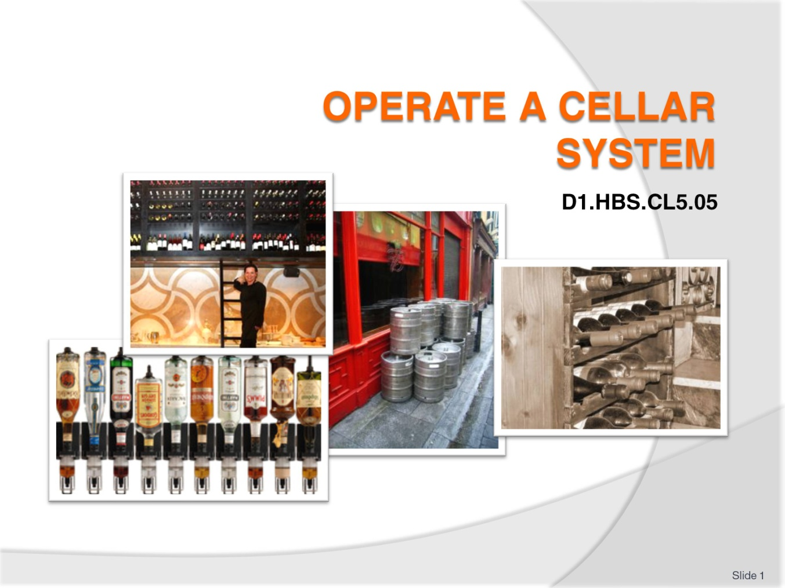
Slide No | Trainer Notes
 | Trainer welcomes students to class.

Slide
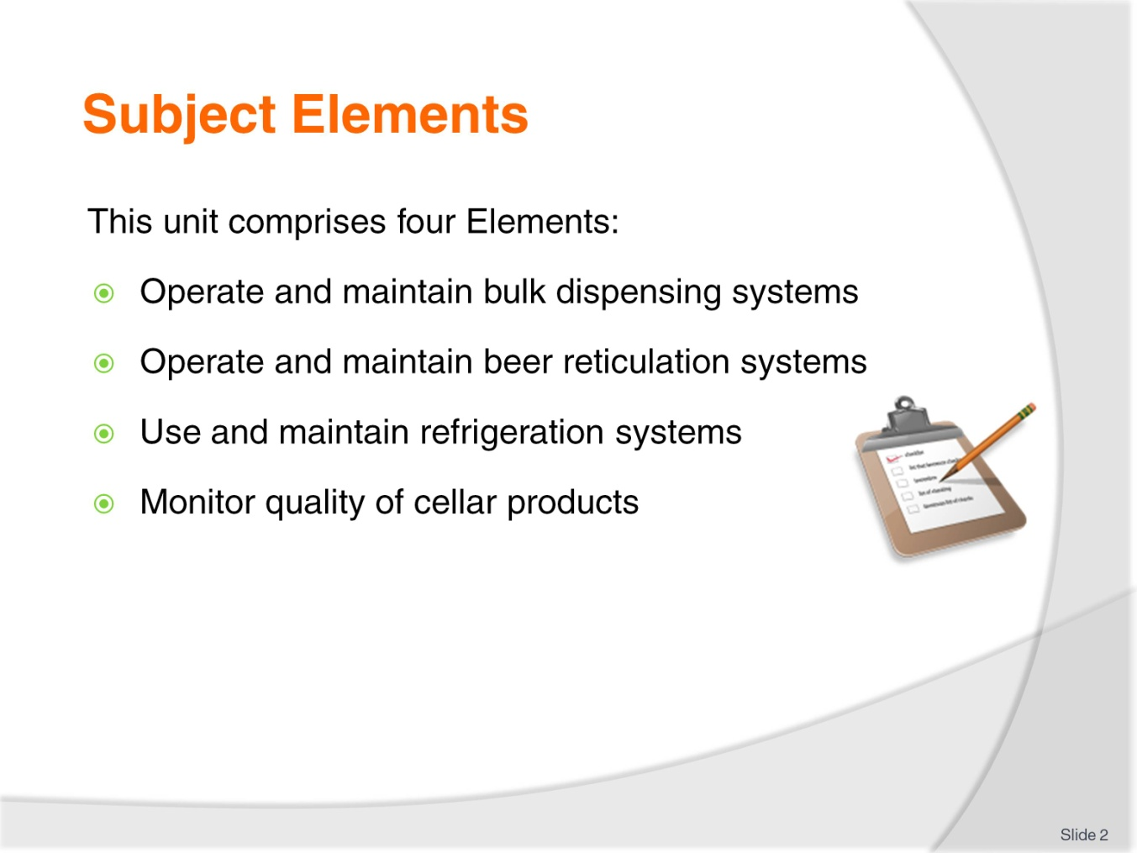
Slide No | Trainer Notes
Trainer advises this Unit comprises four Elements, as listed on the slide explaining:
Each Element comprises a number of Performance Criteria which will be identified throughout the class and explained in detail
Trainees can obtain more detail from their Trainee Manual
At times the course presents advice and information about various protocols but where their workplace requirements differ to what is presented, the workplace practices and standards, as well as policies and procedures must be observed.

Slide
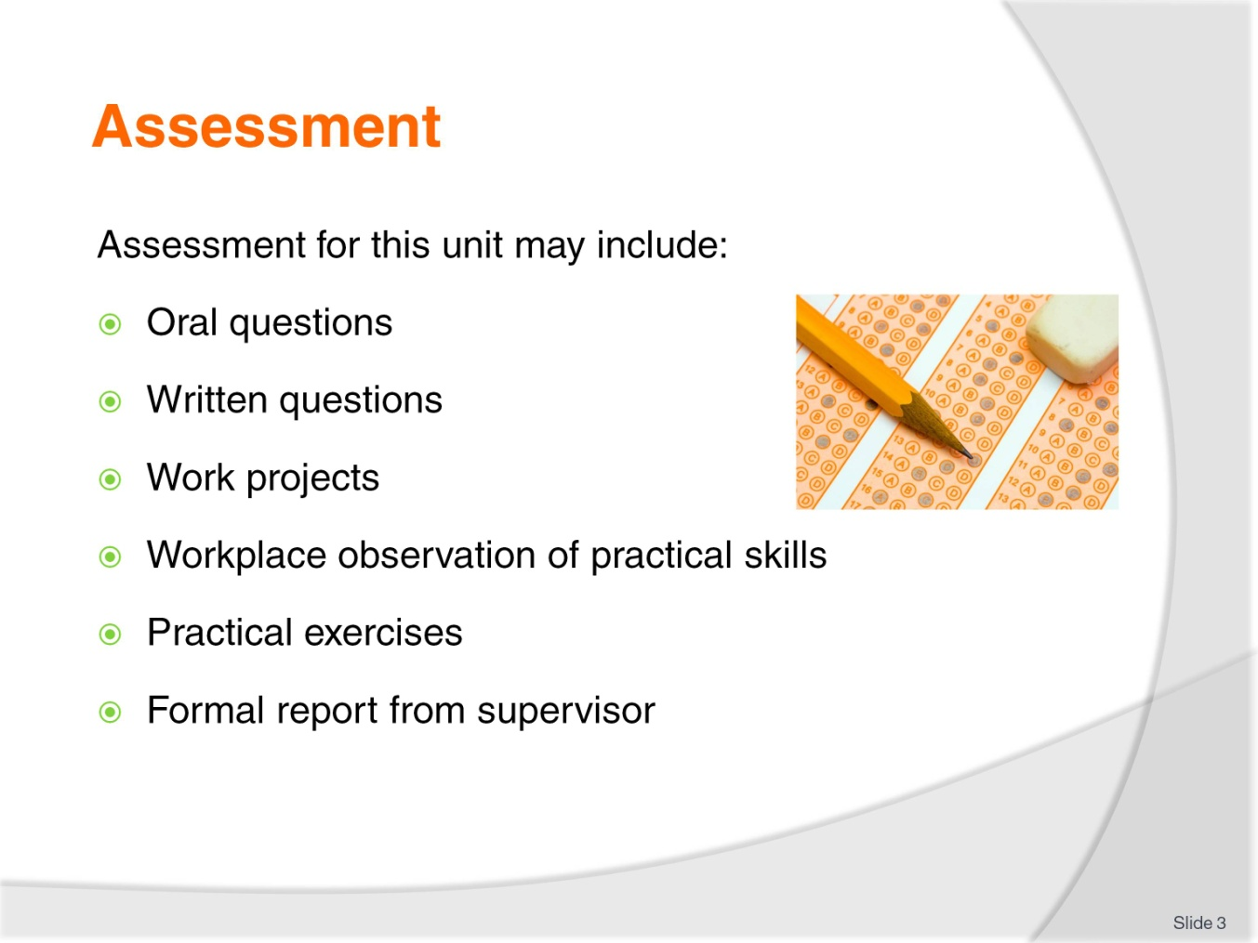
Slide No | Trainer Notes
Trainer advises that assessment for this Unit may take several forms all of which are aimed at verifying they have achieved competency for the Unit as required.
Trainer indicates the methods of assessment that will be applied to them for this Unit.

Slide
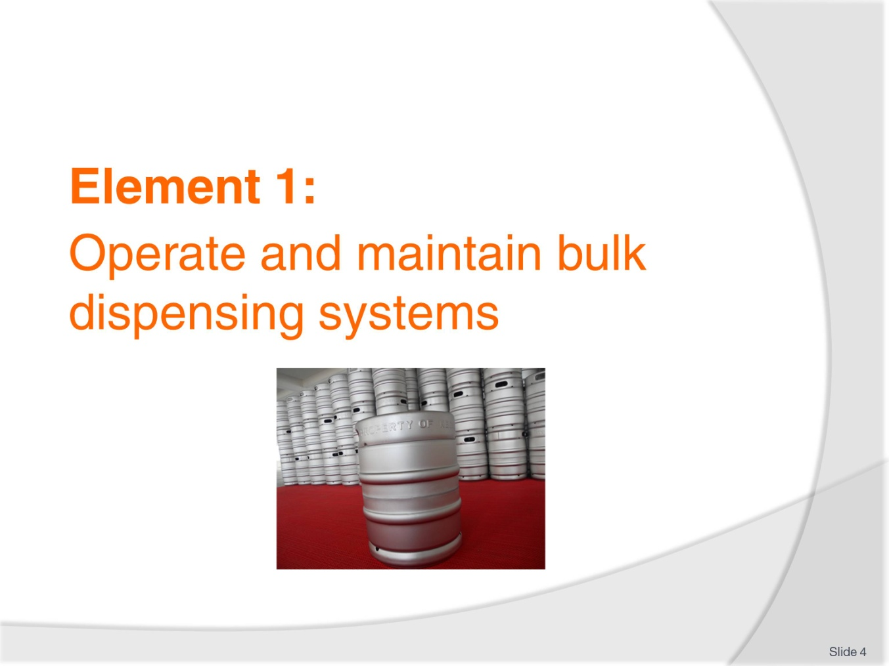
Slide No | Trainer Notes
Introduce topic.
Class Activity – General Discussion
Ask general questions:
What is a cellar?
What equipment is associated with a cellar?
What bulk dispensing systems are used in a bar?

Slide
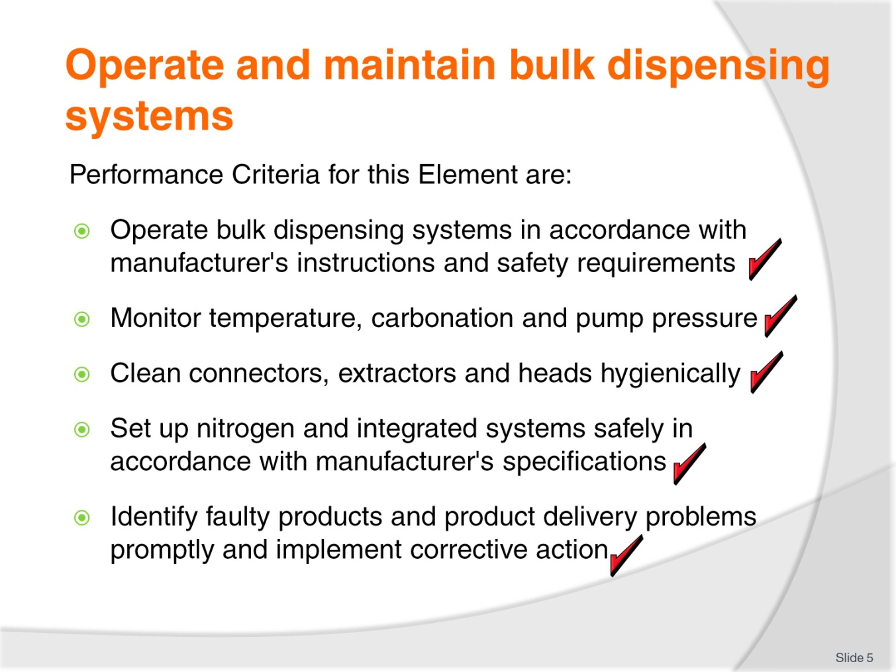
Slide No | Trainer Notes
 | Trainer identifies the Performance Criteria for this Element, as listed on the slide.

Slide
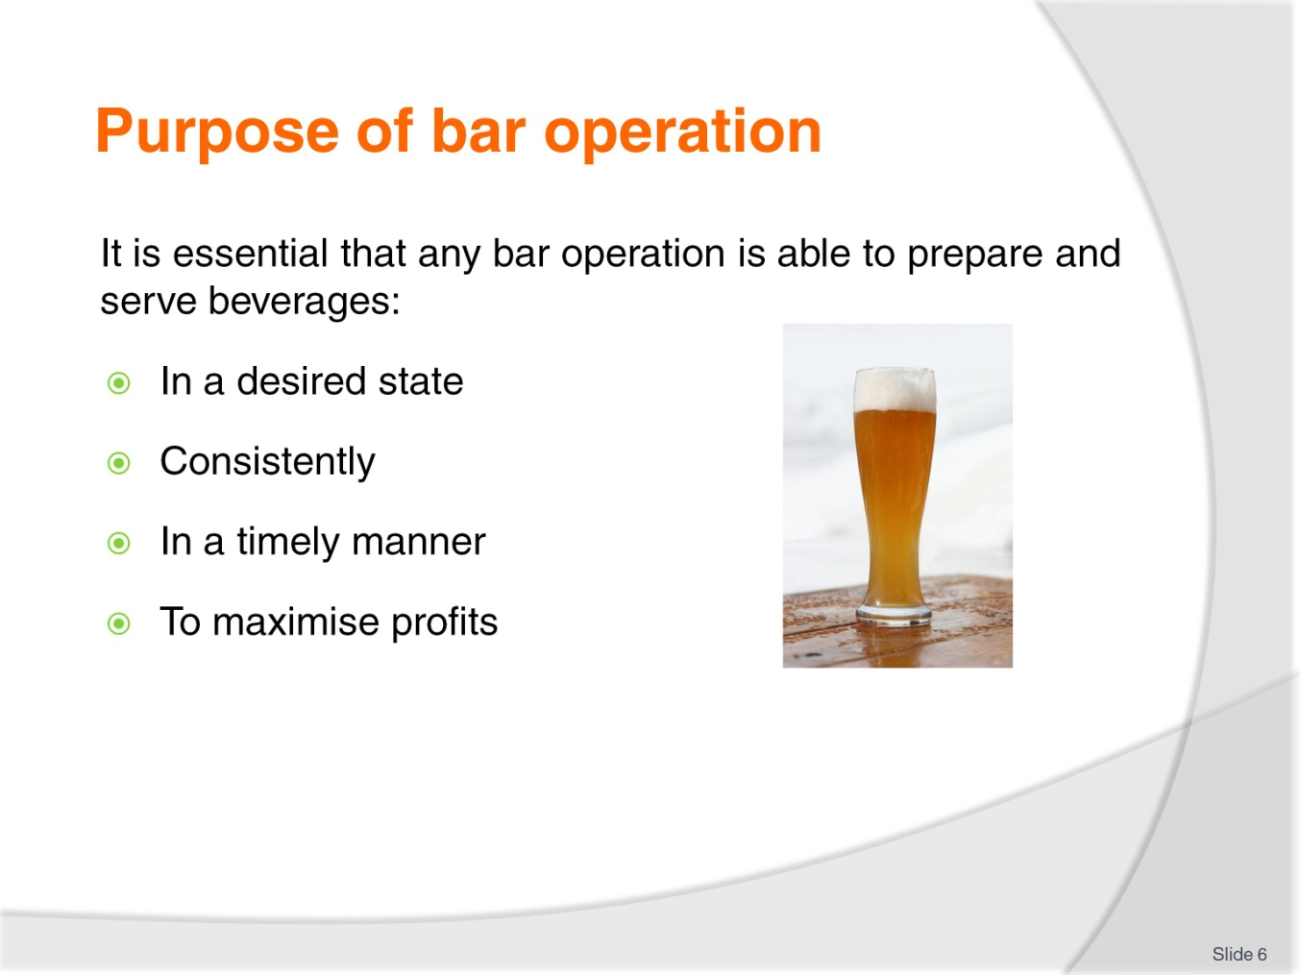
Slide No | Trainer Notes
Class Activity – Questions
What is involved in achieving this purpose?
If you were a bar manager what would be the objectives you would have?

Slide
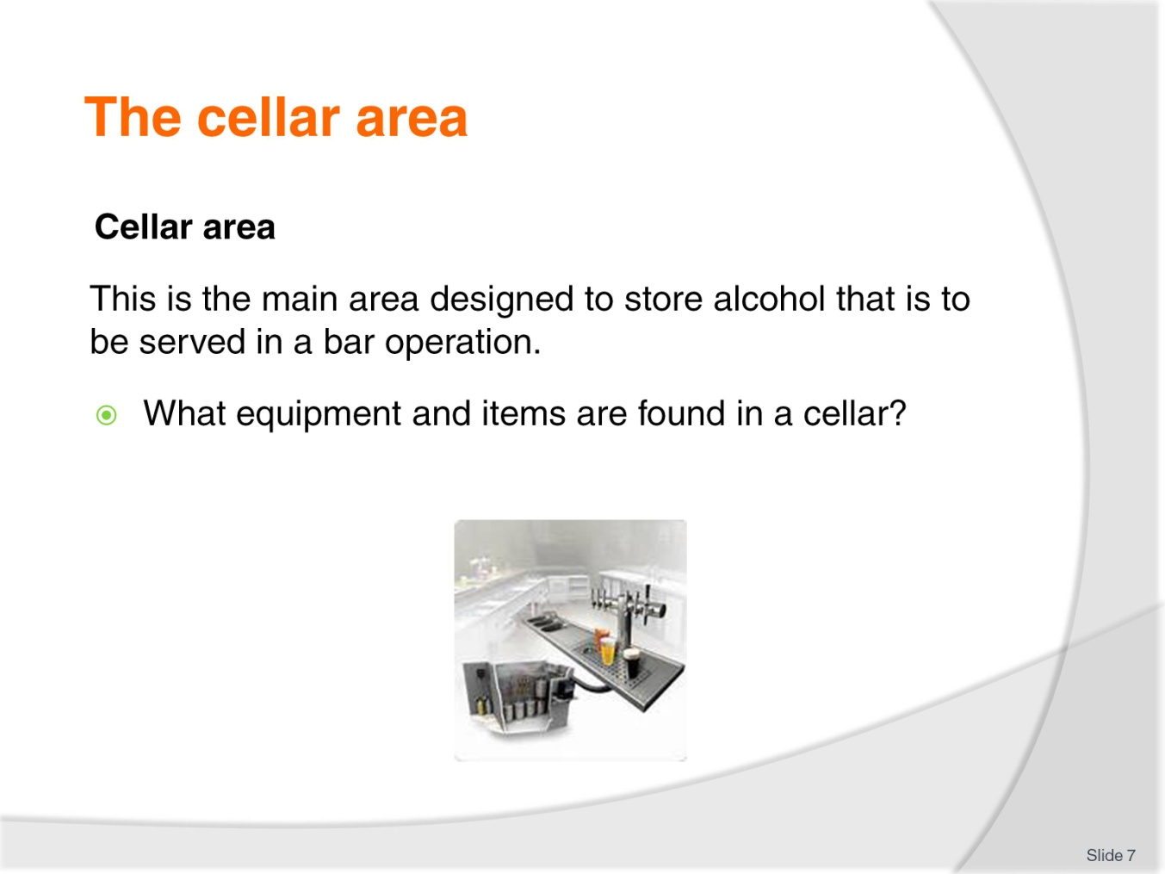
Slide No | Trainer Notes
Class Activity – Question and Visit of cellar
Answer the question in the slide
Trainer to arrange visit of cellar.

Slide
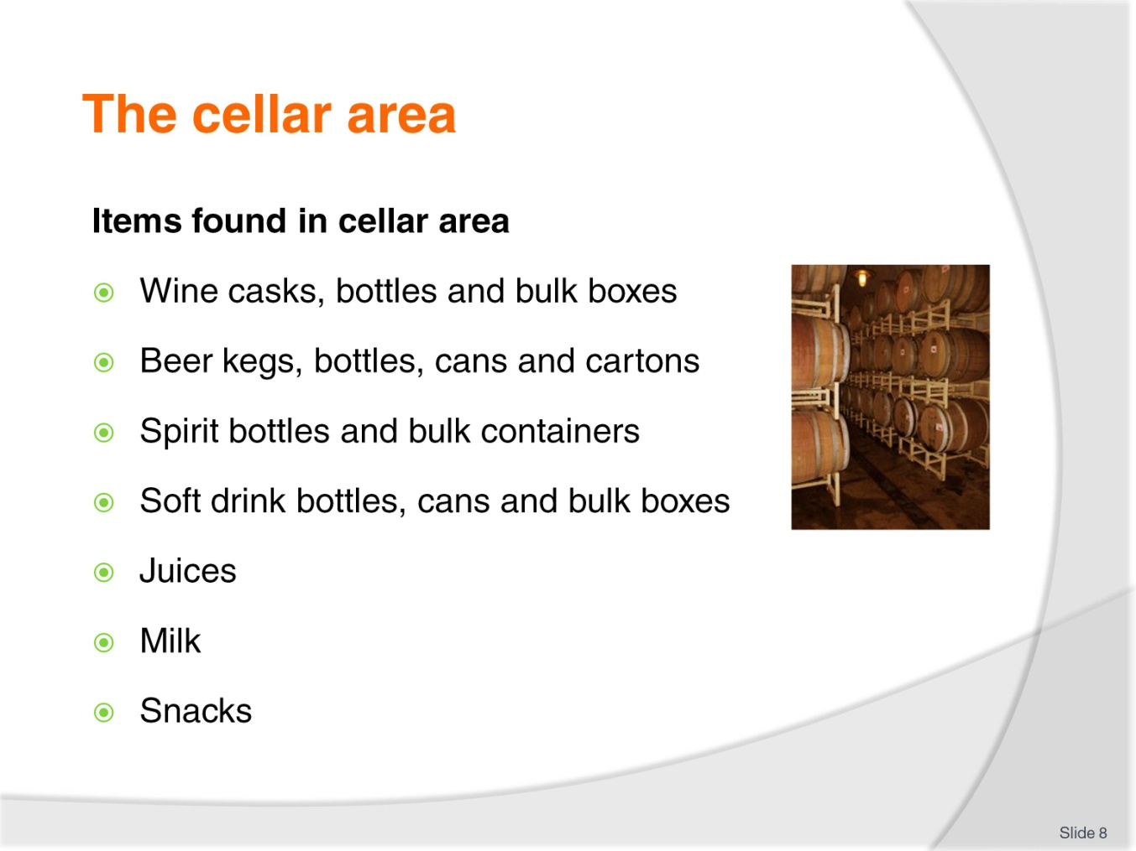
Slide No | Trainer Notes
Class Activity – Visit of cellar
Trainer to arrange visit of cellar
Discuss the purpose of these items as part of cellar visit.

Slide
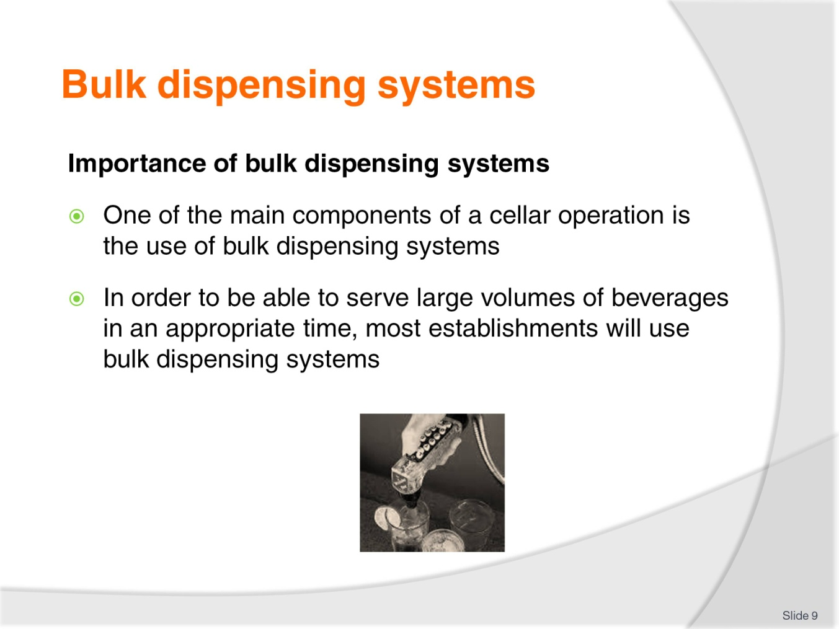
Slide No | Trainer Notes
Class Activity – Questions
What is served using bulk dispensing systems?
What equipment is used in bulk dispensing systems?

Slide
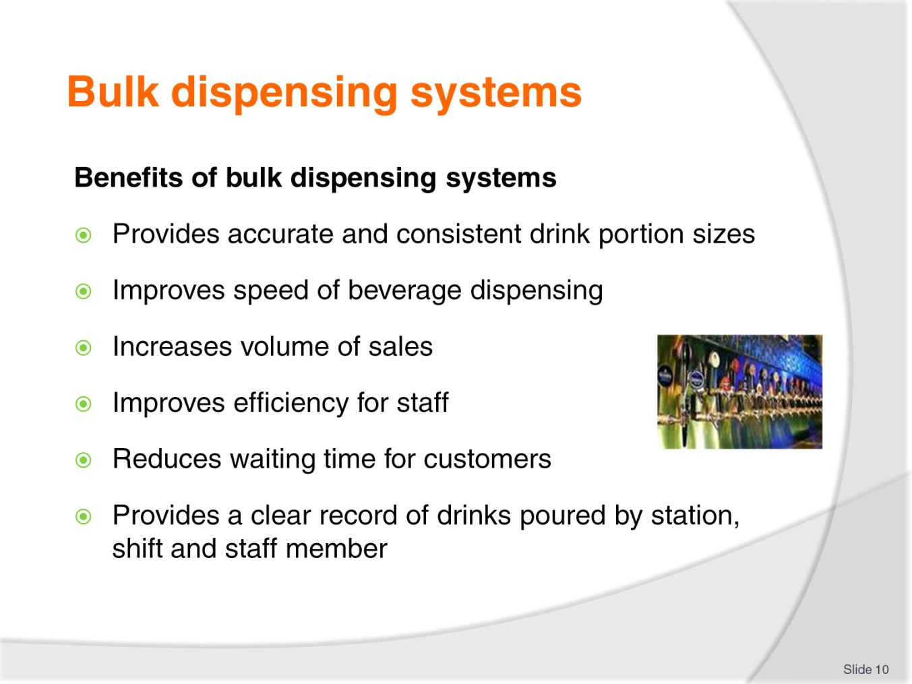
Slide No | Trainer Notes
Class Activity – Discuss benefits and disadvantages
Discuss the benefits of bulk dispensing systems
What disadvantages are there of these systems?

Slide
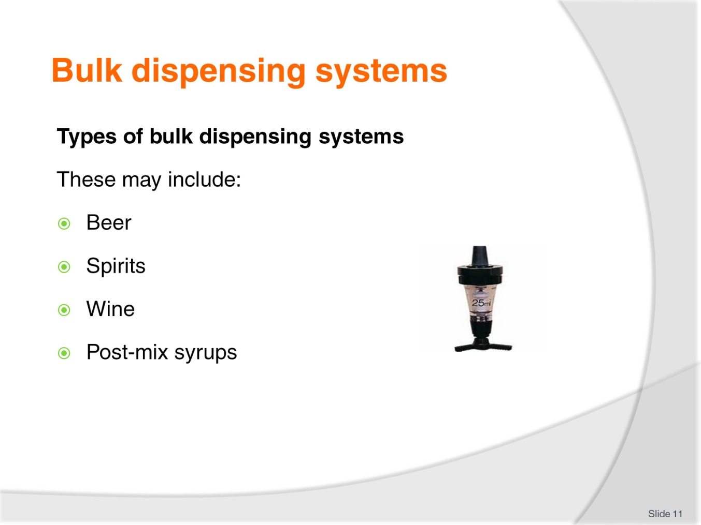
Slide No | Trainer Notes
Class Activity – Discussion
Discuss the different types of systems.

Slide
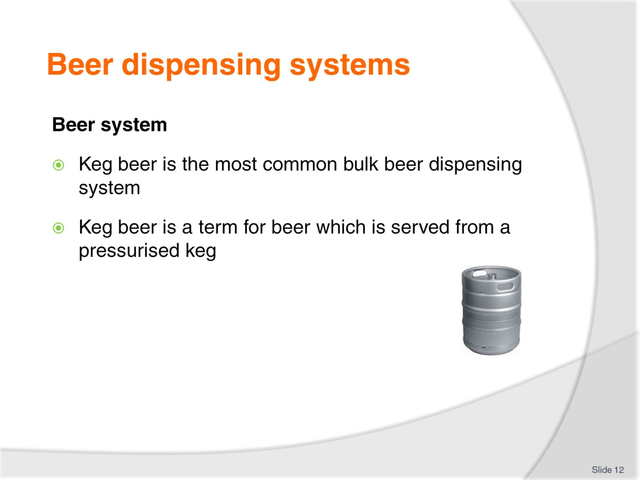
Slide No | Trainer Notes
Class Activity – Discussion
What is the benefit of using kegs?
How is beer distributed from kegs to the customer?

Slide
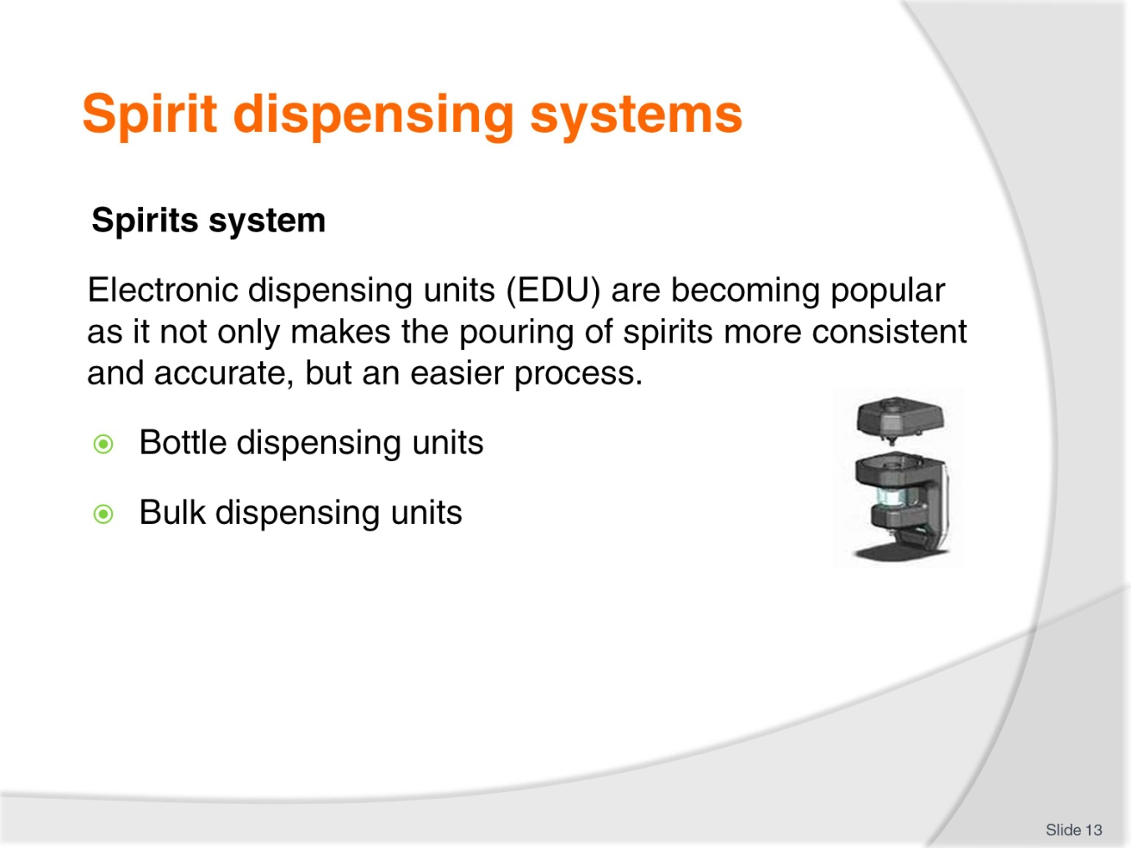
Slide No | Trainer Notes
Class Activity – Discussion
What is the benefit of these spirit systems?
What is the difference between bottle and bulk dispensing units?
What is the common measurement dispensed by these units?

Slide
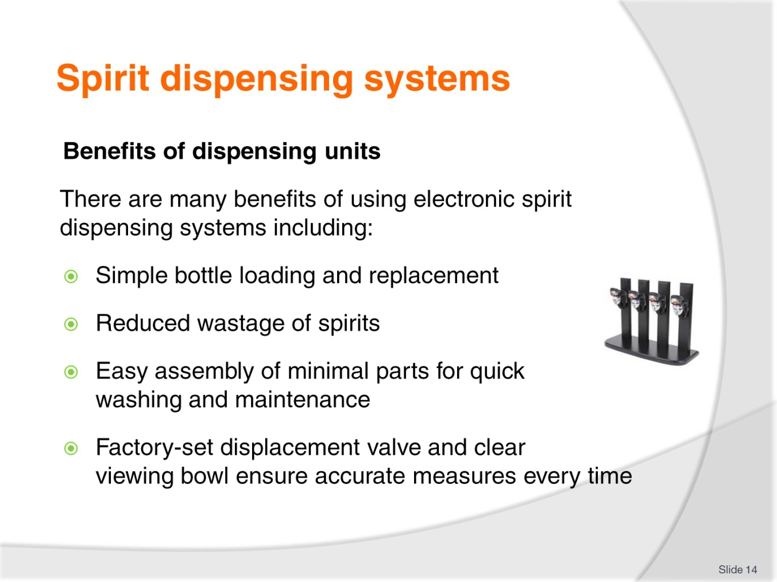
Slide No | Trainer Notes
Class Activity – Discuss benefits and disadvantages of spirit dispensing equipment
Discuss the benefits of spirit dispensing systems
What disadvantages are there of these systems?

Slide
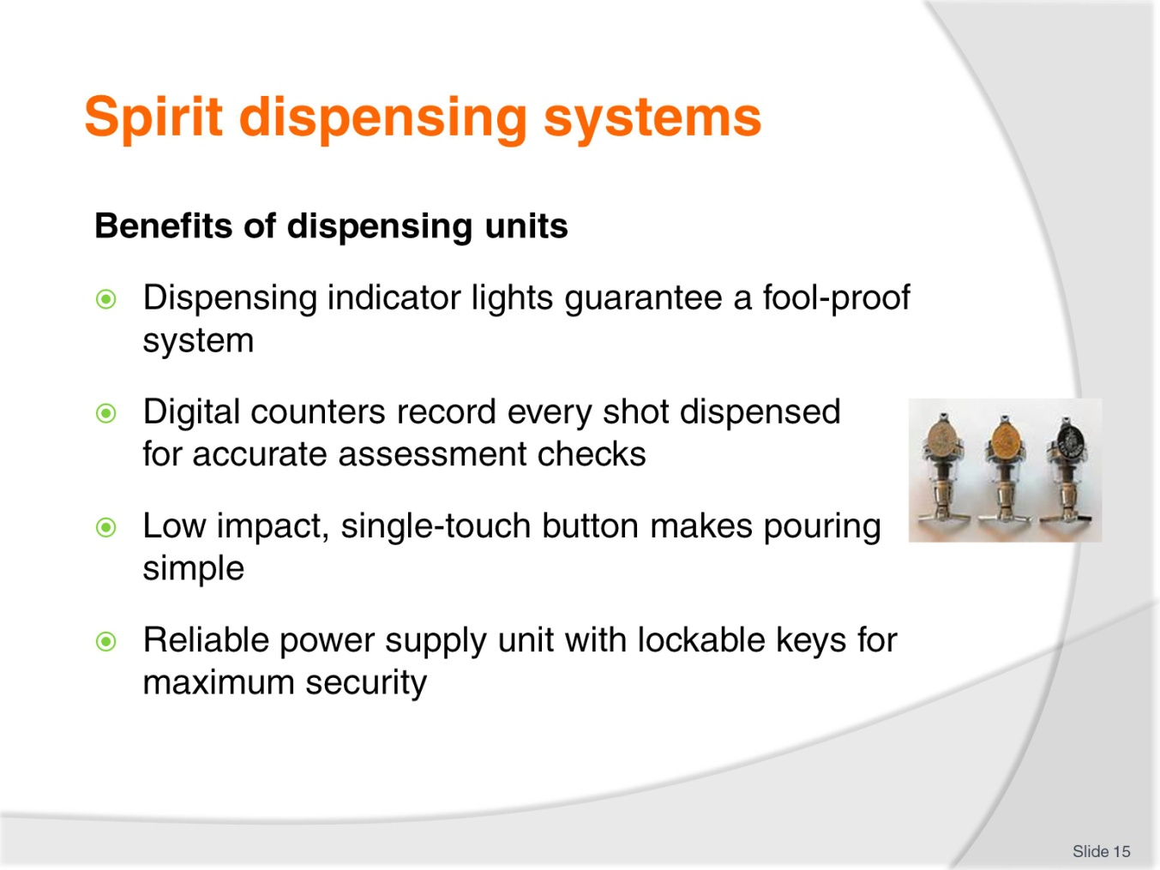
Slide No | Trainer Notes
Class Activity – Discuss benefits and disadvantages of spirit dispensing equipment
Discuss the benefits of spirit dispensing systems
What disadvantages are there of these systems?

Slide
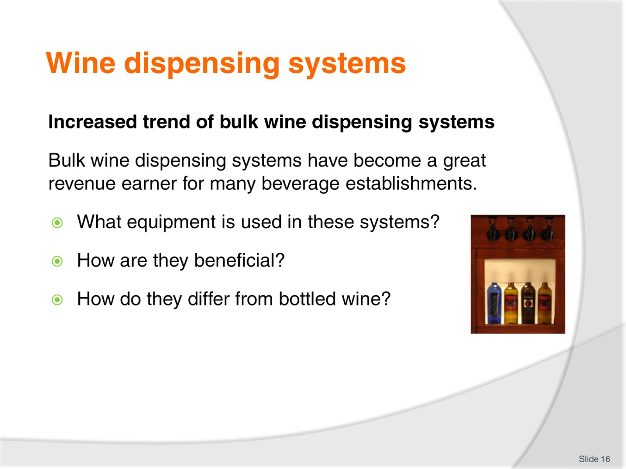
Slide No | Trainer Notes
Class Activity – Discuss benefits and disadvantages of bulk wine dispensing equipment & Research activity
Discuss the benefits of bulk wine dispensing systems
What disadvantages are there of these systems?
Trainer to get audience to research different types of wine dispensing systems and associated costs.

Slide
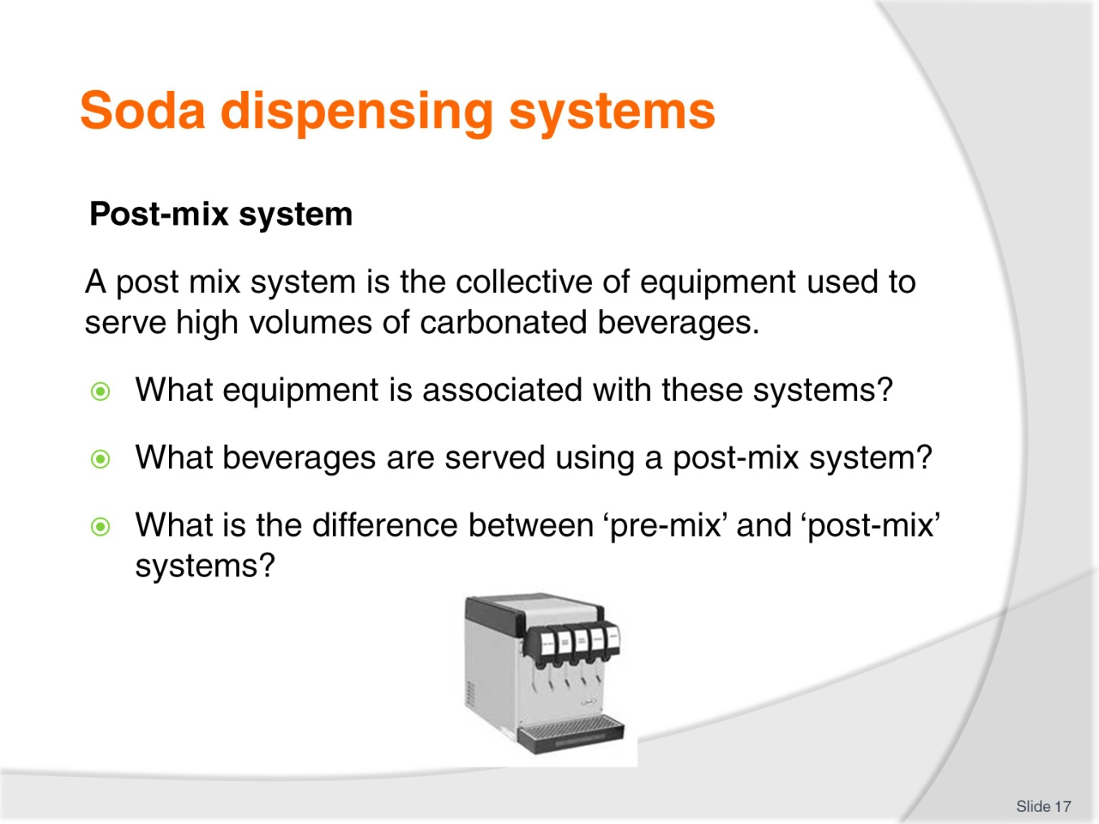
Slide No | Trainer Notes
Class Activity – Discuss benefits and disadvantages of post mix systems
Discuss the benefits of post mix systems
What disadvantages are there of these systems?

Slide
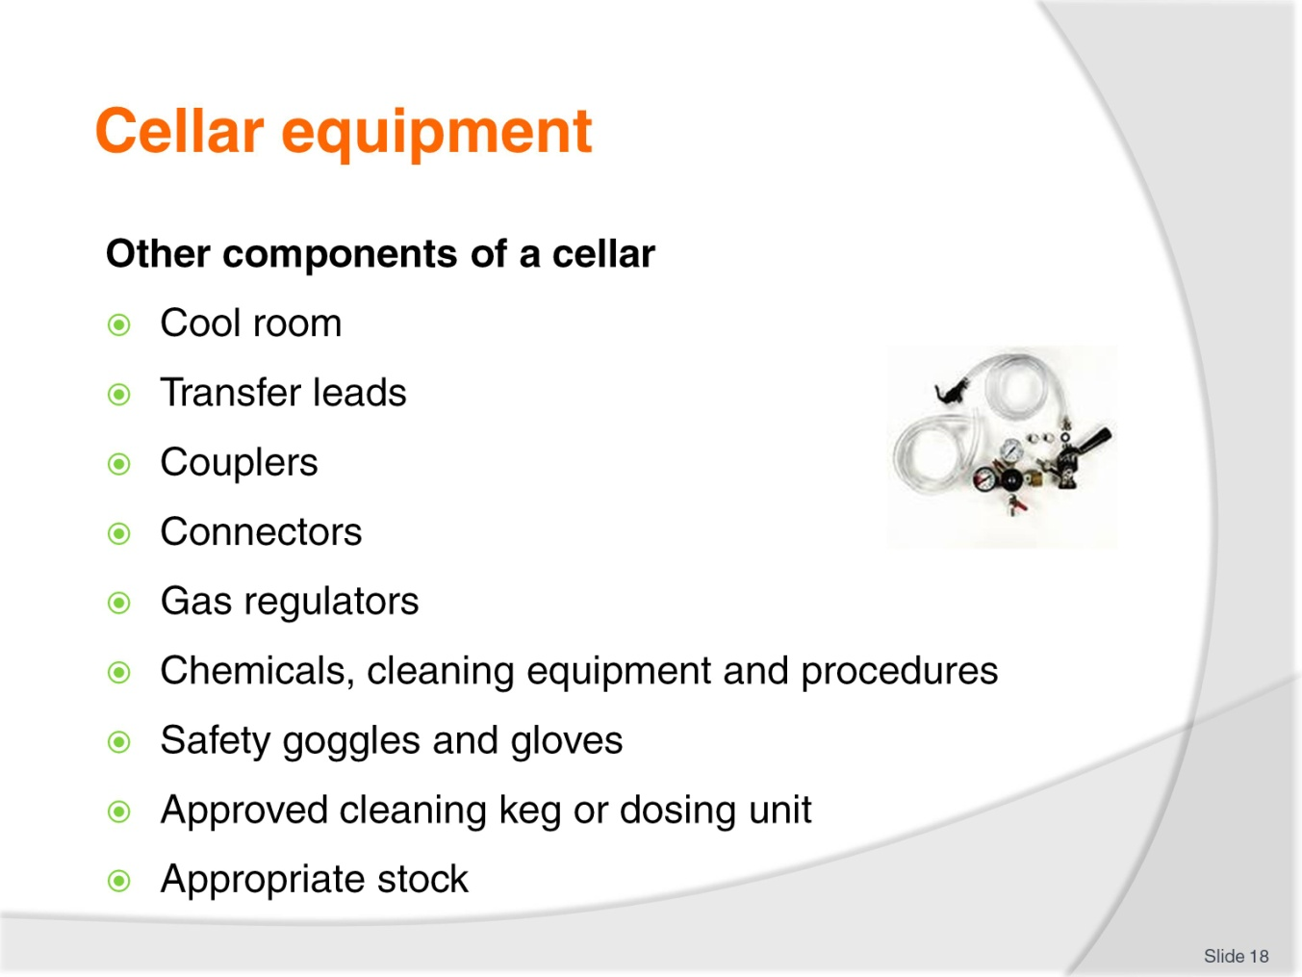
Slide No | Trainer Notes
Class Activity – Discussion and demonstration
Discuss what these pieces of equipment are used for
Trainer to demonstrate these items and their uses.

Slide
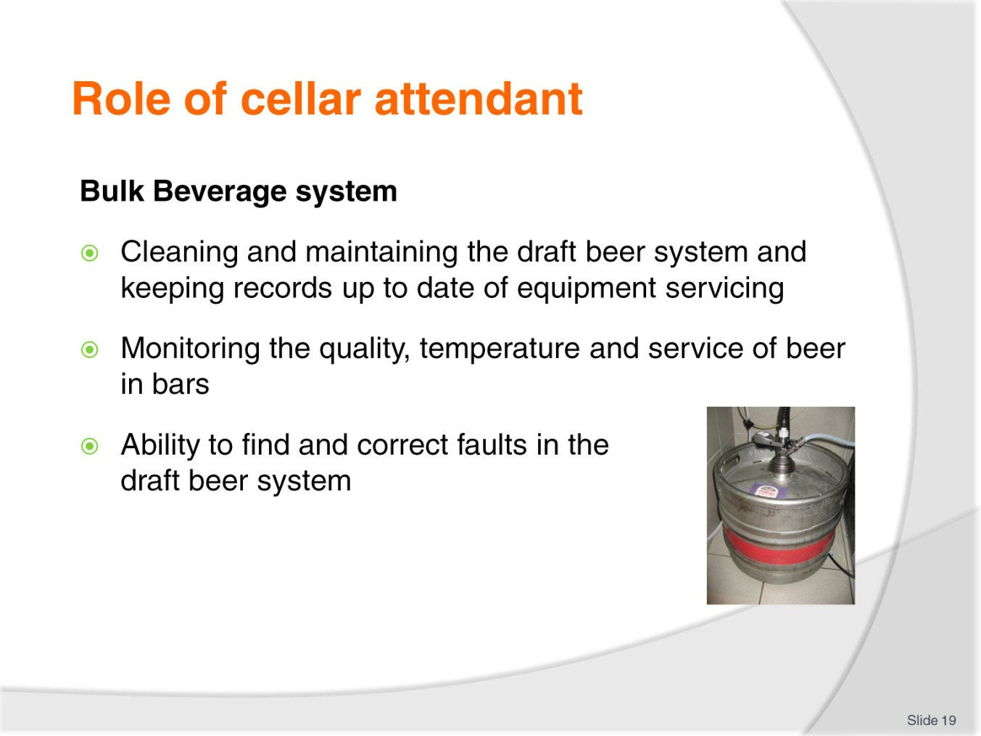
Slide No | Trainer Notes
Class Activity – Discuss role of Cellar Attendant
Discuss the duties of a cellar attendant.

Slide
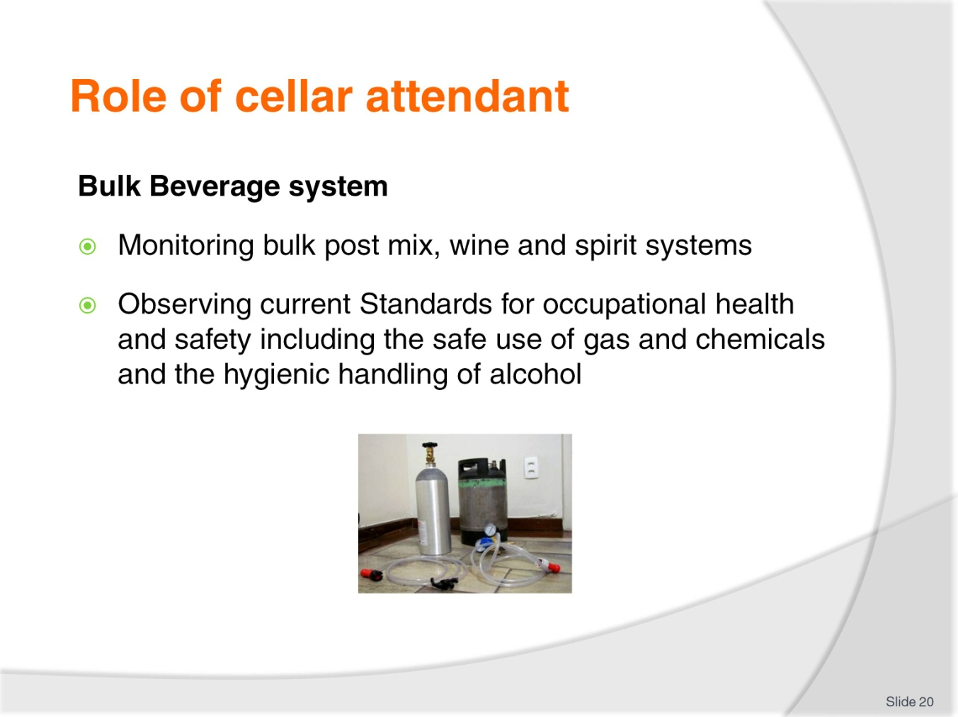
Slide No | Trainer Notes
Class Activity – Discuss role of Cellar Attendant
Discuss the duties of a cellar attendant.

Slide
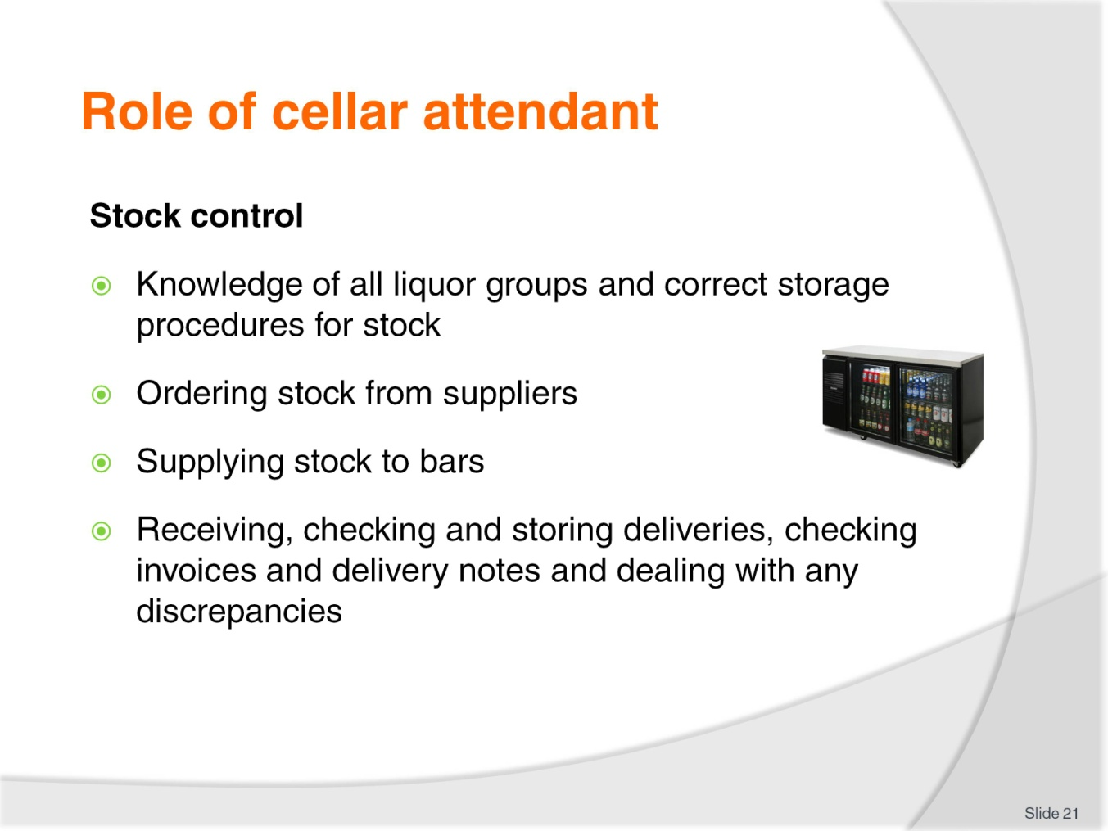
Slide No | Trainer Notes
Class Activity – Discuss role of Cellar Attendant
Discuss the duties of a cellar attendant.

Slide
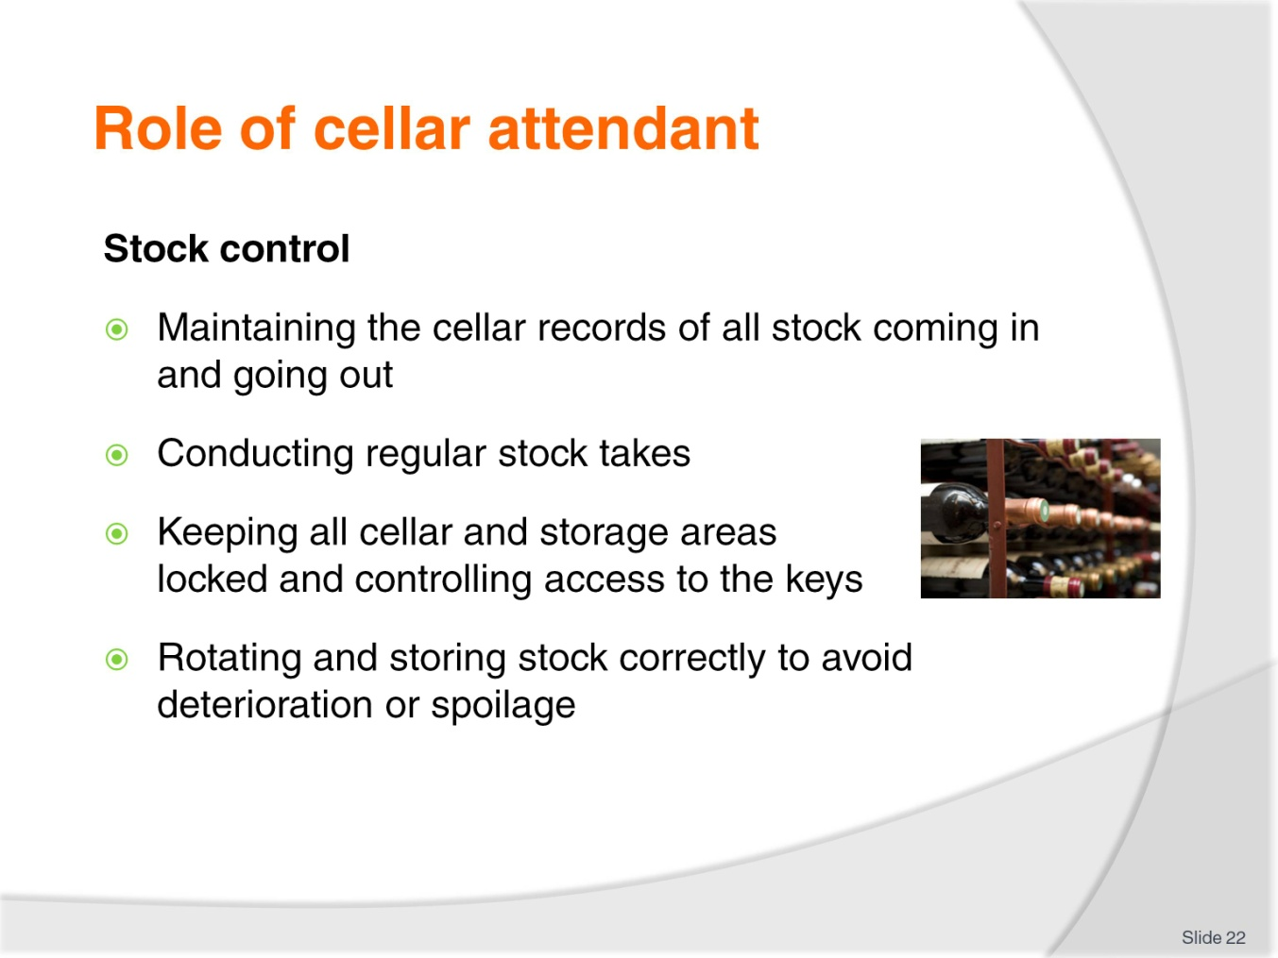
Slide No | Trainer Notes
Class Activity – Discuss role of Cellar Attendant
Discuss the duties of a cellar attendant.

Slide
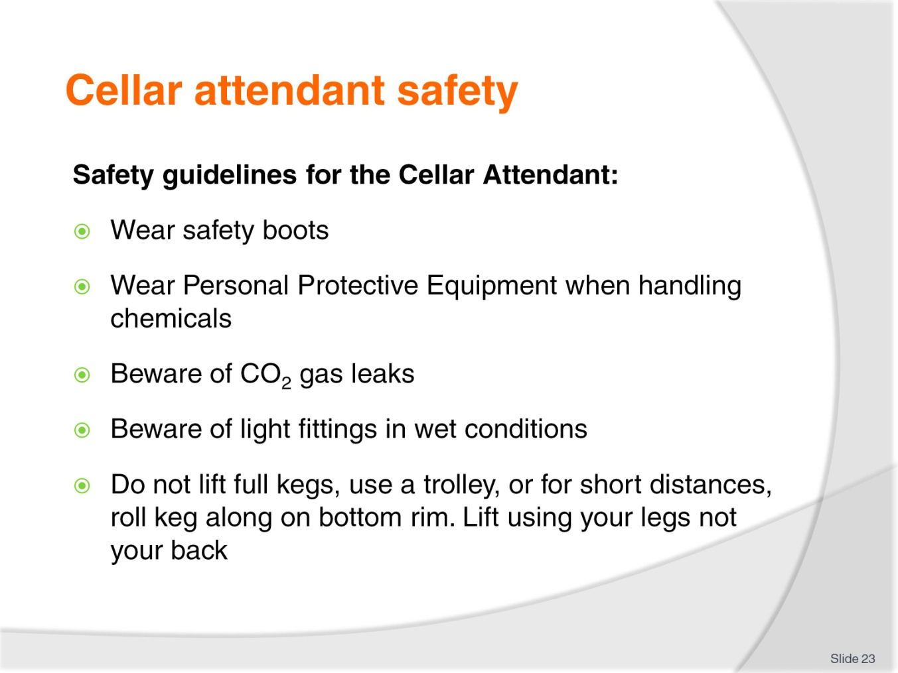
Slide No | Trainer Notes
Class Activity – Discuss importance of cellar attendant safety
Discuss the importance of these safety guidelines.

Slide
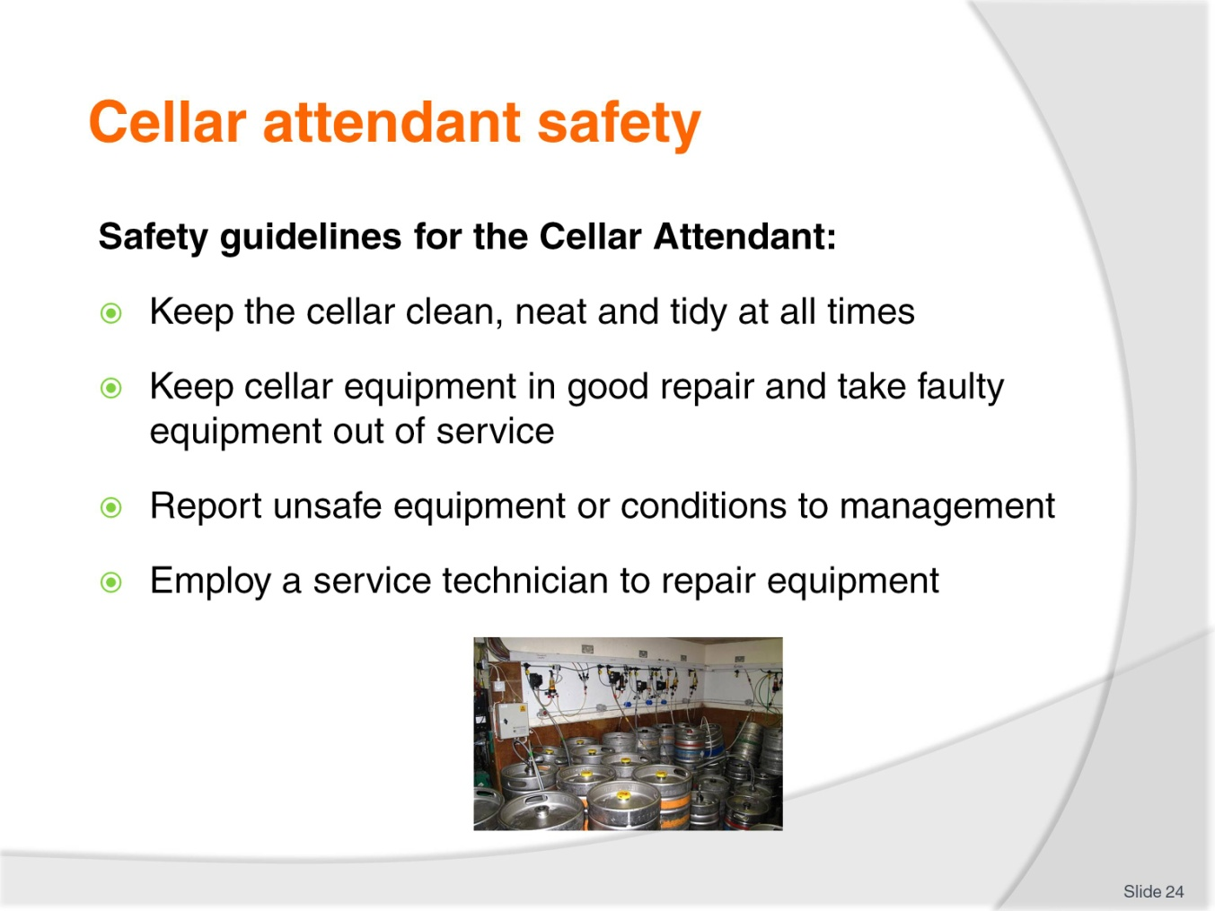
Slide No | Trainer Notes
Class Activity – Discuss importance of cellar attendant safety
Discuss the importance of these safety guidelines.

Slide
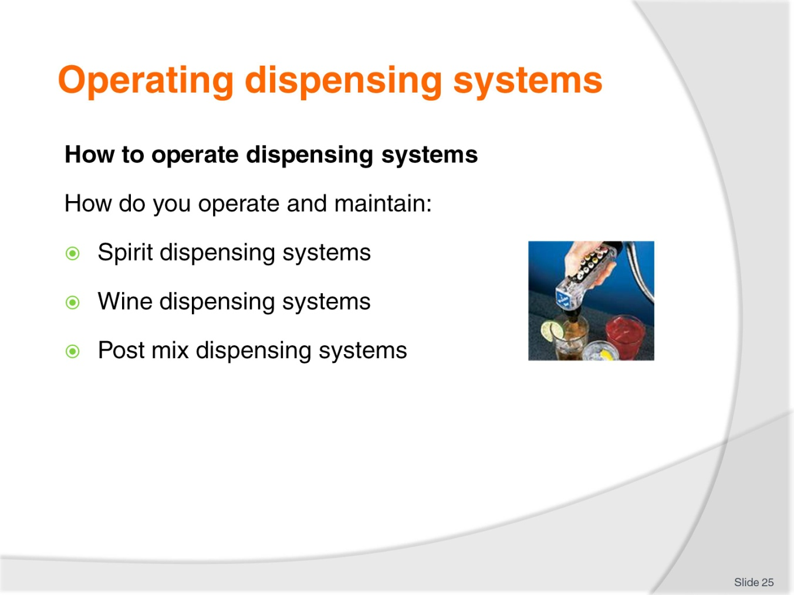
Slide No | Trainer Notes
Class Activity – Discussion
This section will explore how to use these systems but is a good introductory discussion to identify current understanding.

Slide
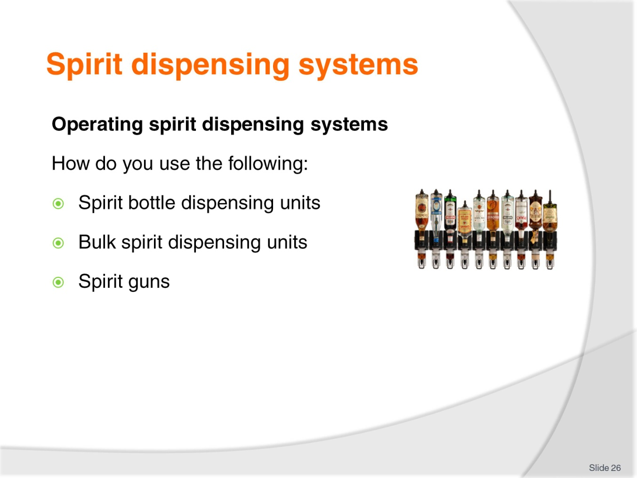
Slide No | Trainer Notes
Class Activity – Demonstration
Trainer to demonstrate how to use these systems.

Slide
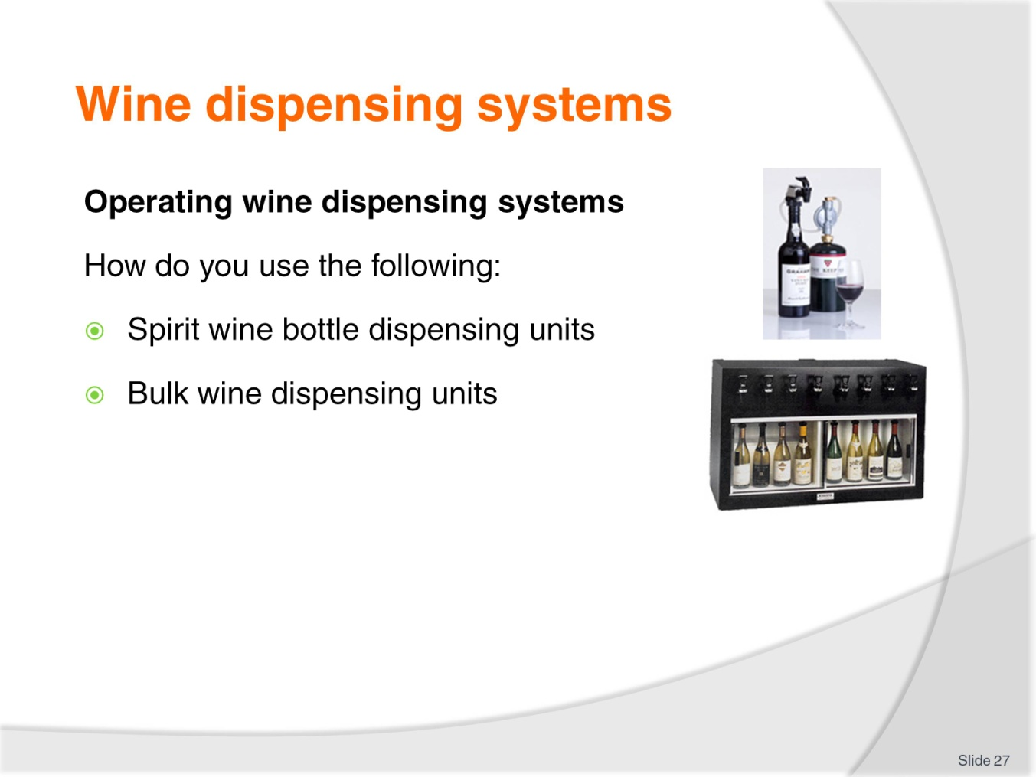
Slide No | Trainer Notes
Class Activity – Demonstration
Trainer to demonstrate how to use these systems.

Slide
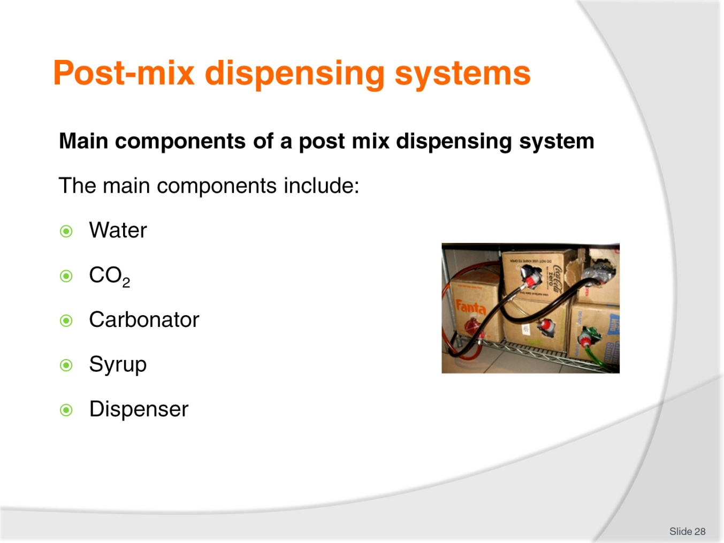
Slide No | Trainer Notes
Class Activity – Discussion
What is the purpose of each of these components?

Slide
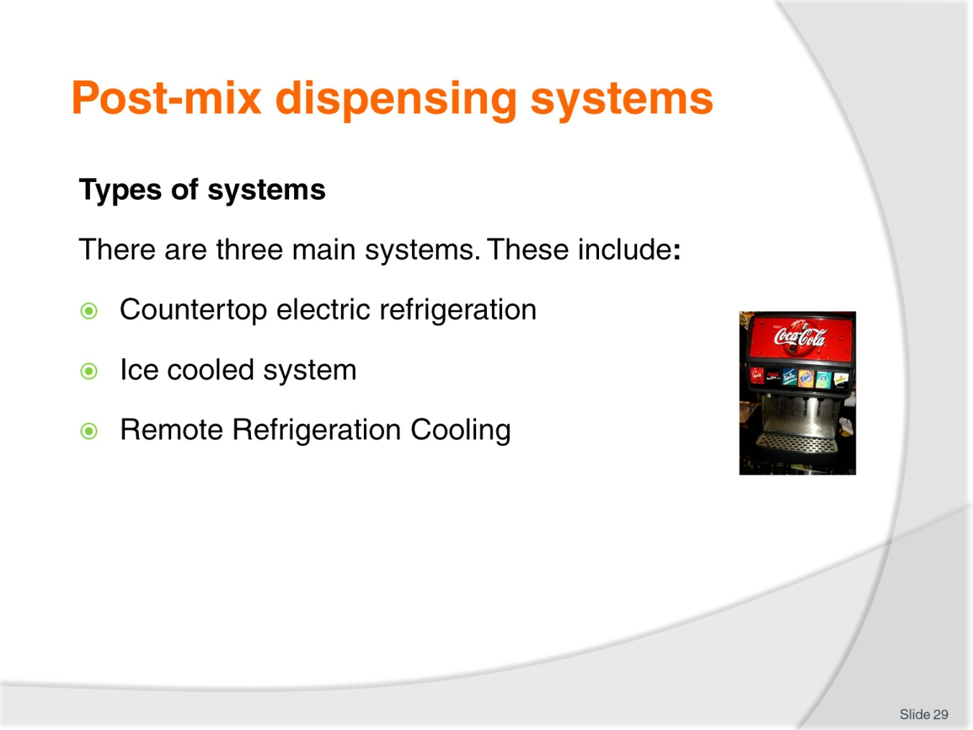
Slide No | Trainer Notes
Class Activity – Discussion of systems
Trainer to discuss the differences of these systems.

Slide
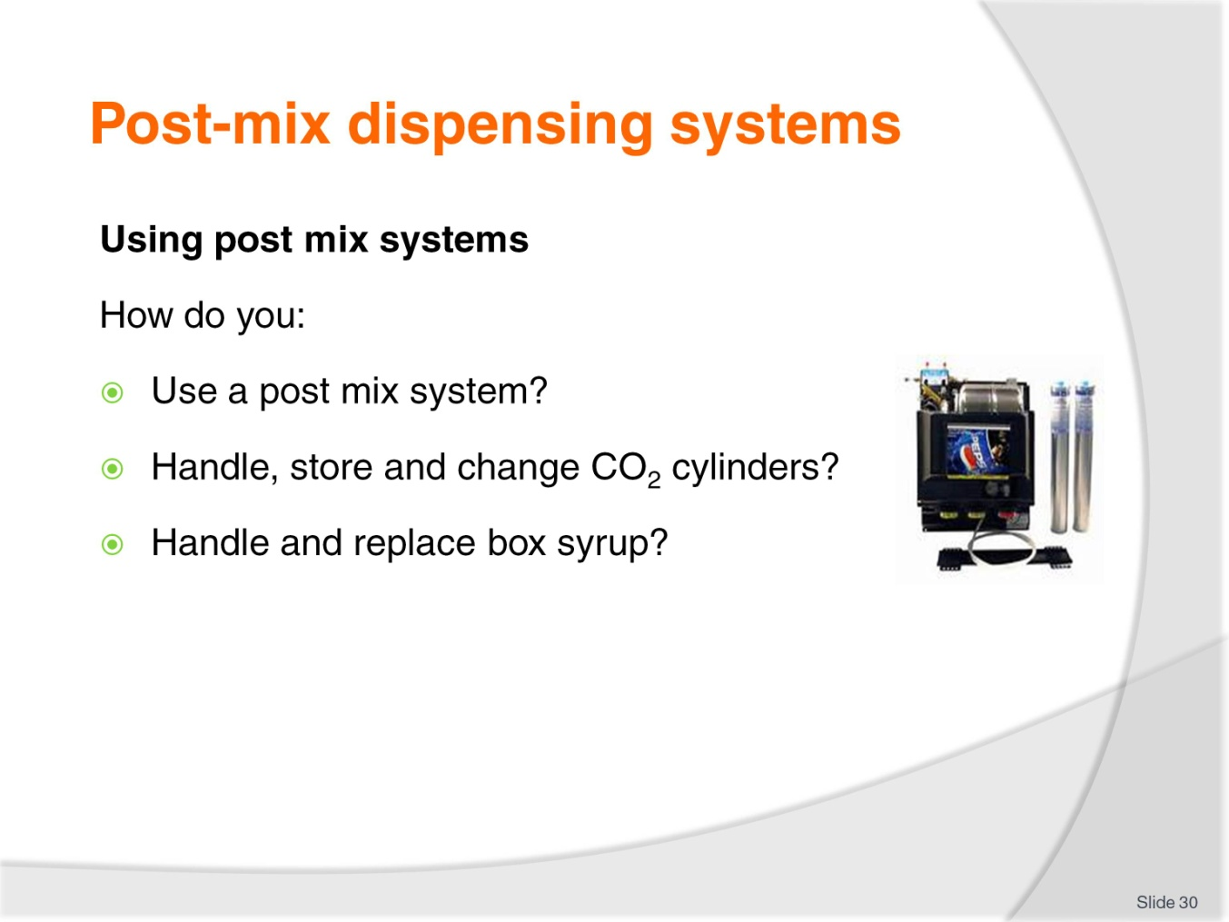
Slide No | Trainer Notes
Class Activity – Demonstration
Trainer to demonstrate how to use post mix systems.

Slide
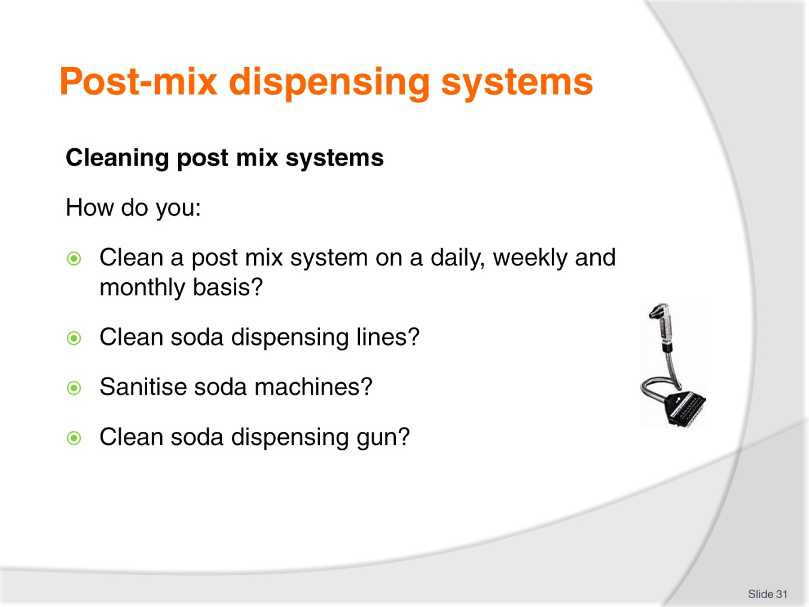
Slide No | Trainer Notes
Class Activity – Demonstration / Discussion
Trainer to demonstrate/discuss how to clean post mix systems.

Slide
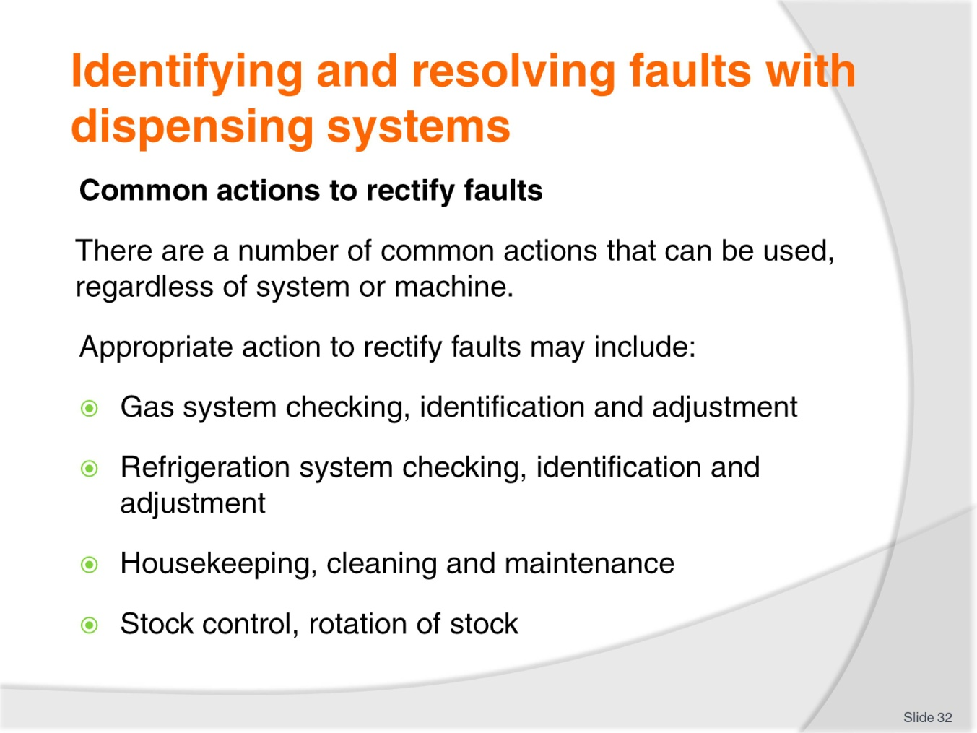
Slide No | Trainer Notes
Class Activity – Discussion
What are common faults of each dispensing system mentioned?
What are possible remedies?

Slide
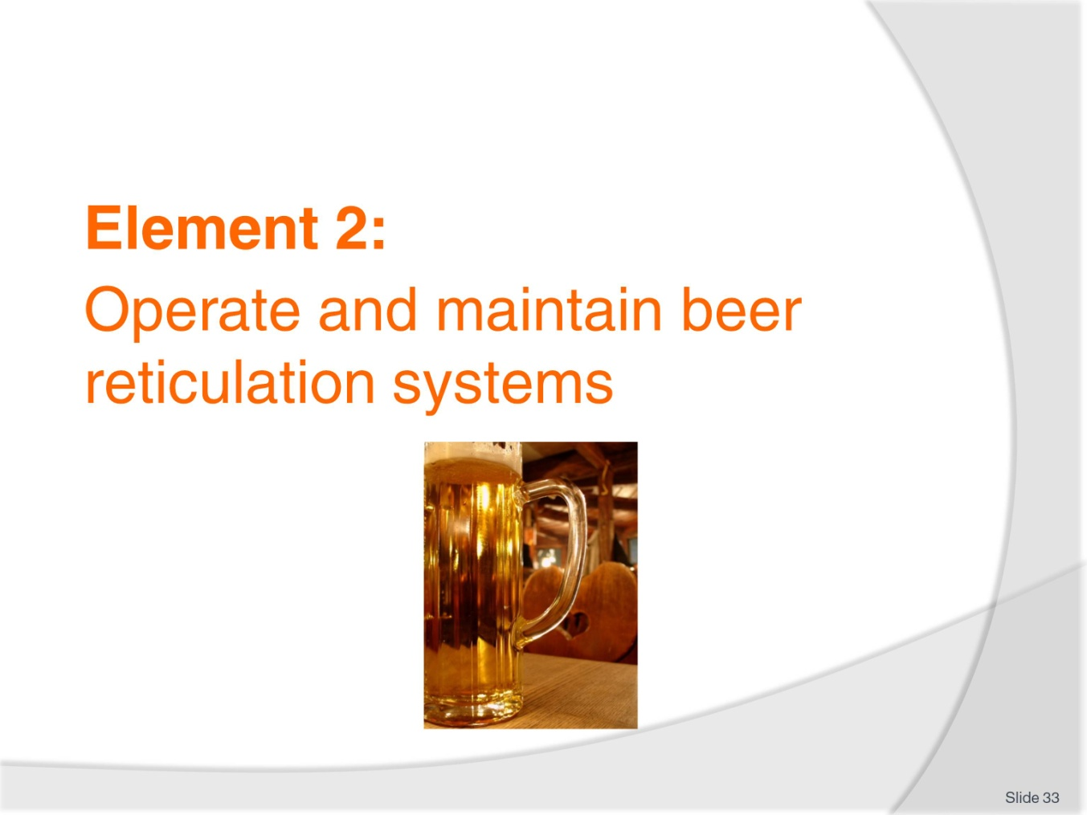
Slide No | Trainer Notes
Introduce topic.
Class Activity – General Discussion
Ask general questions:
Why are beer systems popular?
What are the benefits of these systems?
What equipment is associated with these systems?

Slide
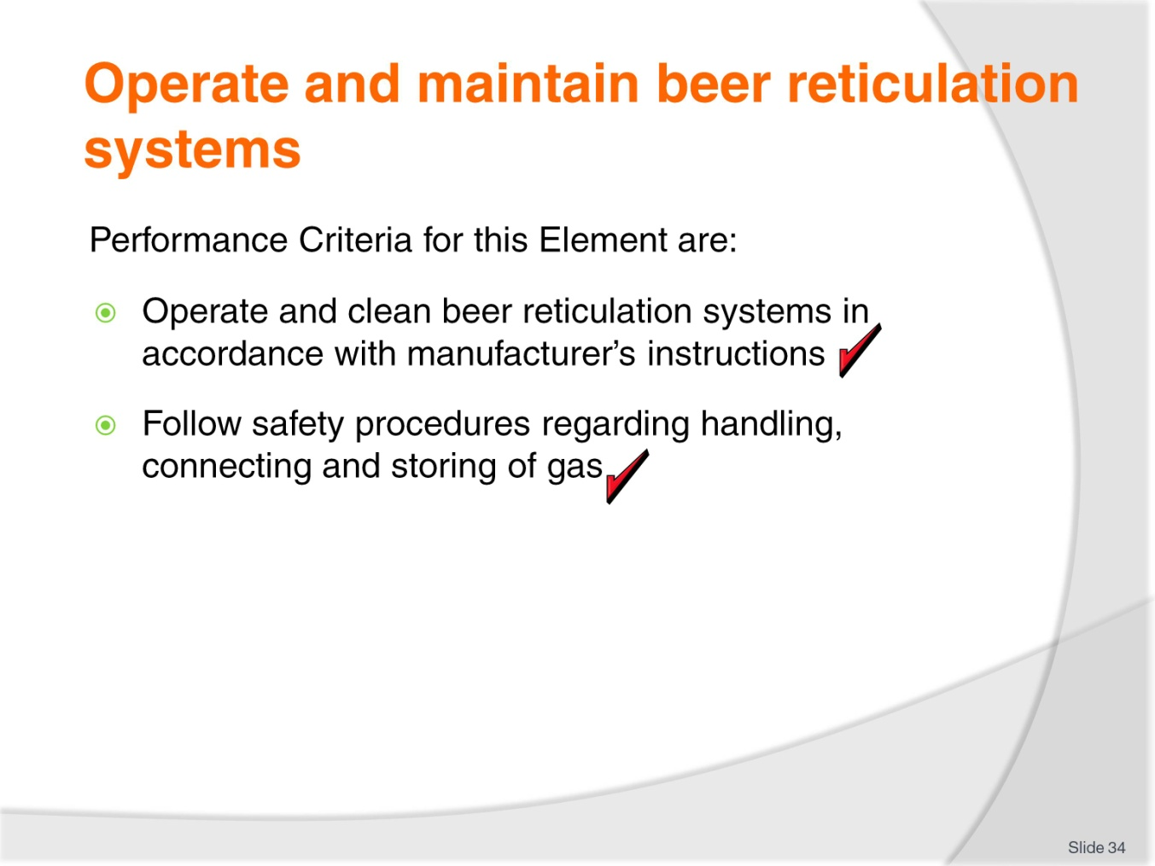
Slide No | Trainer Notes
 | Trainer identifies the Performance Criteria for this Element, as listed on the slide.

Slide
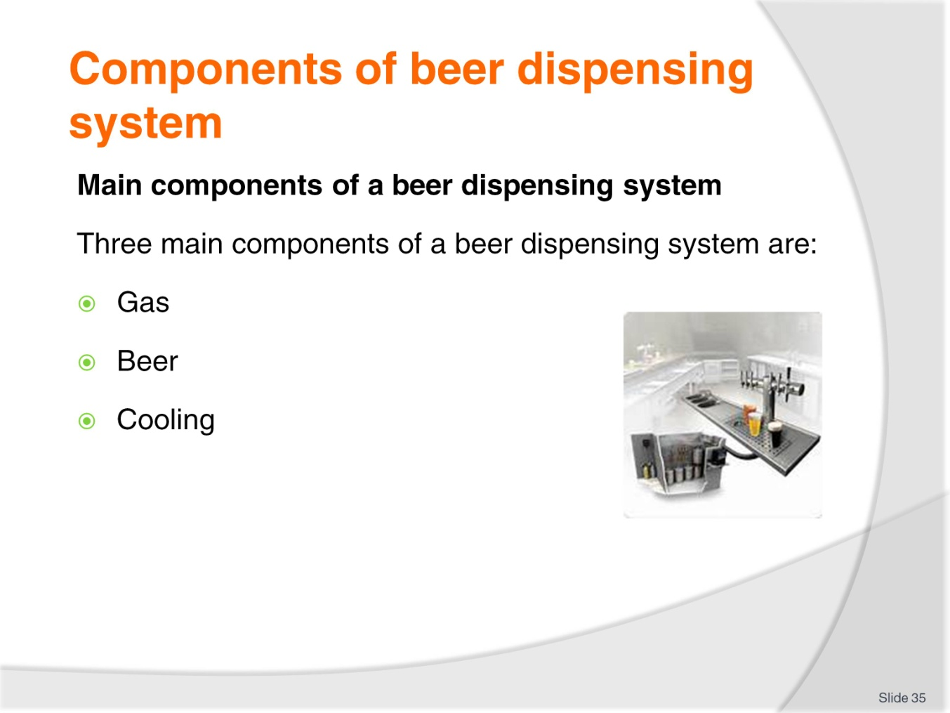
Slide No | Trainer Notes
Class Activity – Discussion
What is the purpose of each of these components?

Slide
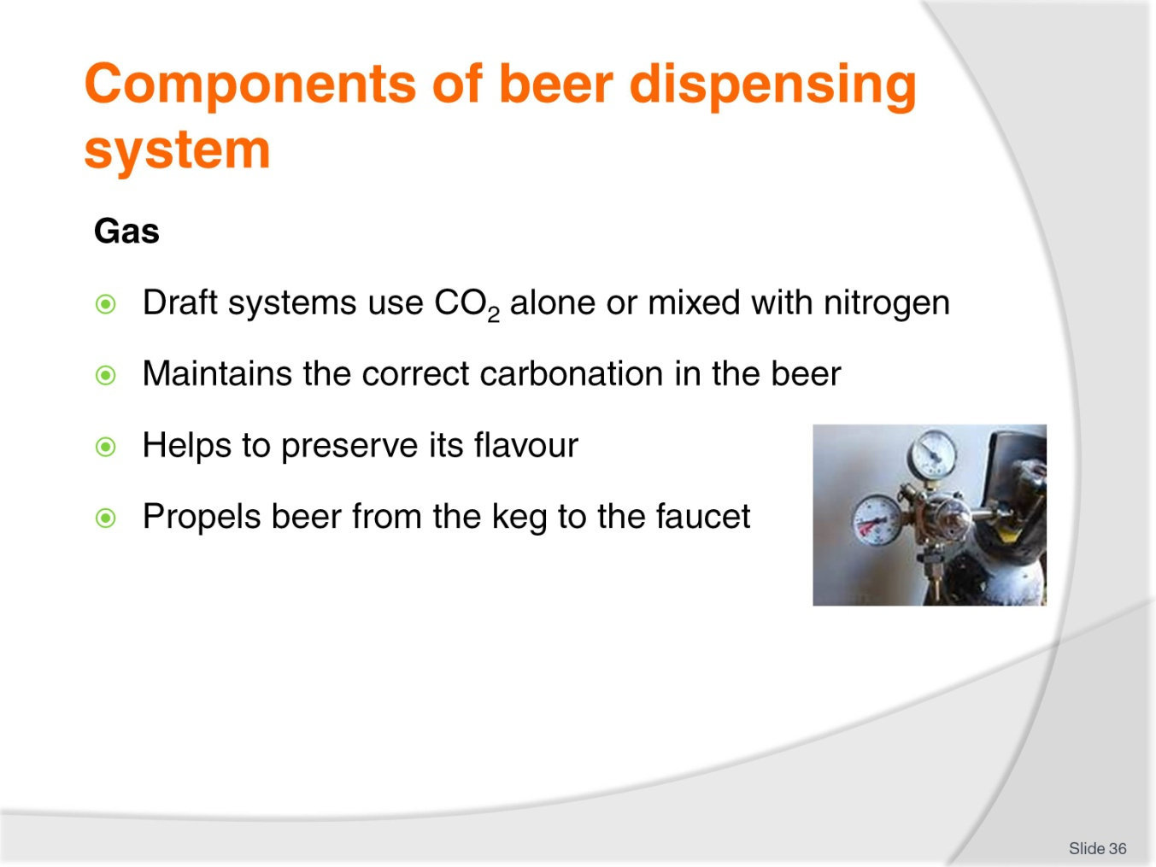
Slide No | Trainer Notes
Class Activity – Discussion / Demonstration
How do you handle, store, use and change gas cylinders?
Trainer to demonstrate where appropriate.

Slide
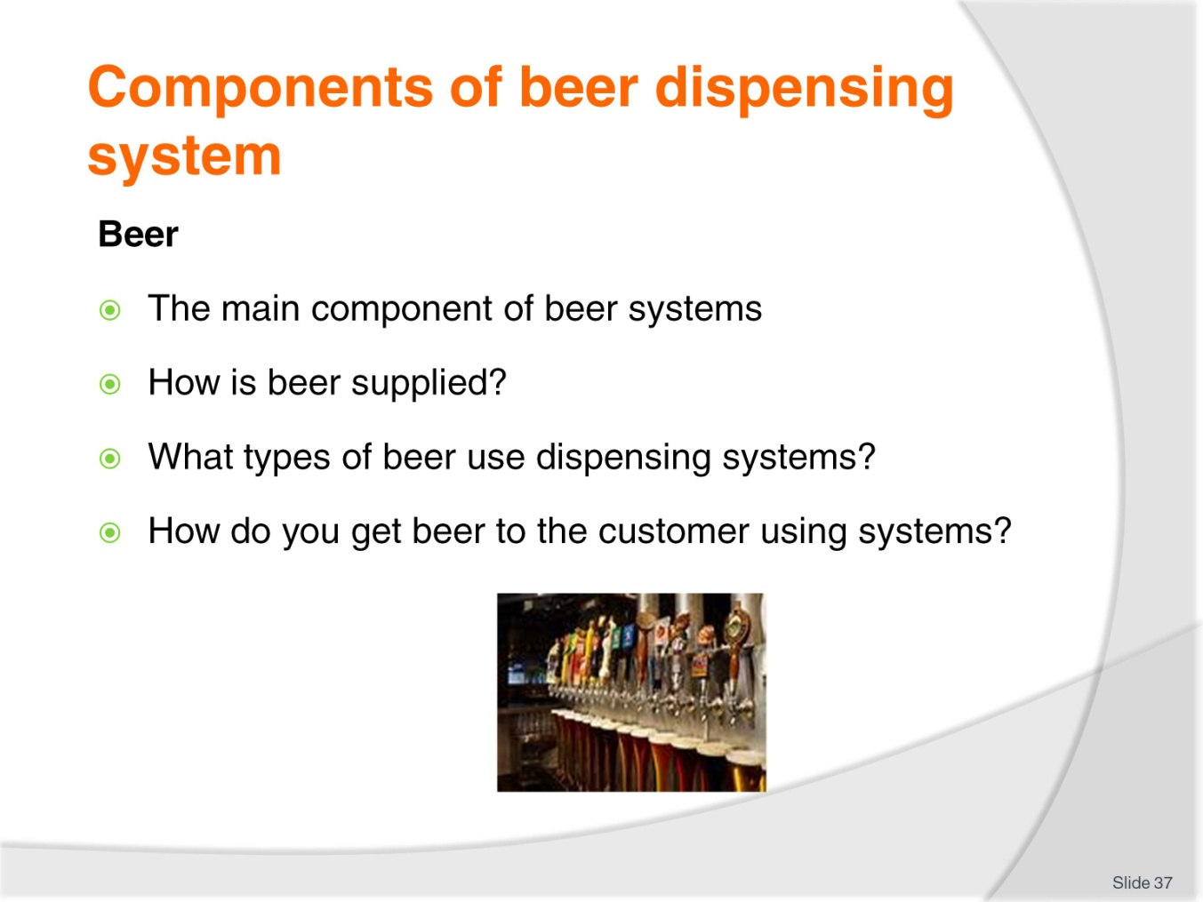
Slide No | Trainer Notes
Class Activity – Discussion / Demonstration
How do you handle, store, use and change gas cylinders?
Trainer to demonstrate where appropriate.

Slide
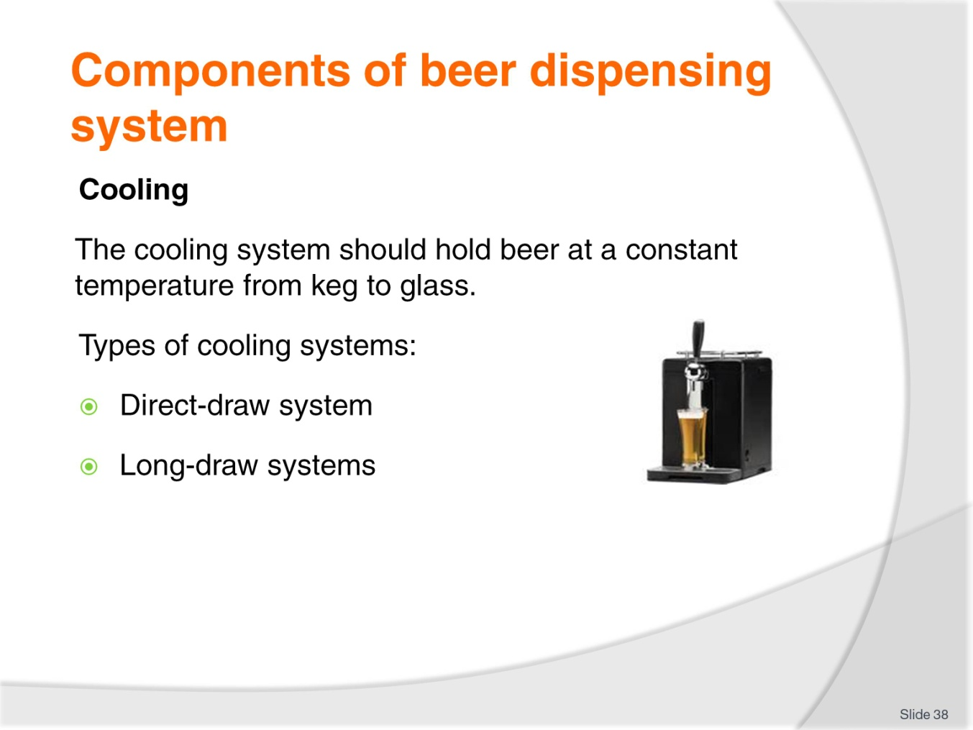
Slide No | Trainer Notes
Class Activity – Discussion
What is the difference between these types of cooling systems?

Slide
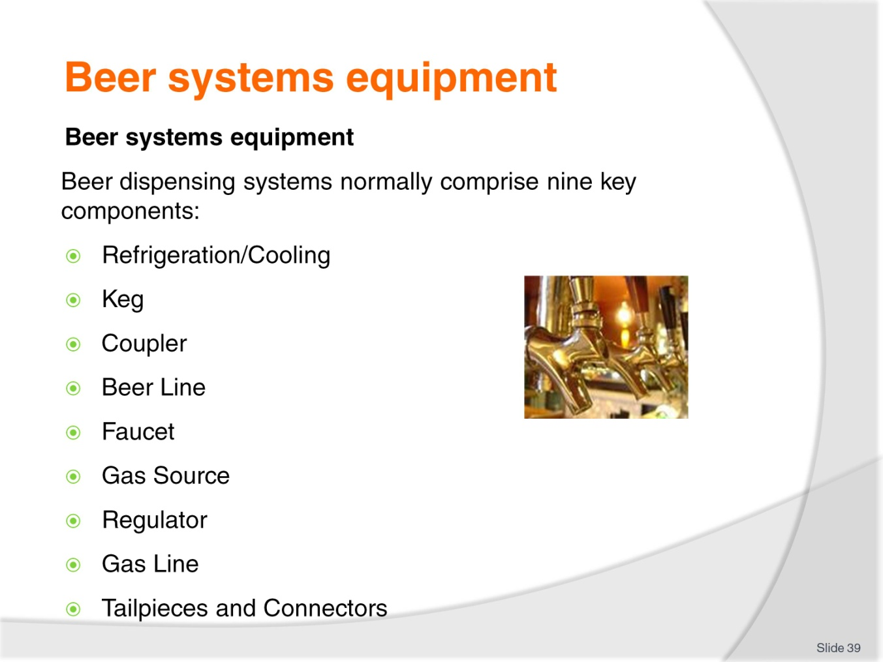
Slide No | Trainer Notes
Class Activity – Discussion
What is the purpose of each piece of equipment?

Slide
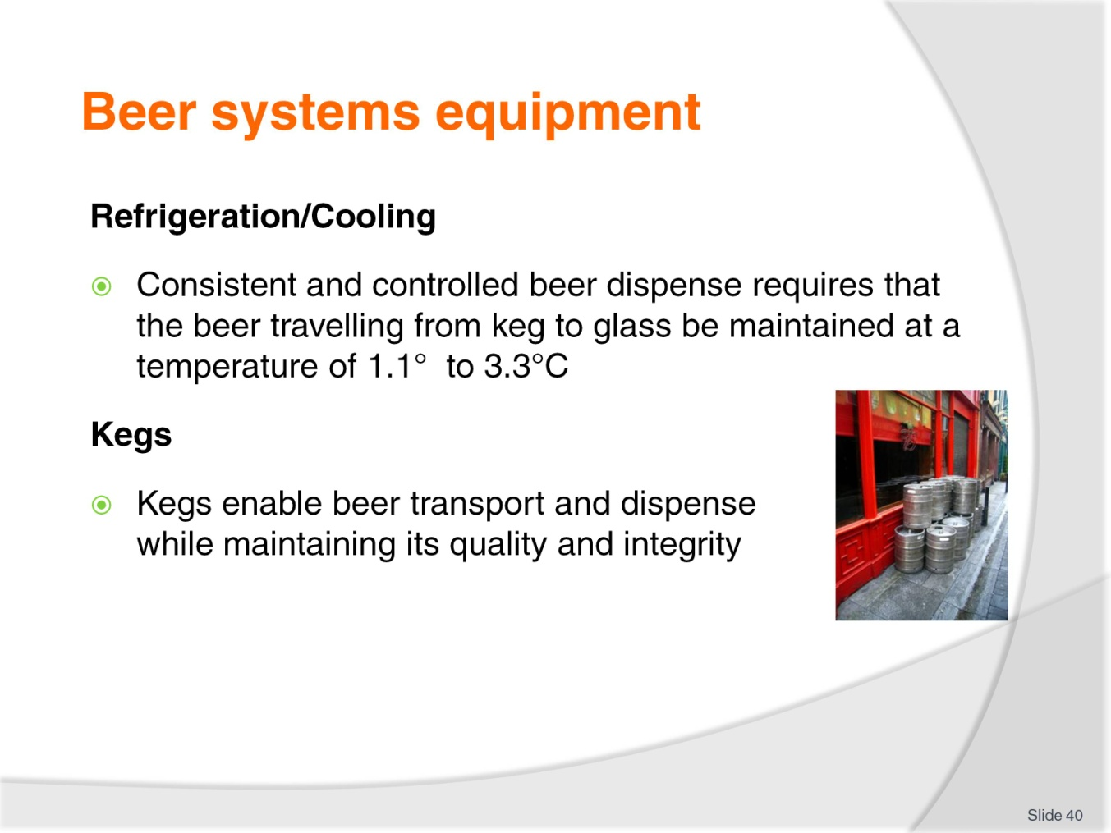
Slide No | Trainer Notes
Class Activity – Discussion / Demonstration
Trainer to discuss and demonstrate each piece of equipment.

Slide
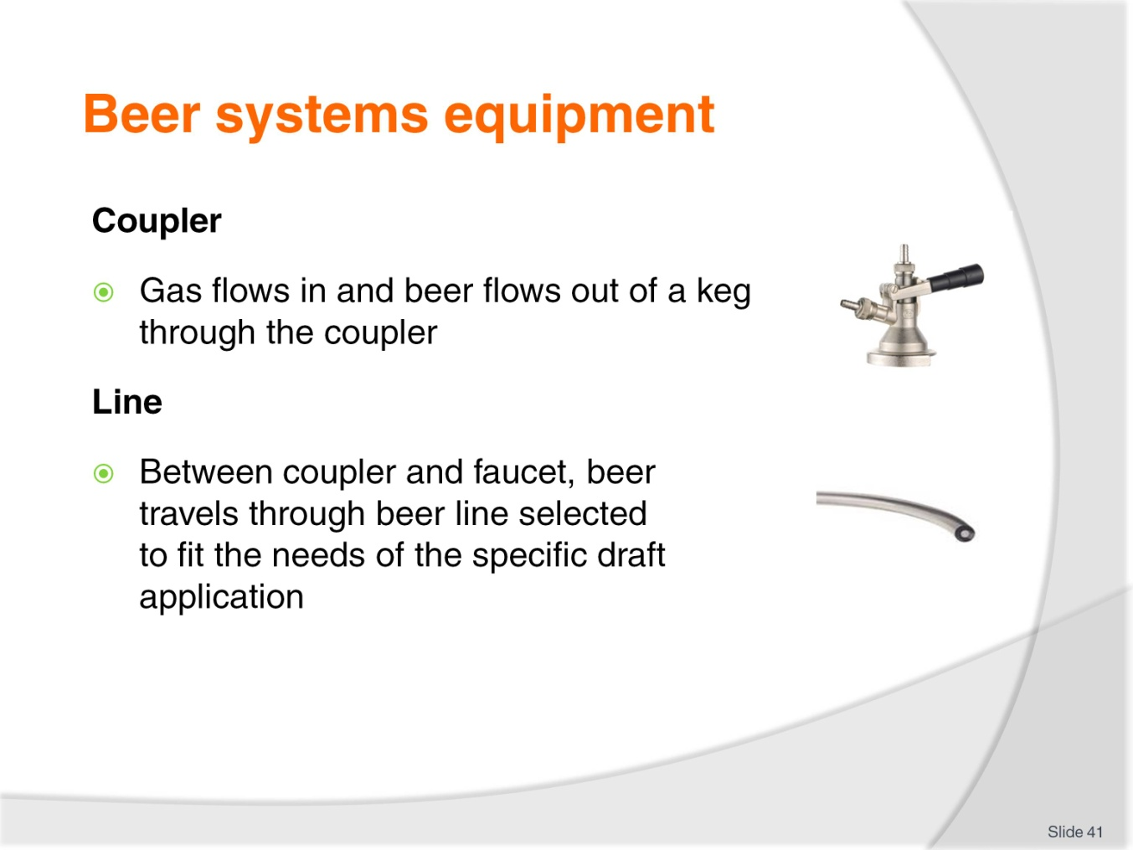
Slide No | Trainer Notes
Class Activity – Discussion / Demonstration
Trainer to discuss and demonstrate each piece of equipment?

Slide
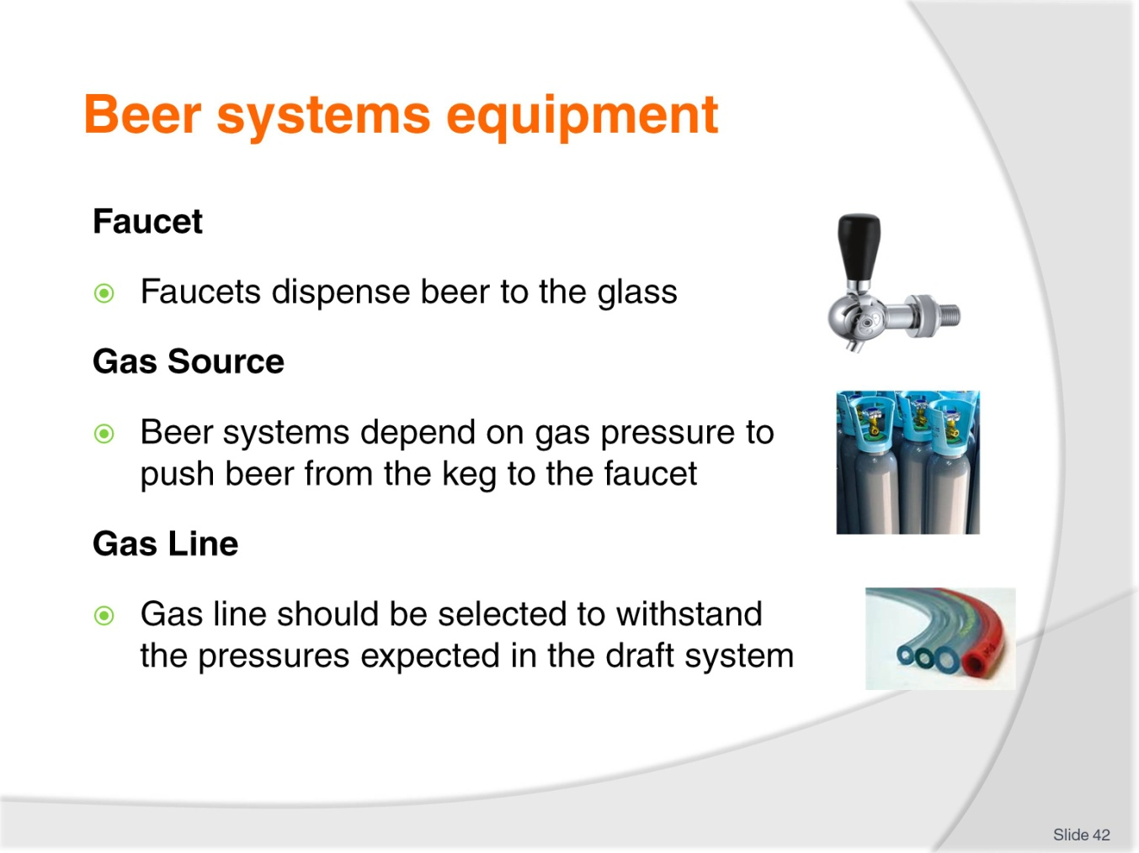
Slide No | Trainer Notes
Class Activity – Discussion / Demonstration
Trainer to discuss and demonstrate each piece of equipment.

Slide
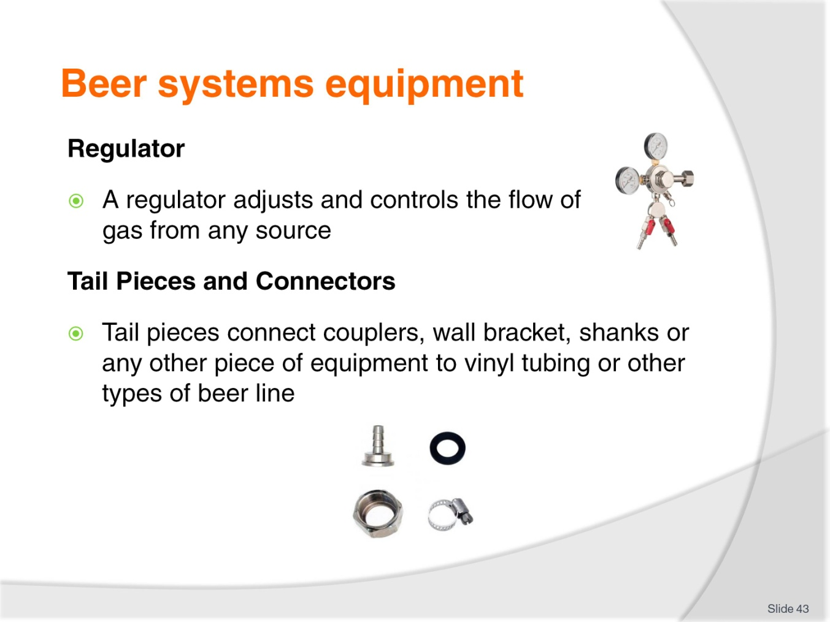
Slide No | Trainer Notes
Class Activity – Discussion / Demonstration
Trainer to discuss and demonstrate each piece of equipment.

Slide
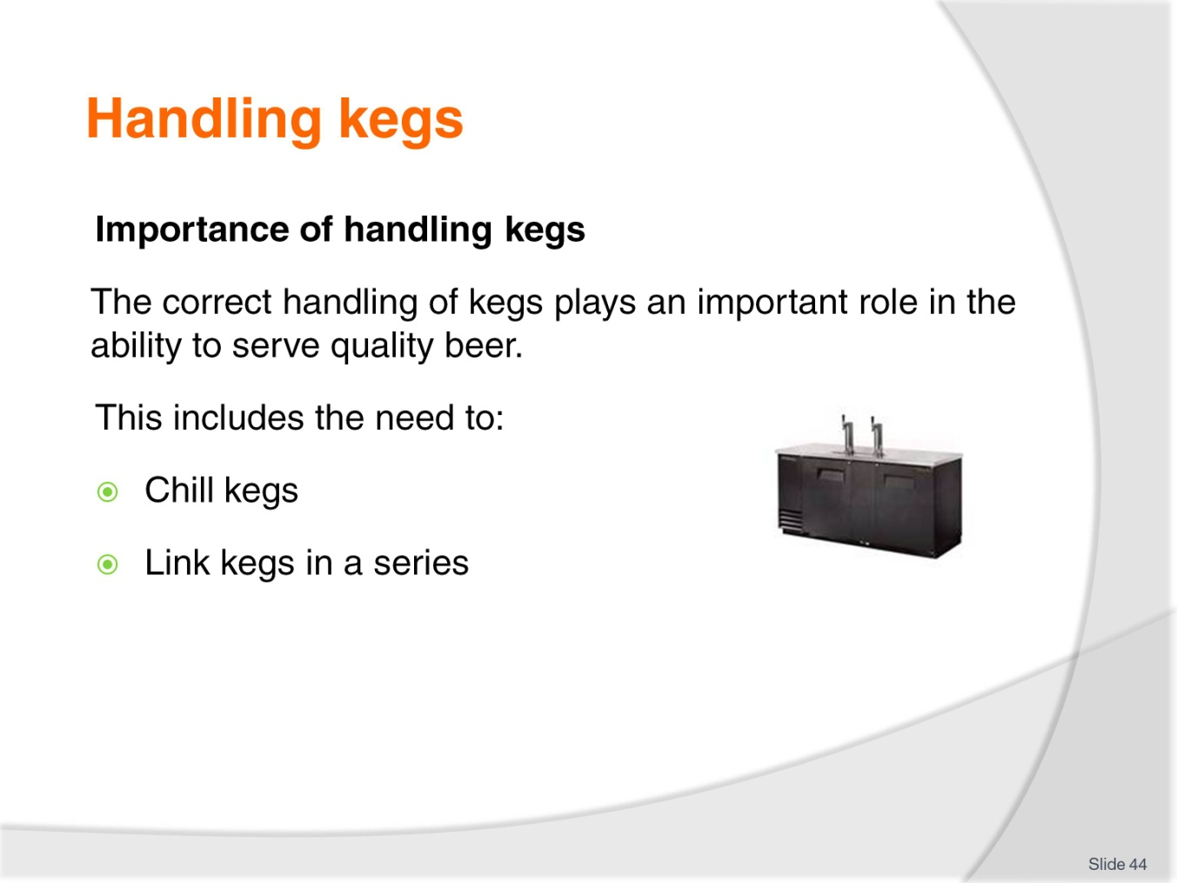
Slide No | Trainer Notes
Class Activity – Discussion
What is the importance of these handling activities?

Slide
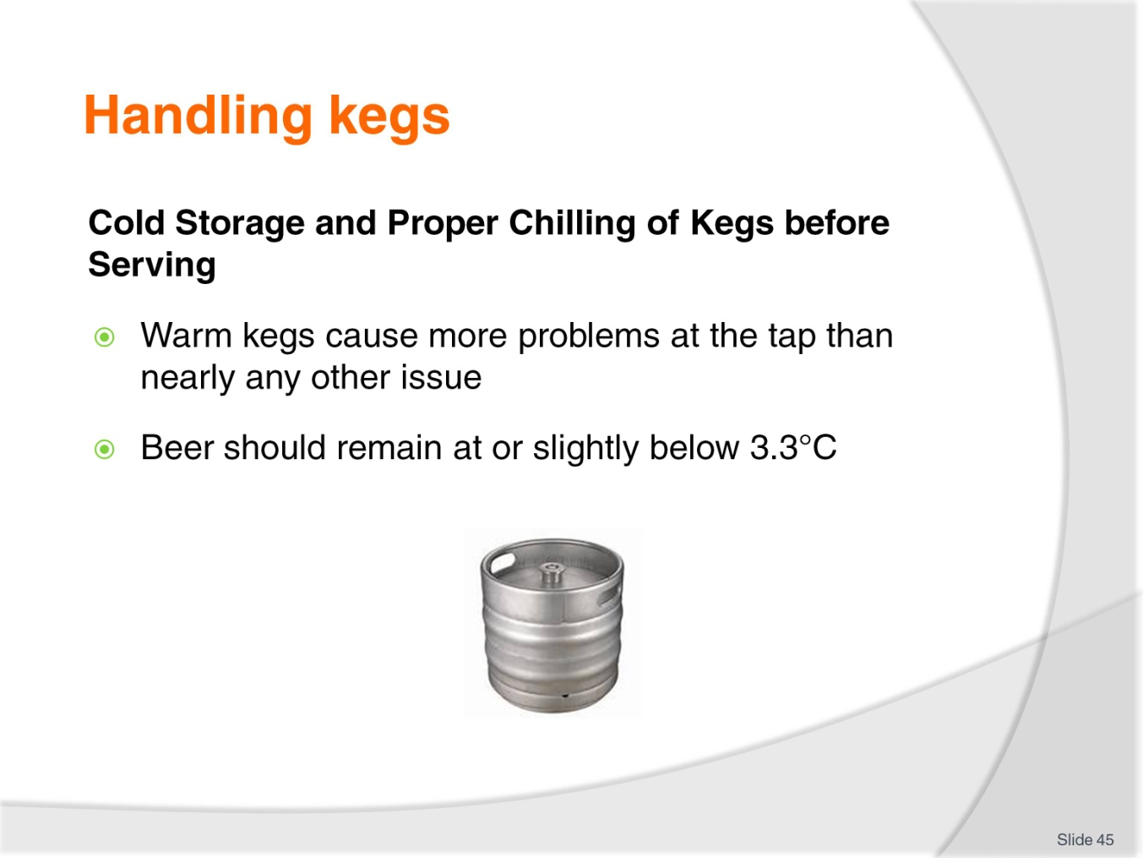
Slide No | Trainer Notes
Class Activity – Discussion
How do you keep kegs at the optimum temperature?

Slide
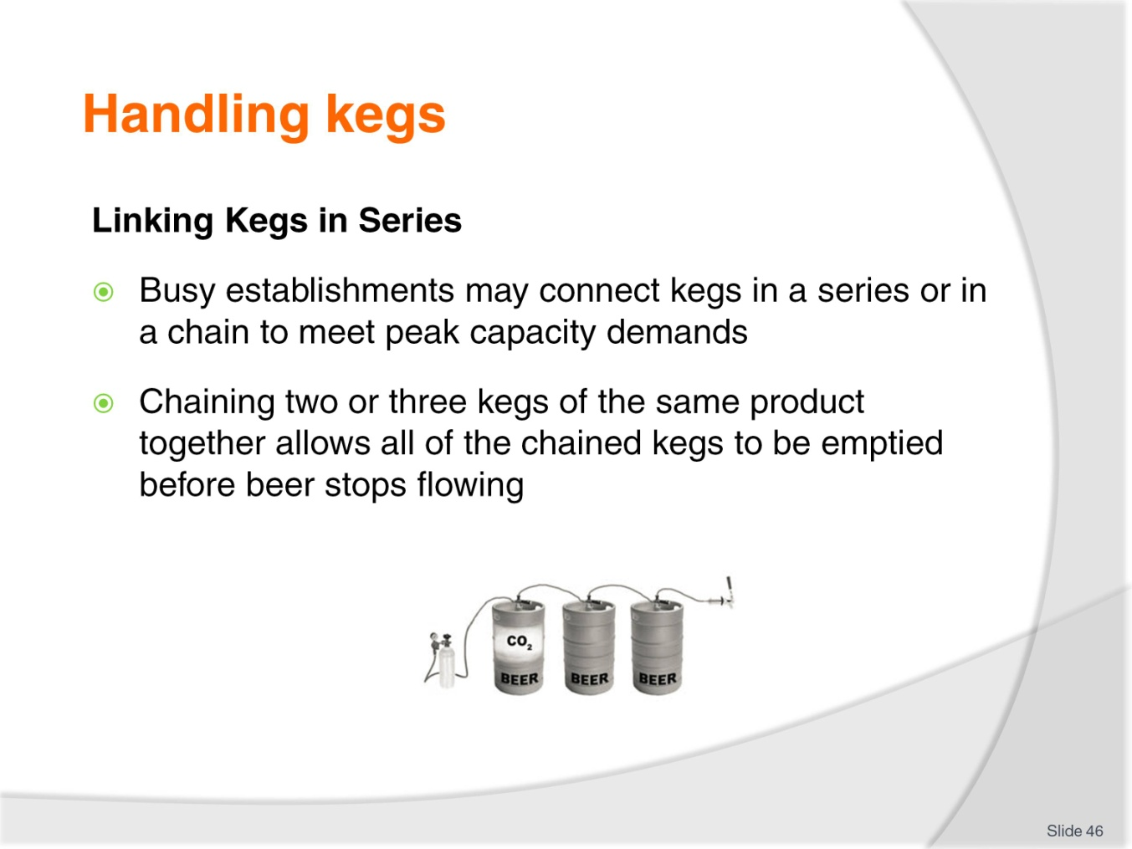
Slide No | Trainer Notes
Class Activity – Discussion
What is the benefit of linking kegs into a series?

Slide
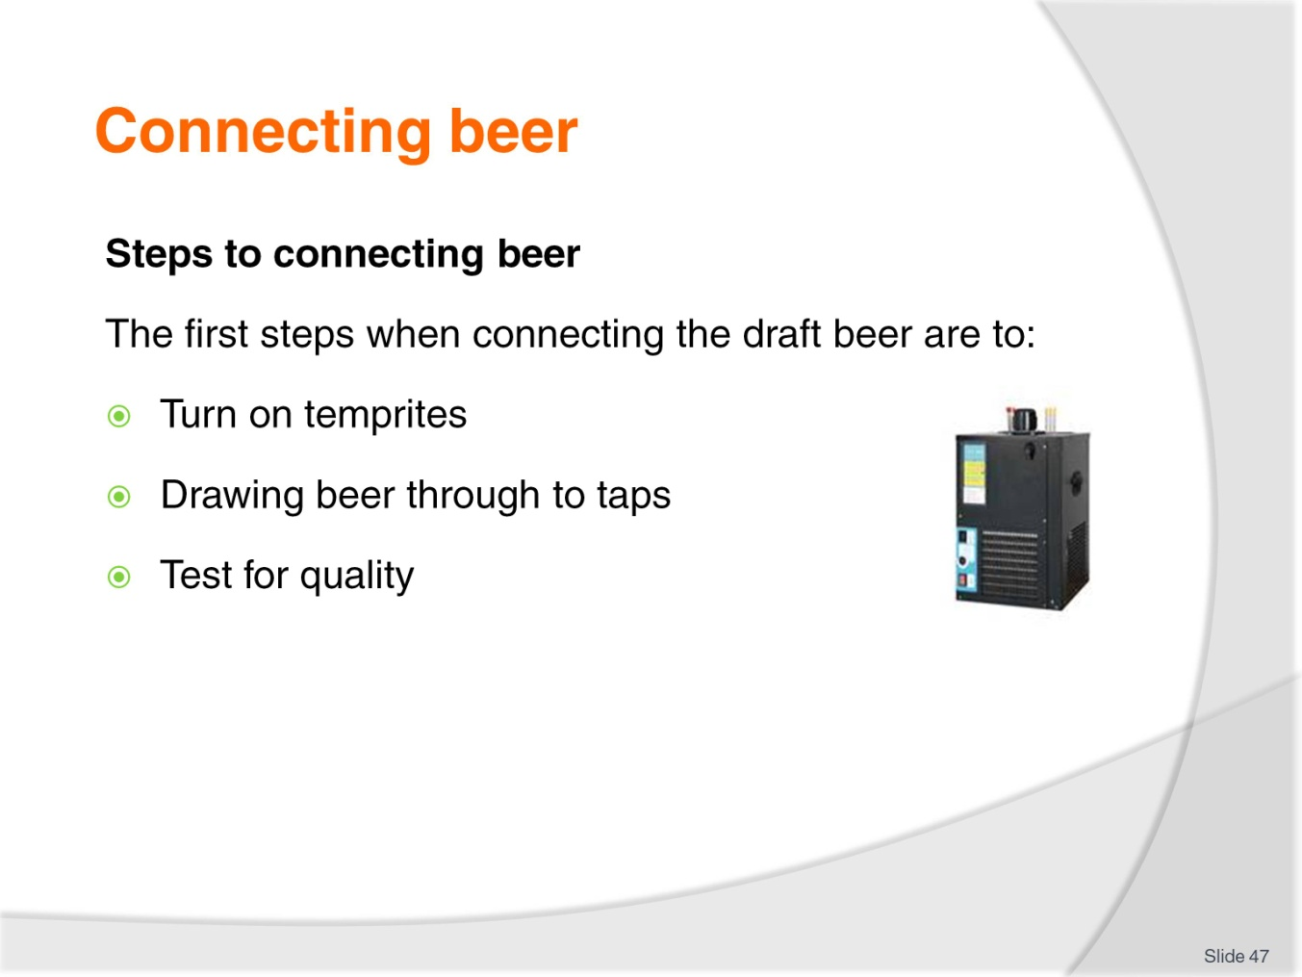
Slide No | Trainer Notes
Class Activity – Discussion / Demonstration
Show how to connect beer.

Slide
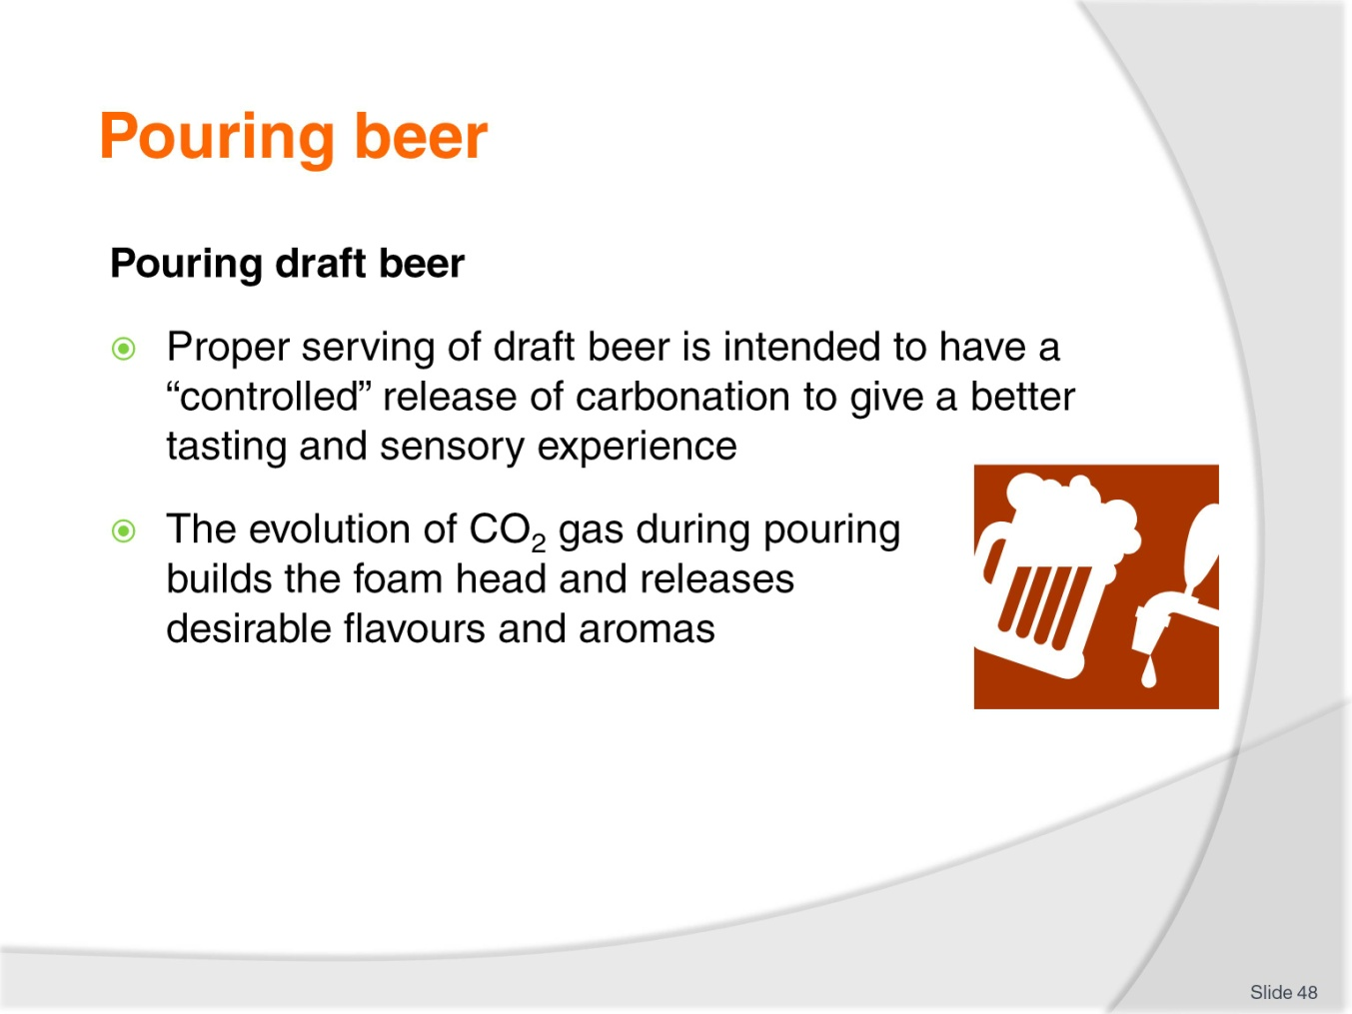
Slide No | Trainer Notes
Class Activity – Discussion
How should you pour beer?

Slide
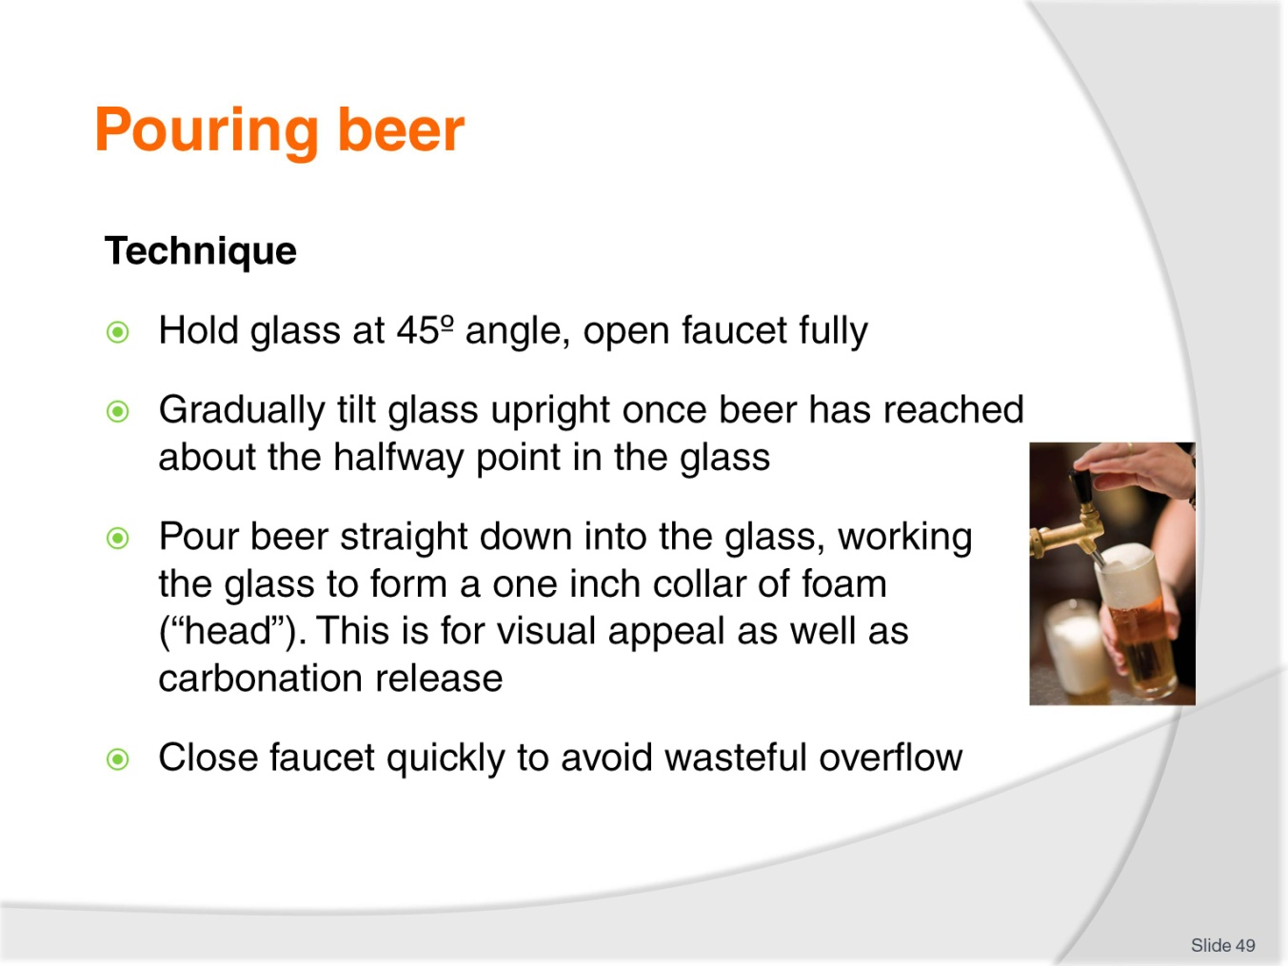
Slide No | Trainer Notes
Class Activity – Demonstration
Show how to pour beer.

Slide
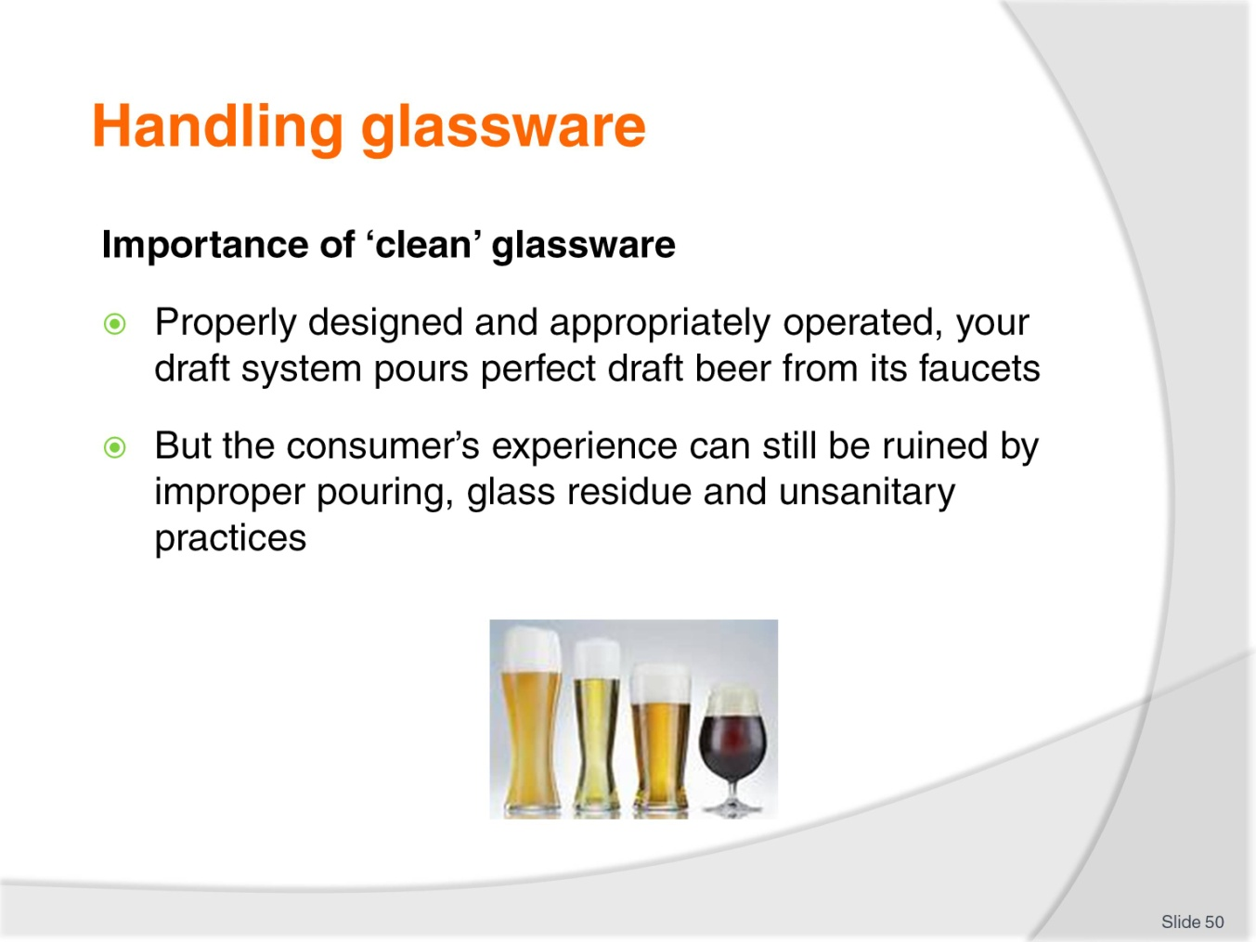
Slide No | Trainer Notes
Class Activity – Discussion / Demonstration
How do you clean glasses?
How should glasses be stored?
What temperatures should glasses be for service?

Slide
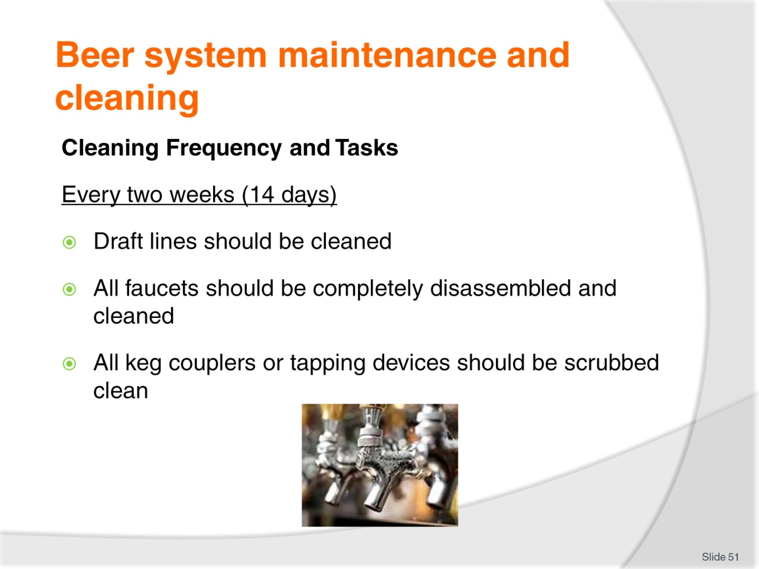
Slide No | Trainer Notes
Class Activity – Discussion
Discuss the purpose of these cleaning activities.

Slide
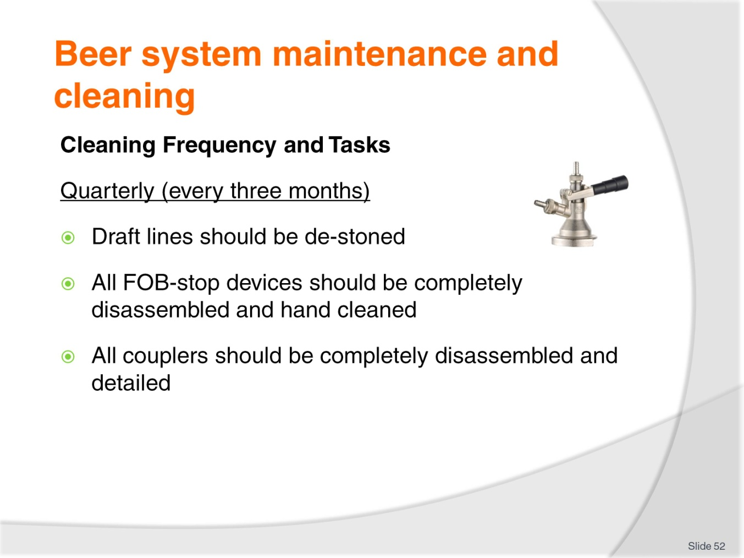
Slide No | Trainer Notes
Class Activity – Discussion
Discuss the purpose of these cleaning activities.

Slide
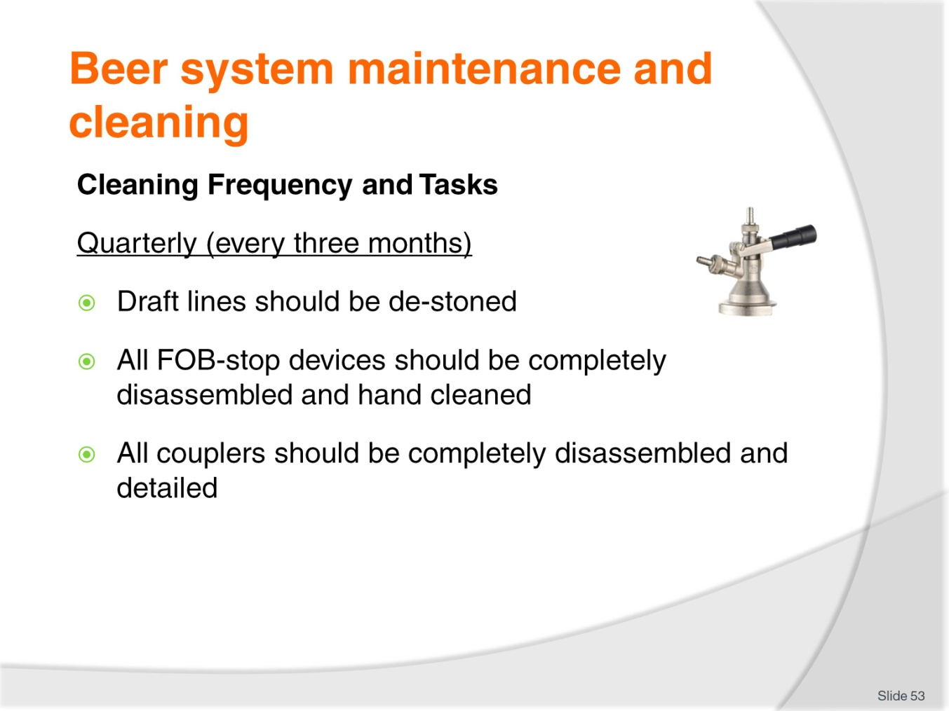
Slide No | Trainer Notes
Class Activity – Discussion
Discuss the purpose of these cleaning activities.

Slide
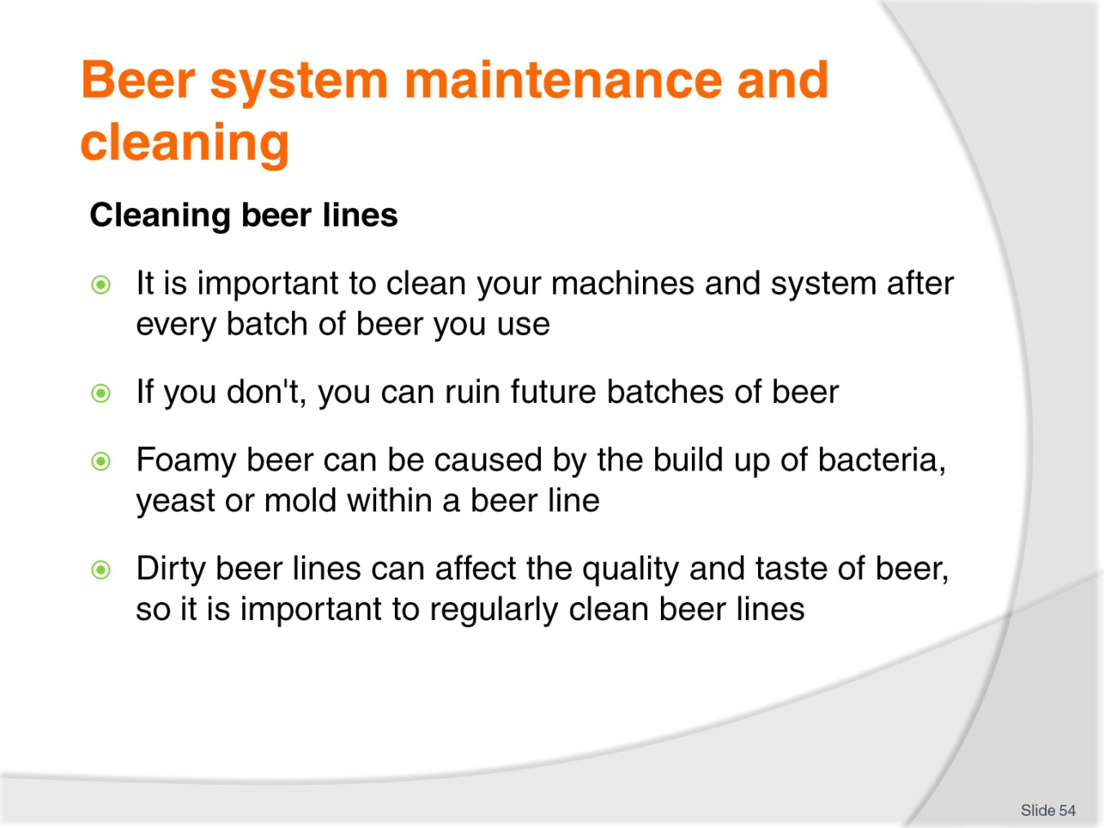
Slide No | Trainer Notes
Class Activity – Discussion
How do you clean beer lines?

Slide
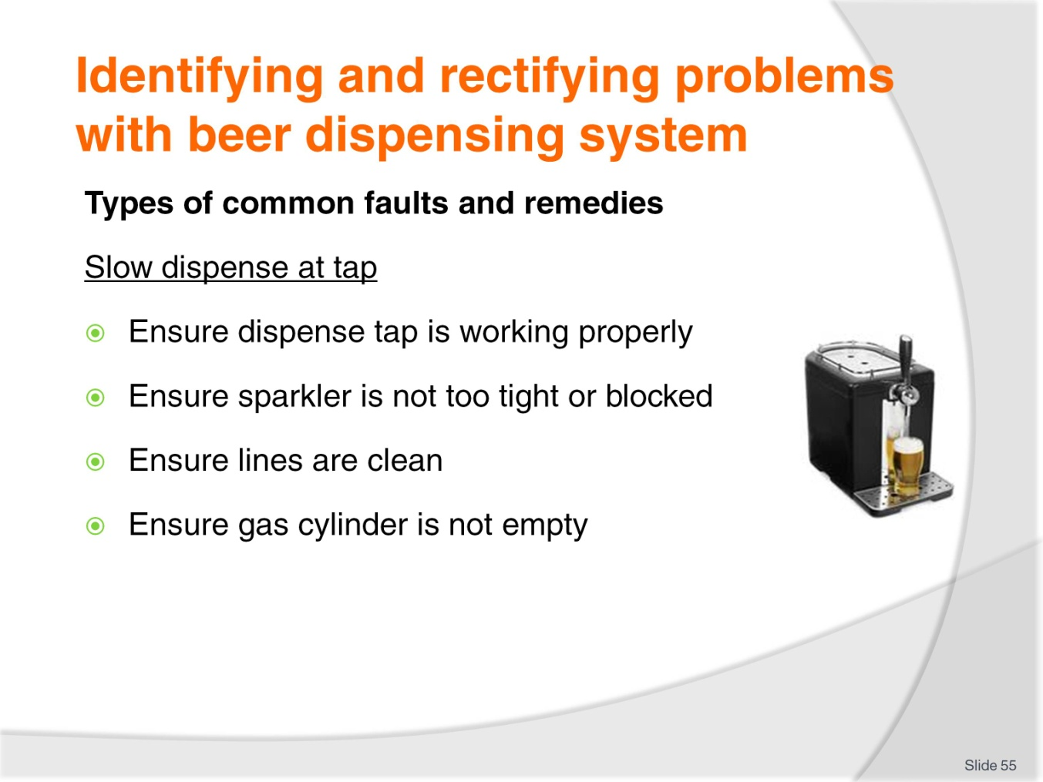
Slide No | Trainer Notes
Class Activity – Discussion
Discuss these steps.

Slide
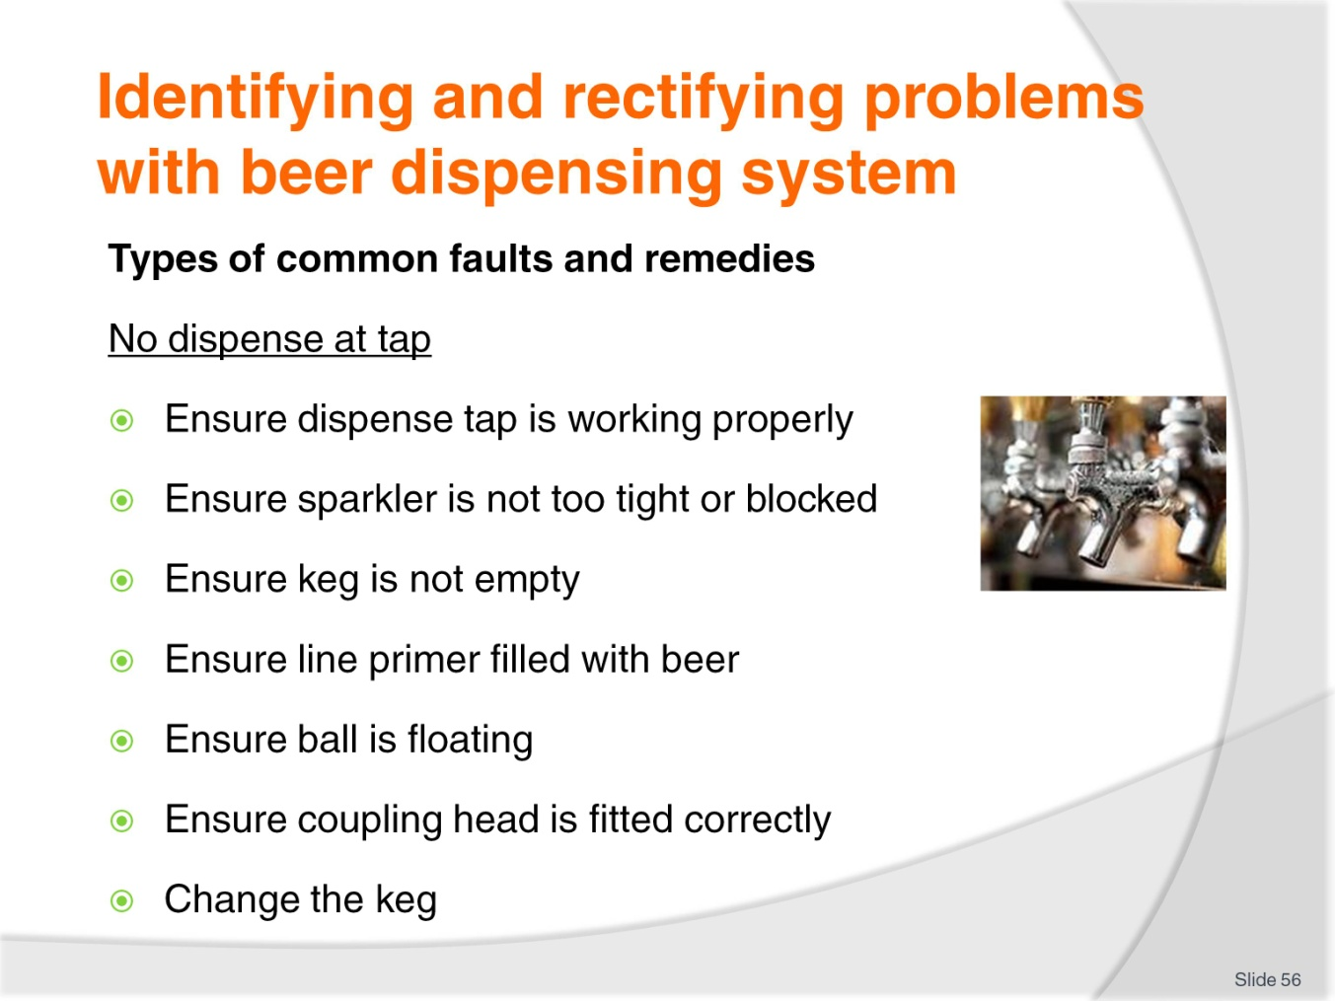
Slide No | Trainer Notes
Class Activity – Discussion
Discuss these steps.

Slide
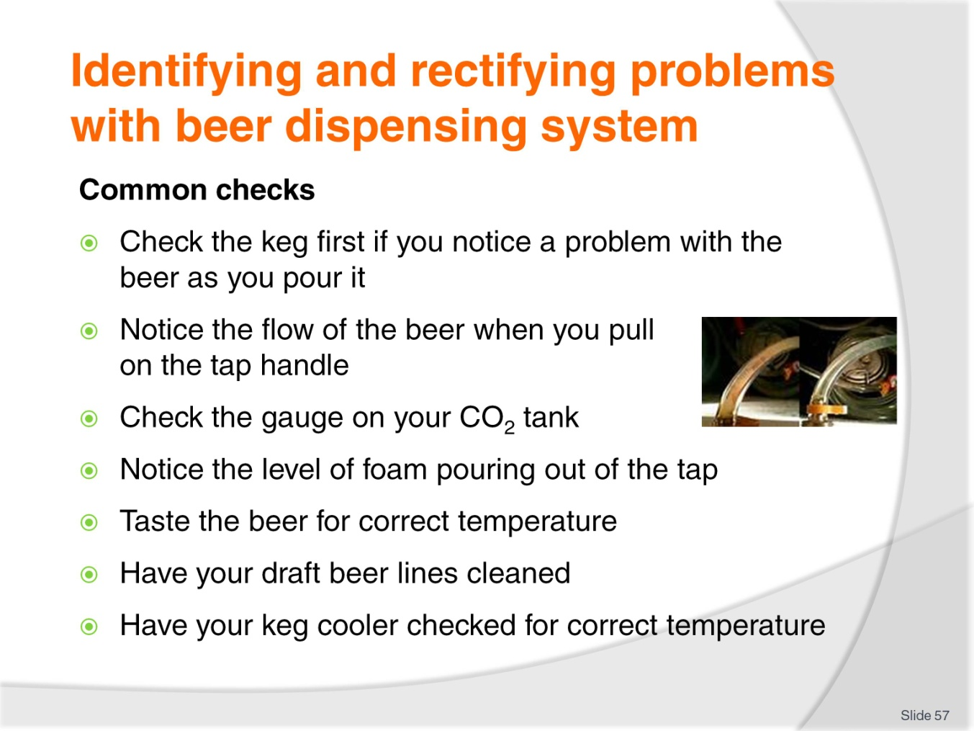
Slide No | Trainer Notes
Class Activity – Discussion
Discuss these checks.

Slide
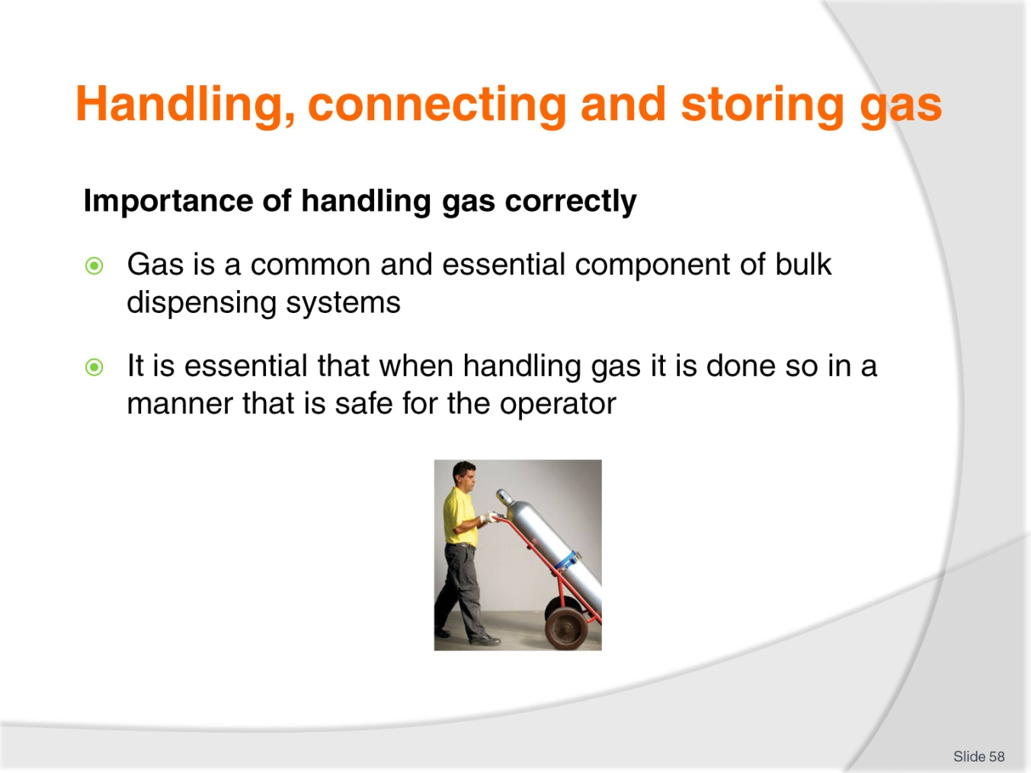
Slide No | Trainer Notes
Class Activity – Discussion
How do you handle, connect and store gas correctly?

Slide
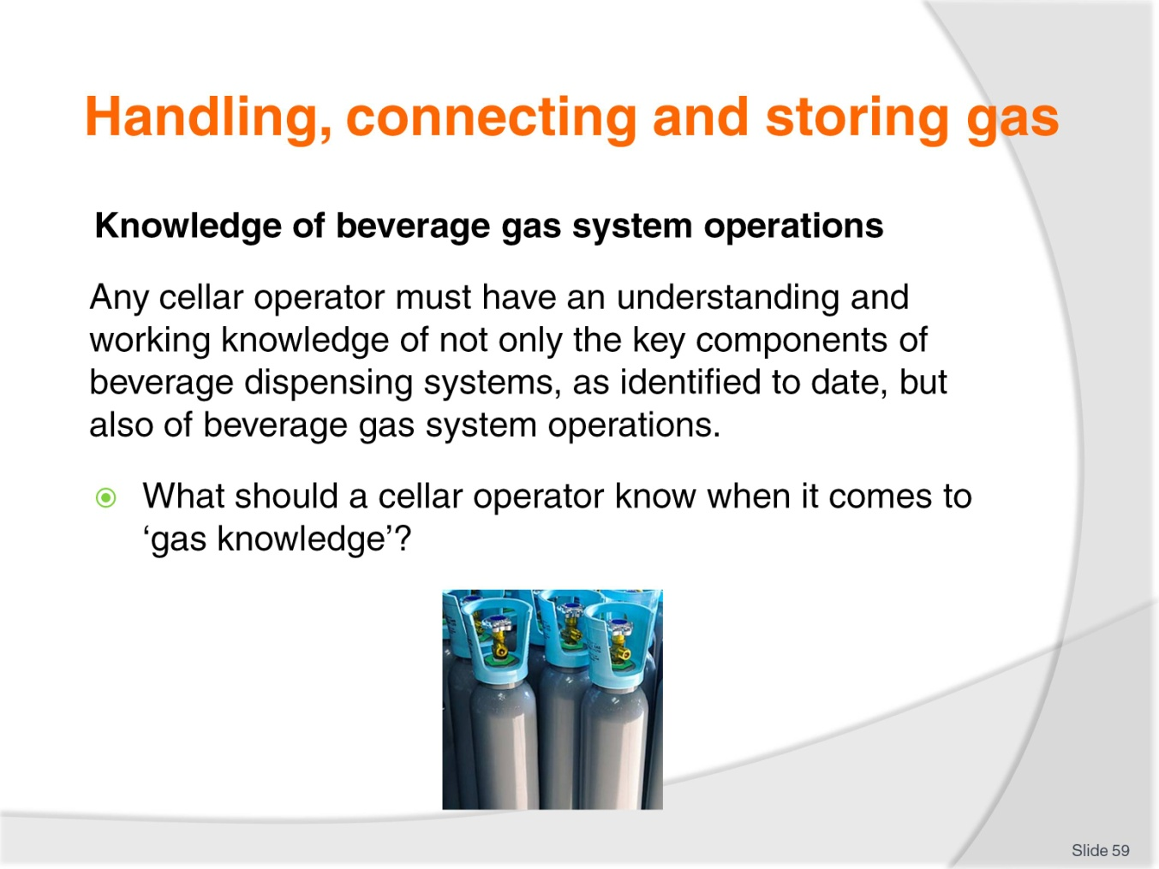
Slide No | Trainer Notes
Class Activity – Discussion
Discuss the question in the slide.

Slide
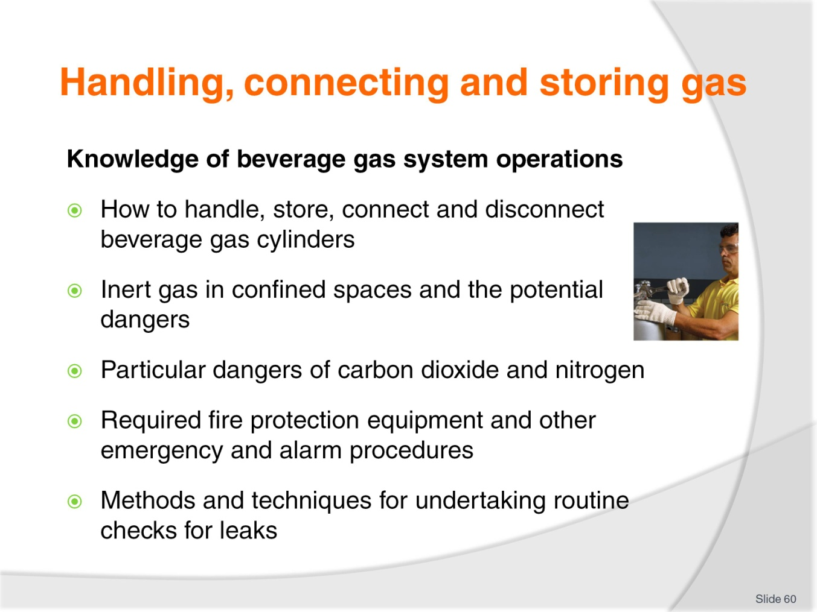
Slide No | Trainer Notes
Class Activity – Discussion
How can a cellar operator build their knowledge?

Slide
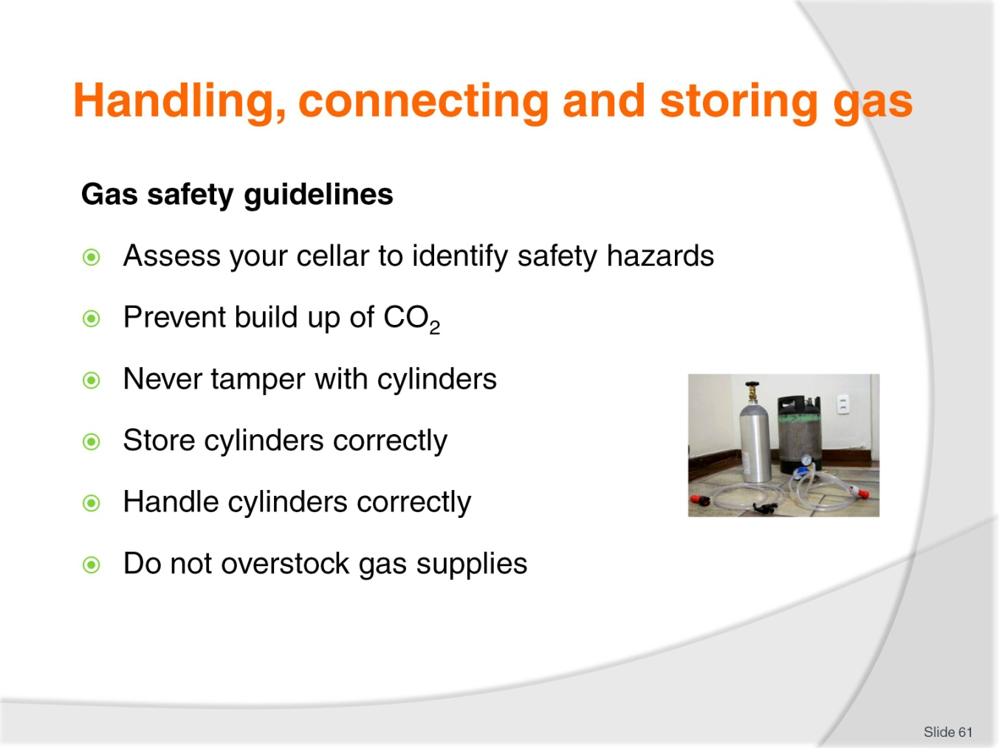
Slide No | Trainer Notes
Class Activity – Discussion
Who should perform these tasks?
Why are they important?

Slide
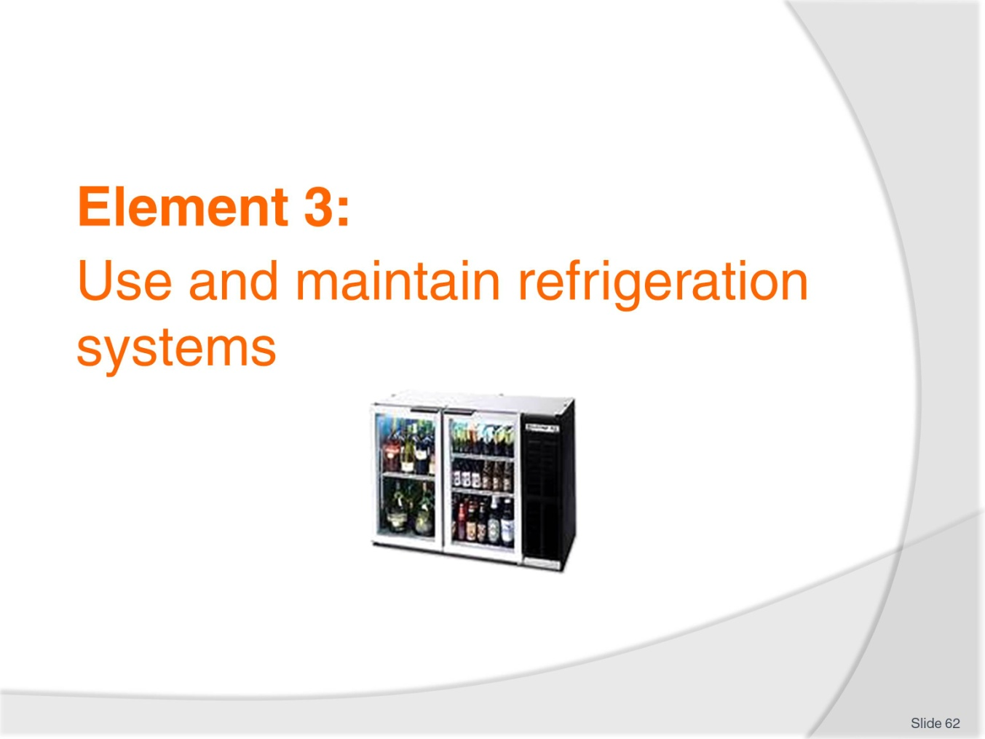
Slide No | Trainer Notes
Introduce topic.
Class Activity – General Discussion
Ask general questions:
What types of refrigeration systems are used in a commercial bar?

Slide
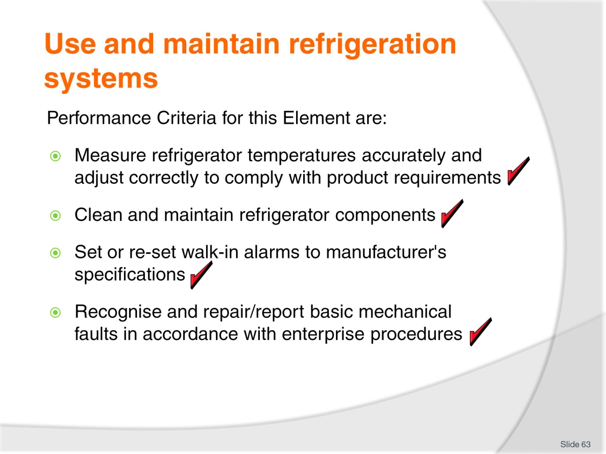
Slide No | Trainer Notes
 | Trainer identifies the Performance Criteria for this Element, as listed on the slide.

Slide
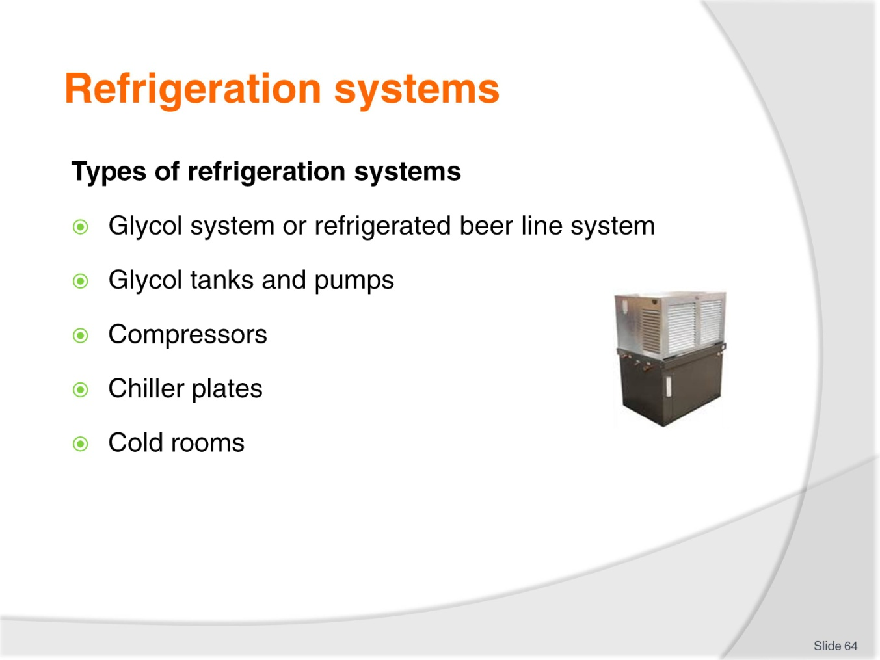
Slide No | Trainer Notes
Class Activity – Discussion
What is the difference between these systems?

Slide
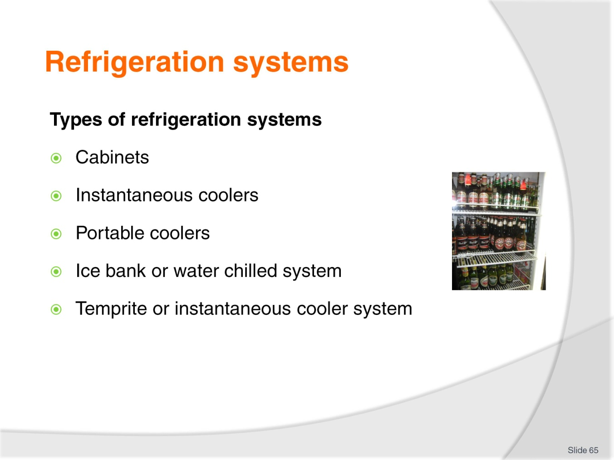
Slide No | Trainer Notes
Class Activity – Discussion
What is the difference between these systems?

Slide
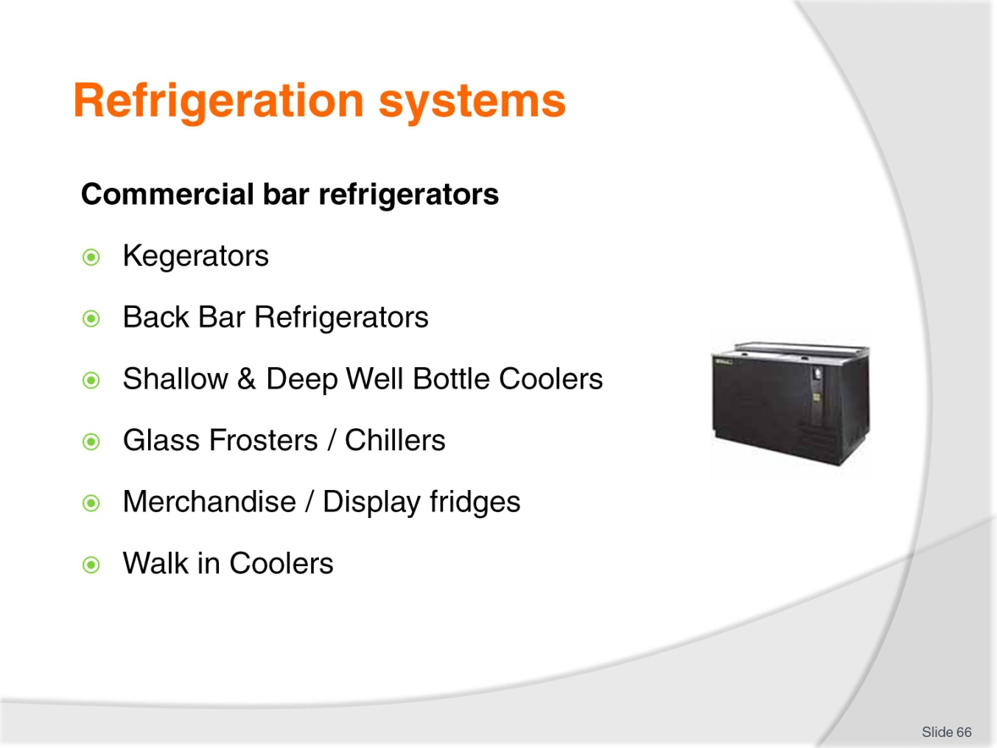
Slide No | Trainer Notes
Class Activity – Discussion
What is the difference between these systems?

Slide
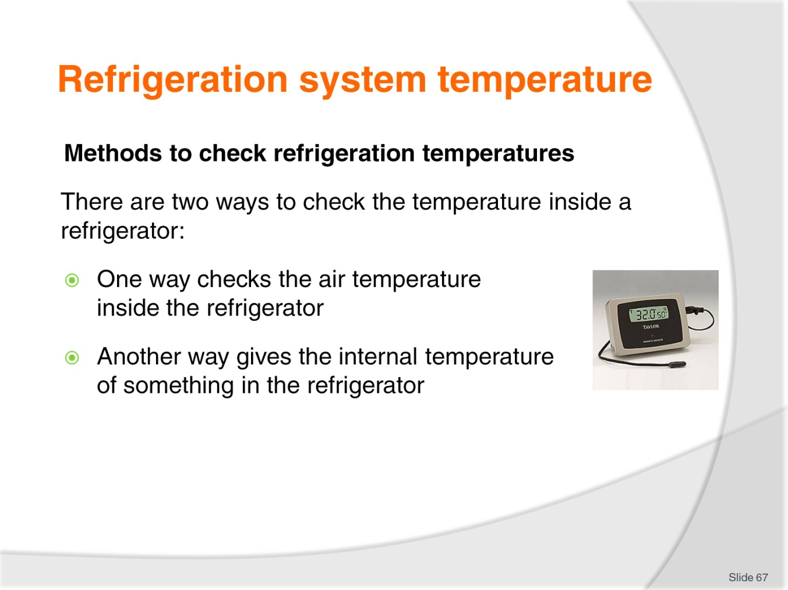
Slide No | Trainer Notes
Class Activity – Discussion
What is used to test these temperatures?
What is the ideal temperature for refrigerators?

Slide
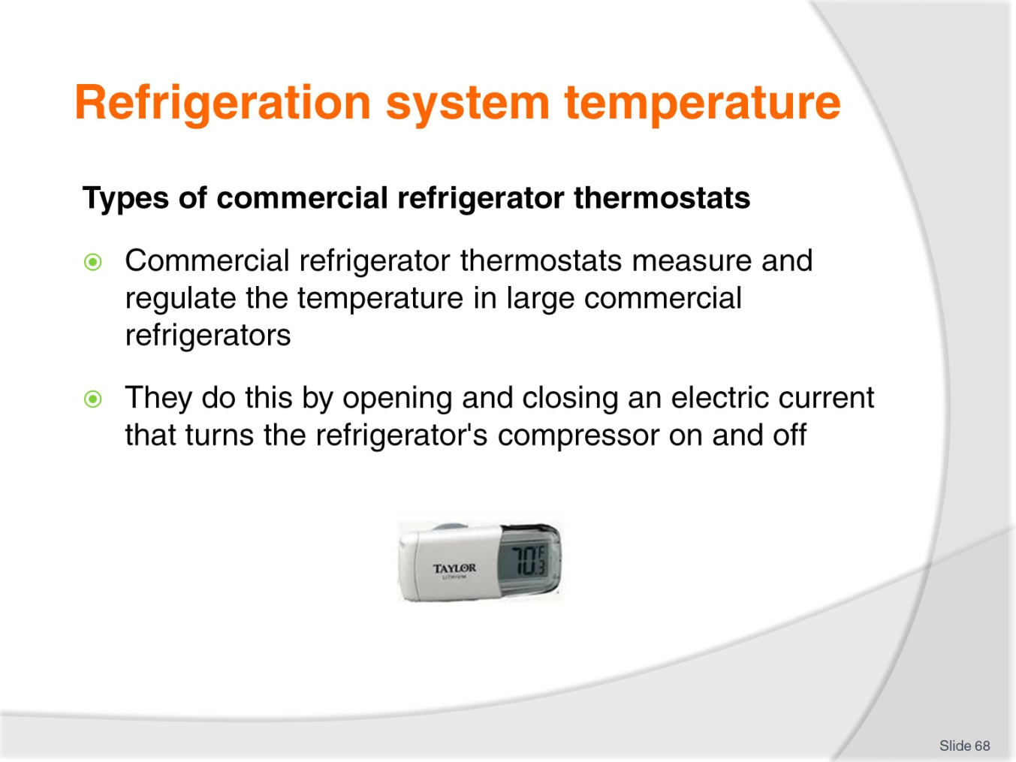
Slide No | Trainer Notes
Class Activity – Research activity
Trainer to get audience to research different types of thermostats and related equipment that can be used in commercial bar operations.

Slide
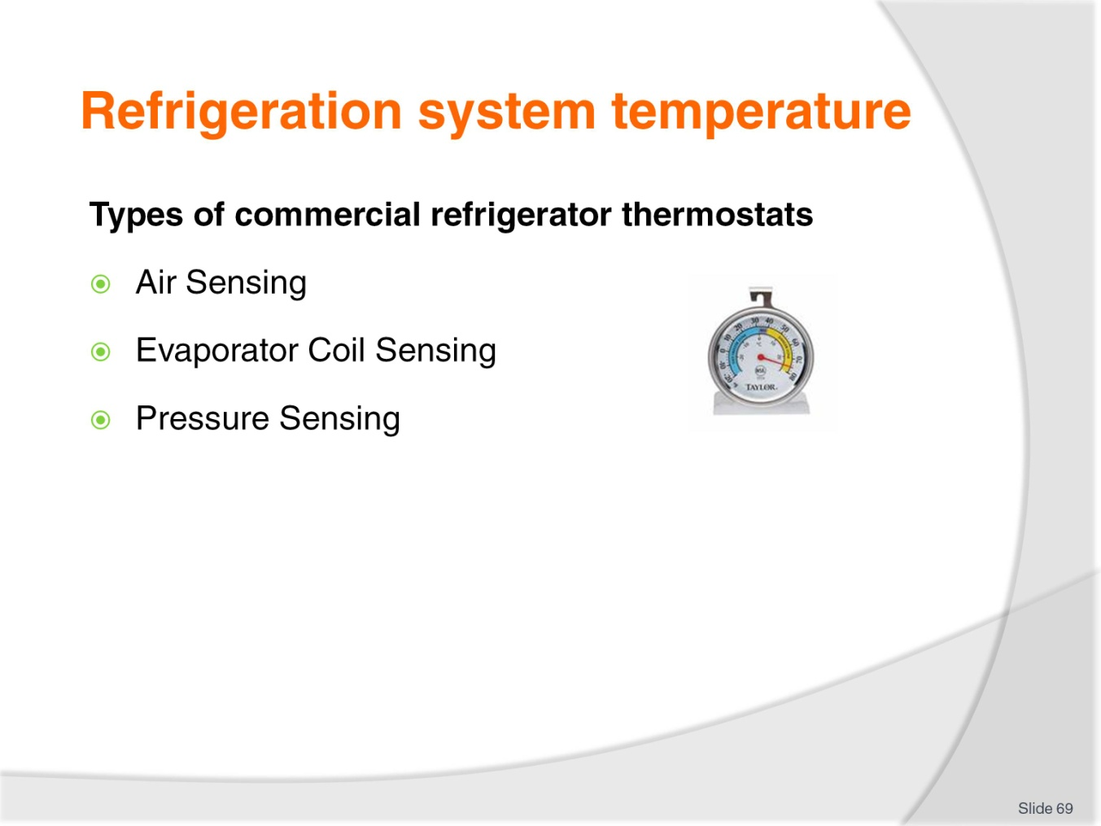
Slide No | Trainer Notes
Class Activity – Research activity
Trainer to explain difference between these methods to identify fridge temperature.

Slide
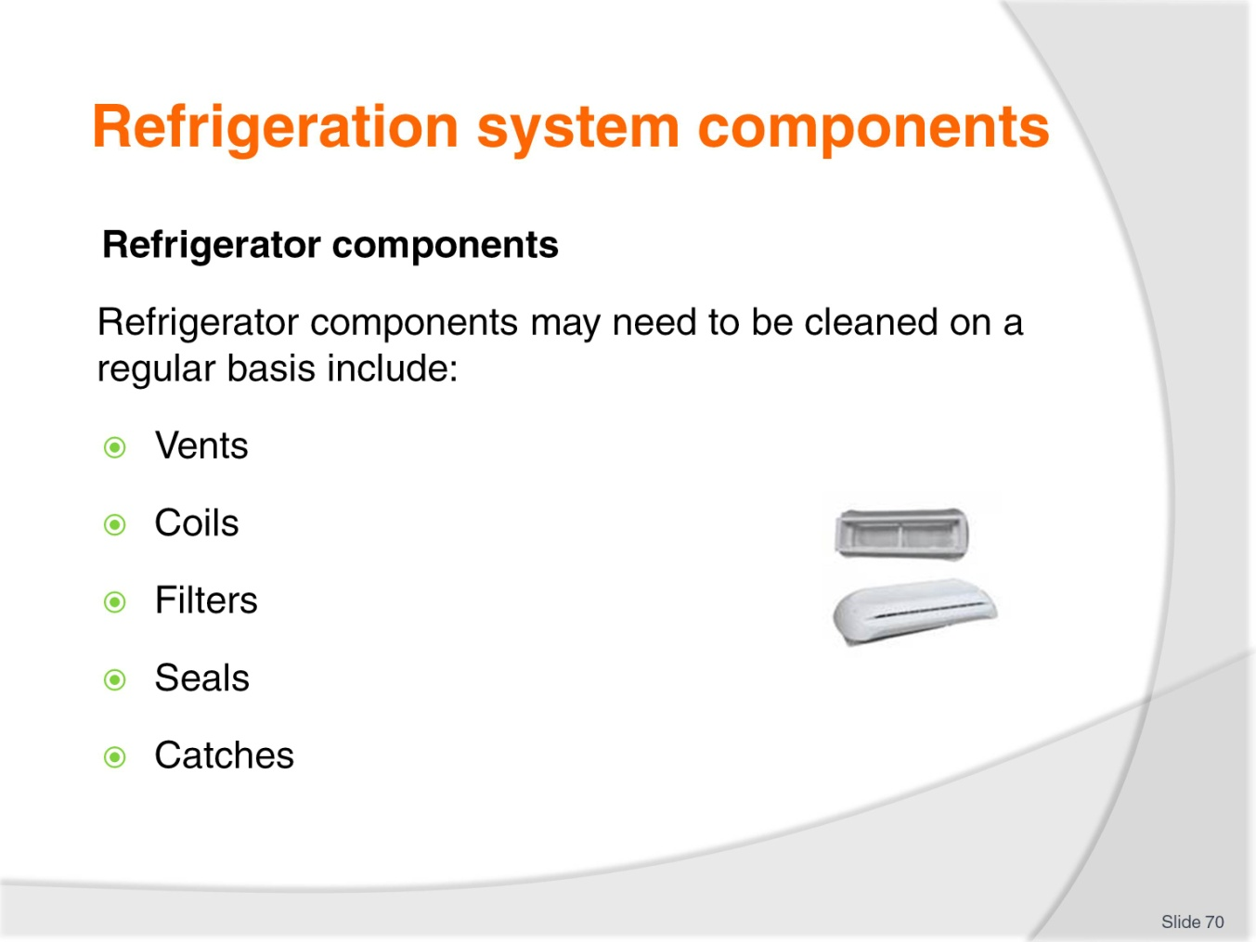
Slide No | Trainer Notes
Class Activity – Discussion
What is the purpose of these components?
How do you clean and maintain them?

Slide
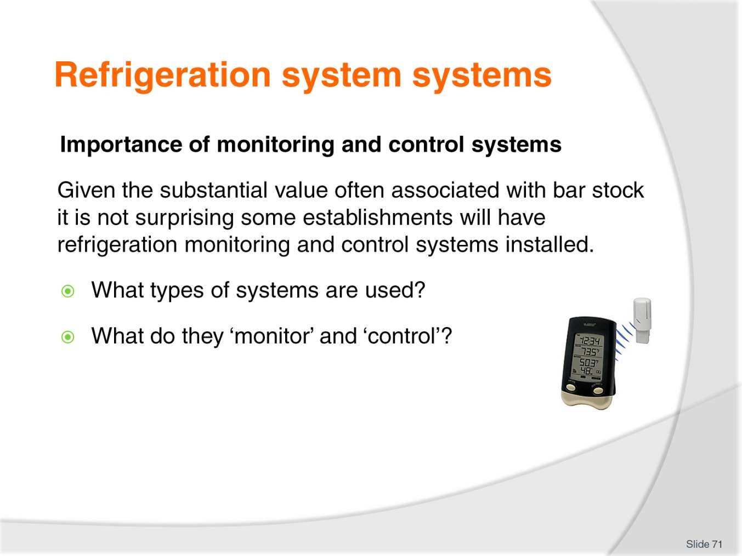
Slide No | Trainer Notes
Class Activity – Discussion
Discuss questions in the slide.

Slide
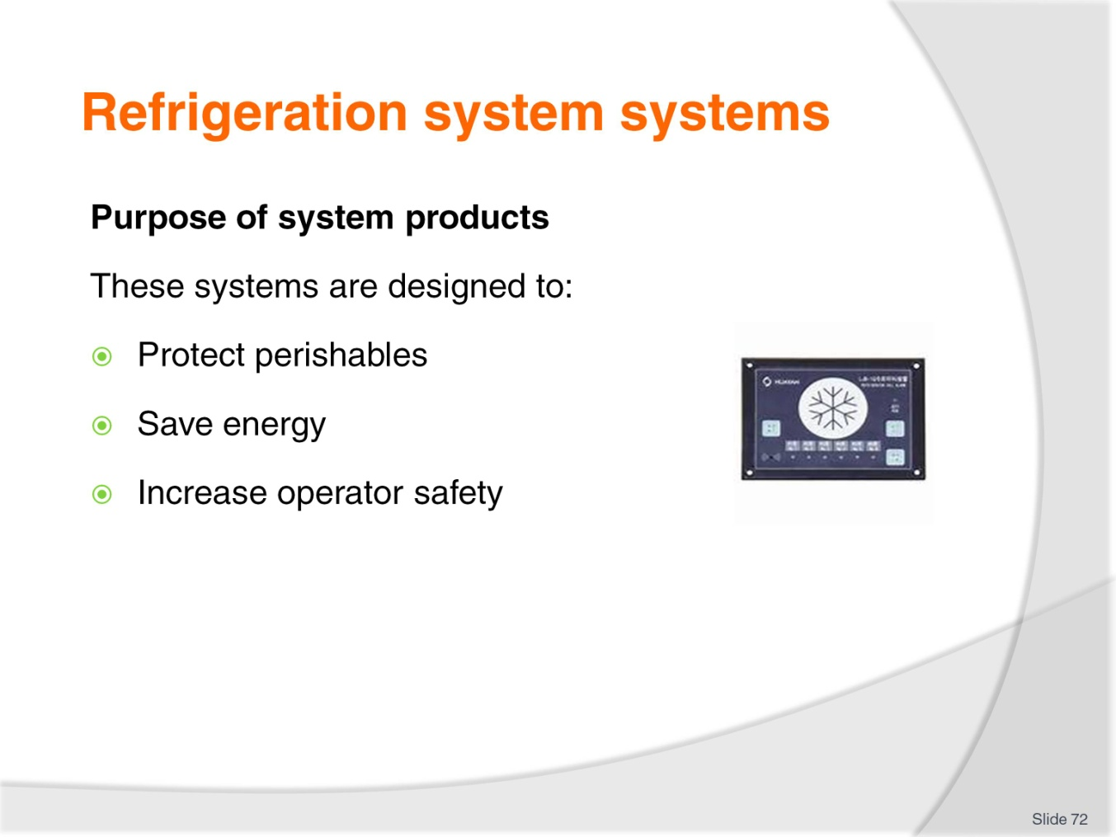
Slide No | Trainer Notes
Class Activity – Discussion
What other benefits exist?
How much money can they systems actually save?

Slide
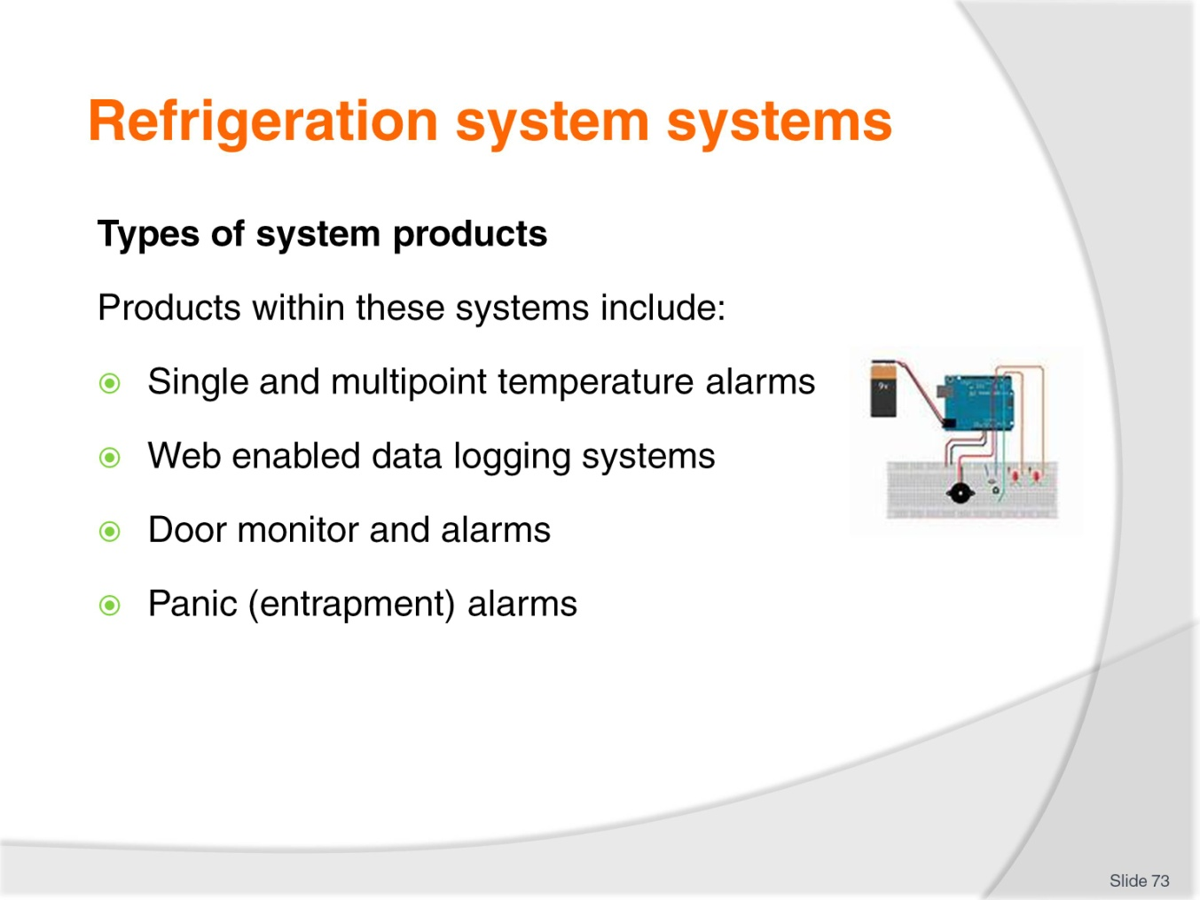
Slide No | Trainer Notes
Class Activity – Discussion
Types of system products
Products within these systems include:
Single and multipoint temperature alarms – this is important as it is vital that temperatures of food and beverage items remain within acceptable temperature ranges
Web enabled data logging systems – records who enters fridges and at what time
Door monitor and alarms – notifies when fridge doors are opened
Panic (entrapment) alarms – commonly found in ‘walk-in’ fridges that notify the appropriate person when someone has been locked into a unit.

Slide
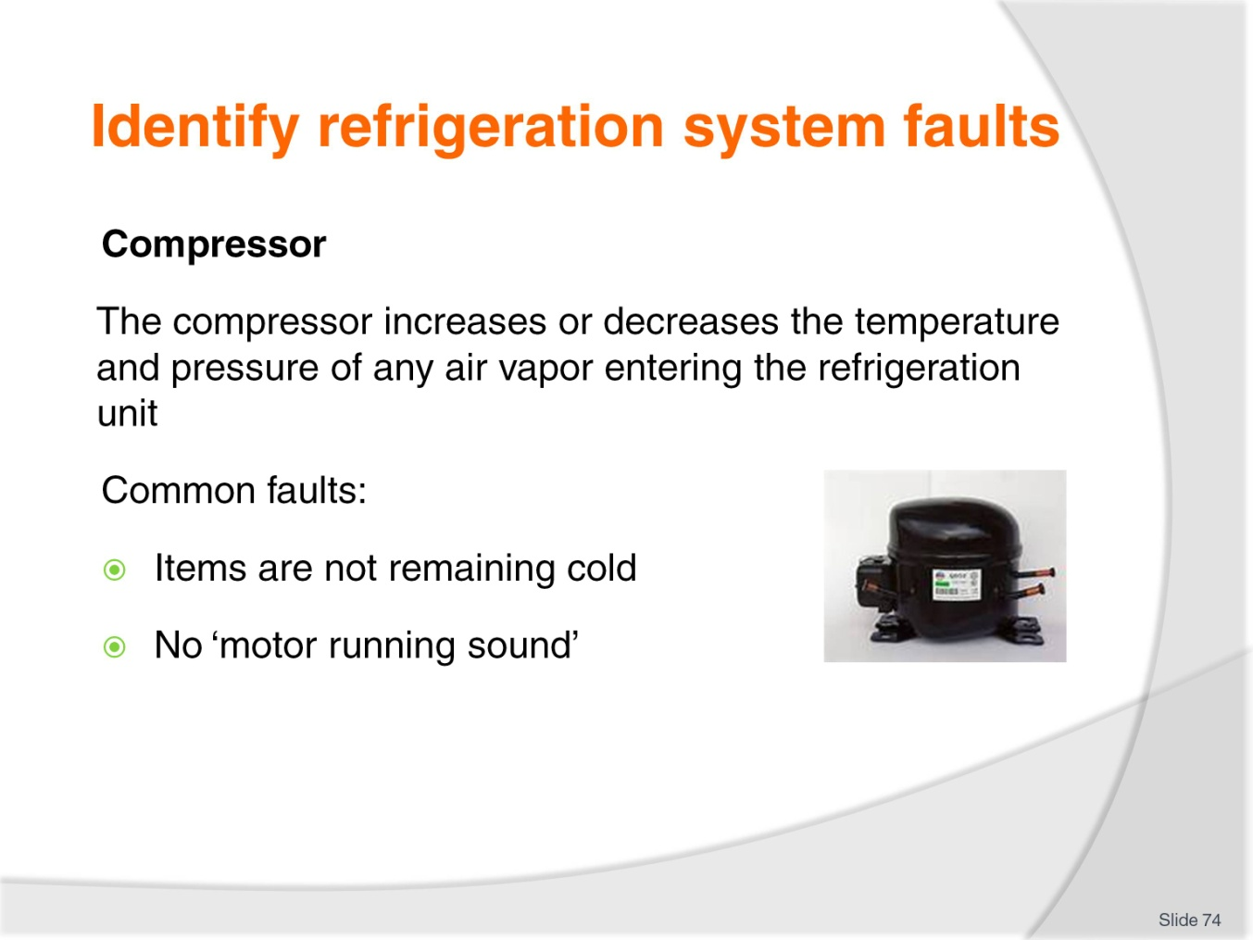
Slide No | Trainer Notes
Class Activity – Discussion
How do you fix these faults?

Slide
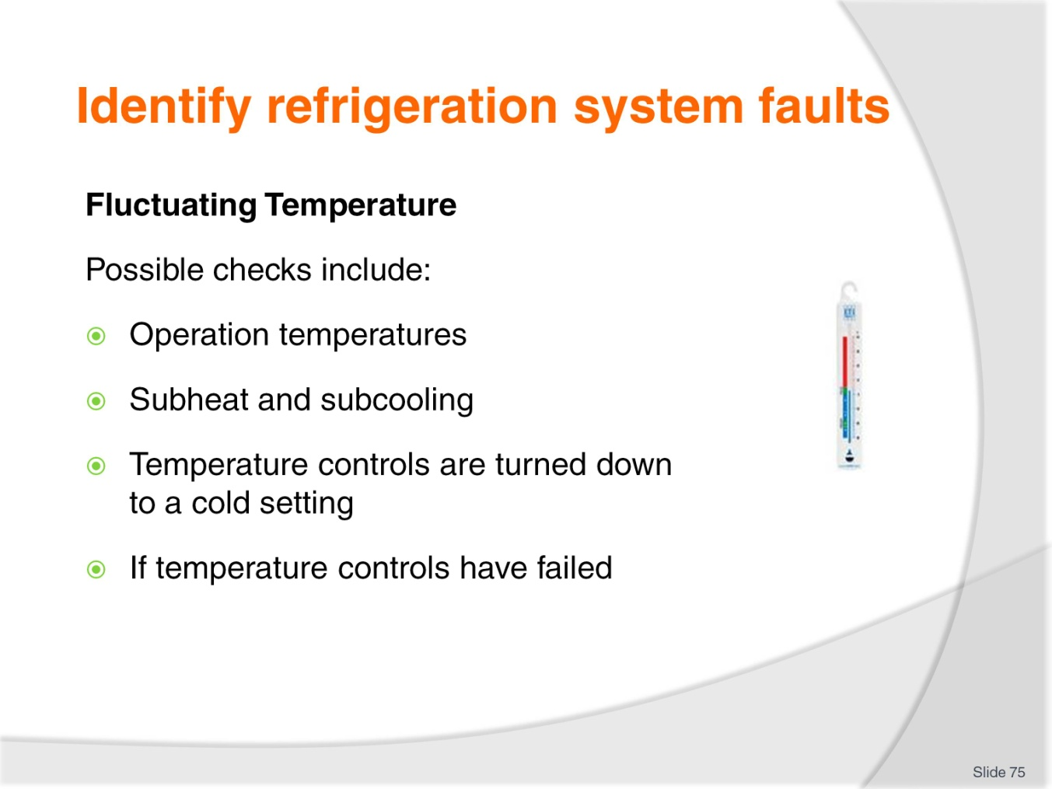
Slide No | Trainer Notes
Class Activity – Discussion
Discuss how to perform these checks.

Slide
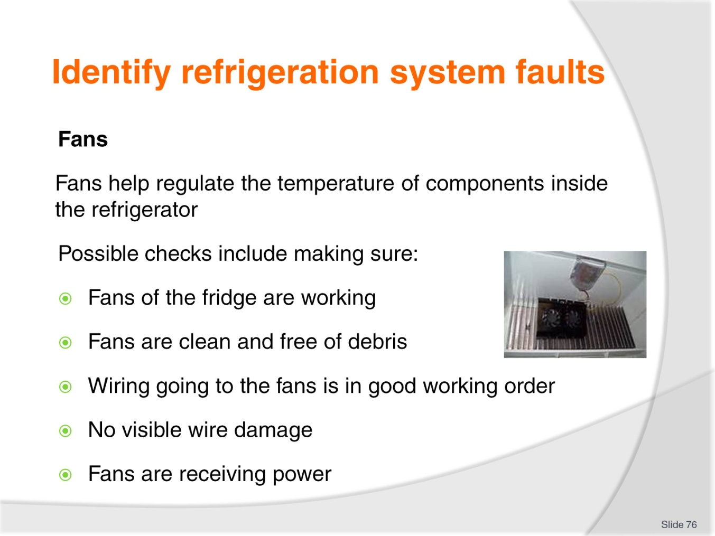
Slide No | Trainer Notes
Class Activity – Discussion
Discuss how to perform these checks.

Slide
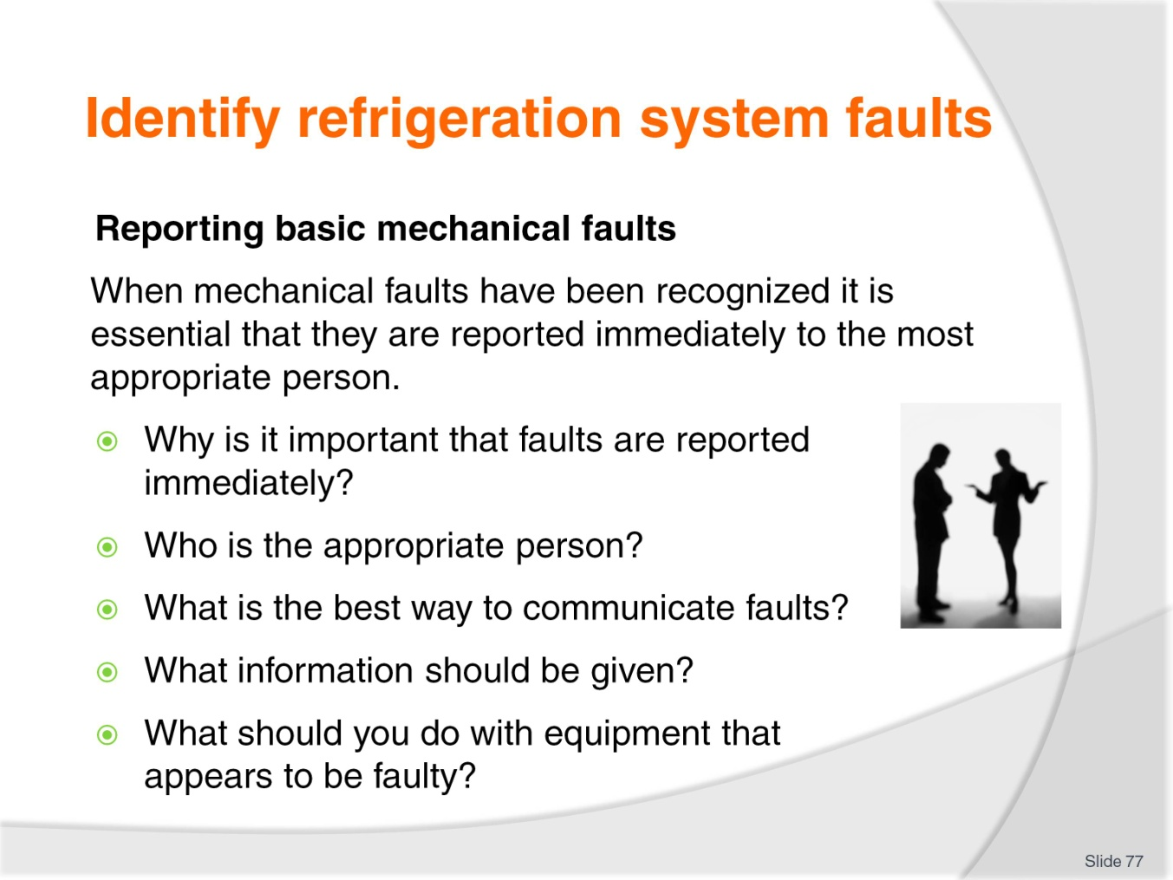
Slide No | Trainer Notes
Class Activity – Discussion
Discuss questions in the slide.

Slide
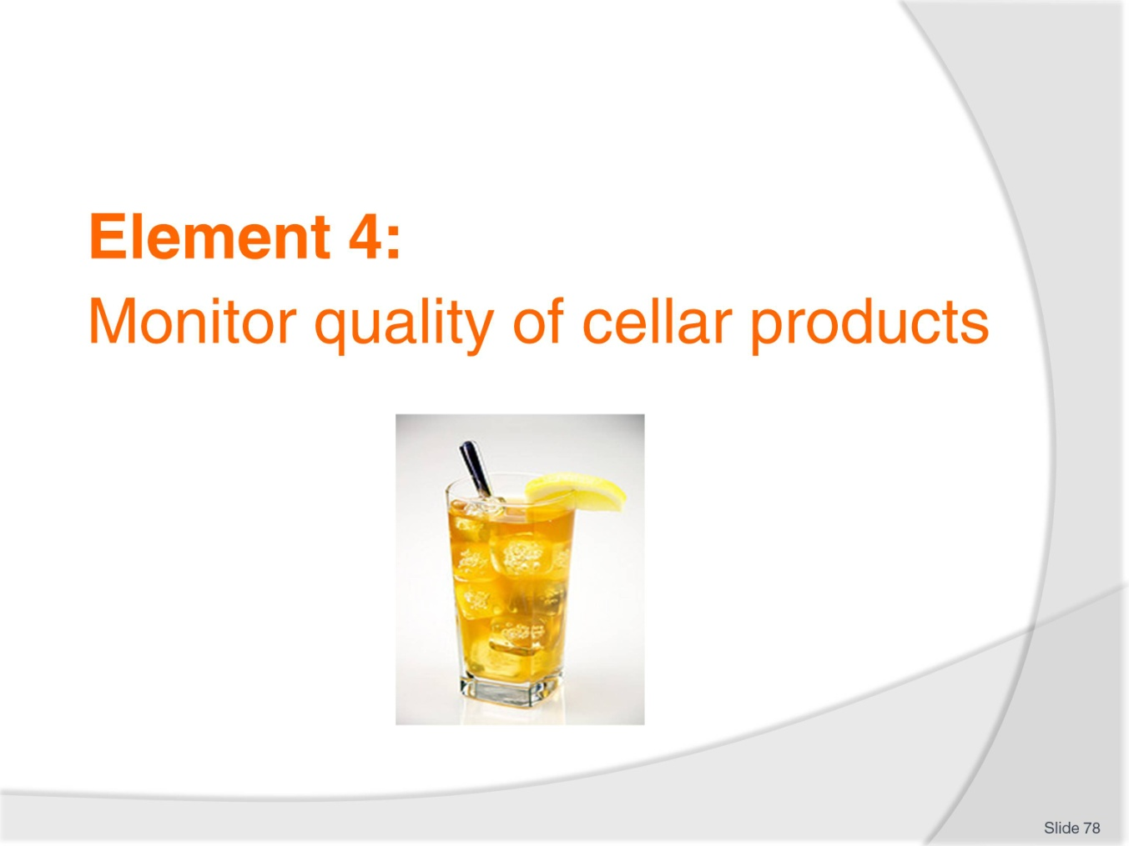
Slide No | Trainer Notes
Introduce topic.
Class Activity – General Discussion
Ask general questions:
Why is it important to monitor quality of products?
Which products should be test?

Slide
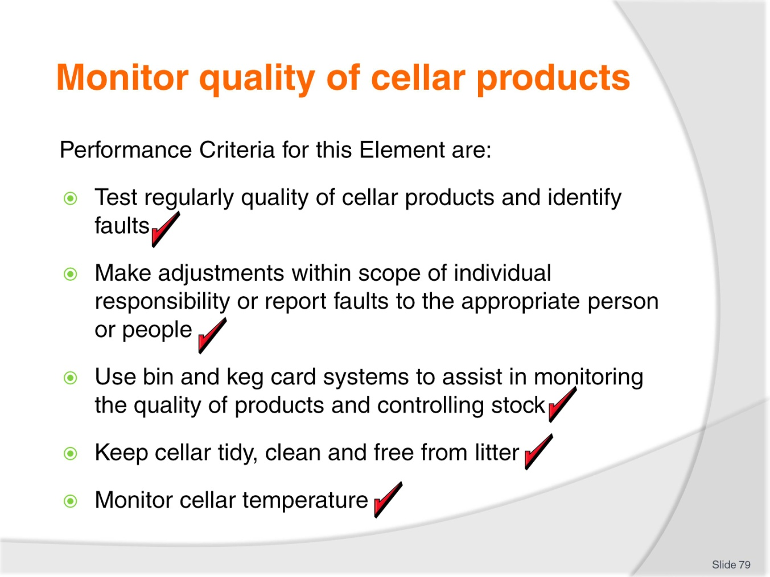
Slide No | Trainer Notes
 | Trainer identifies the Performance Criteria for this Element, as listed on the slide.

Slide
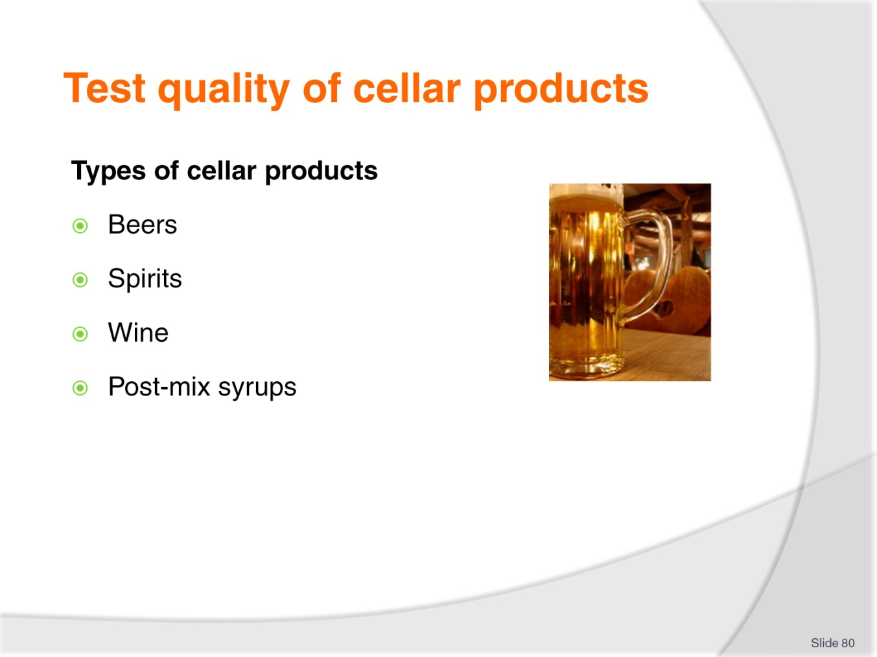
Slide No | Trainer Notes
Class Activity – Discussion
How can you test these products?

Slide
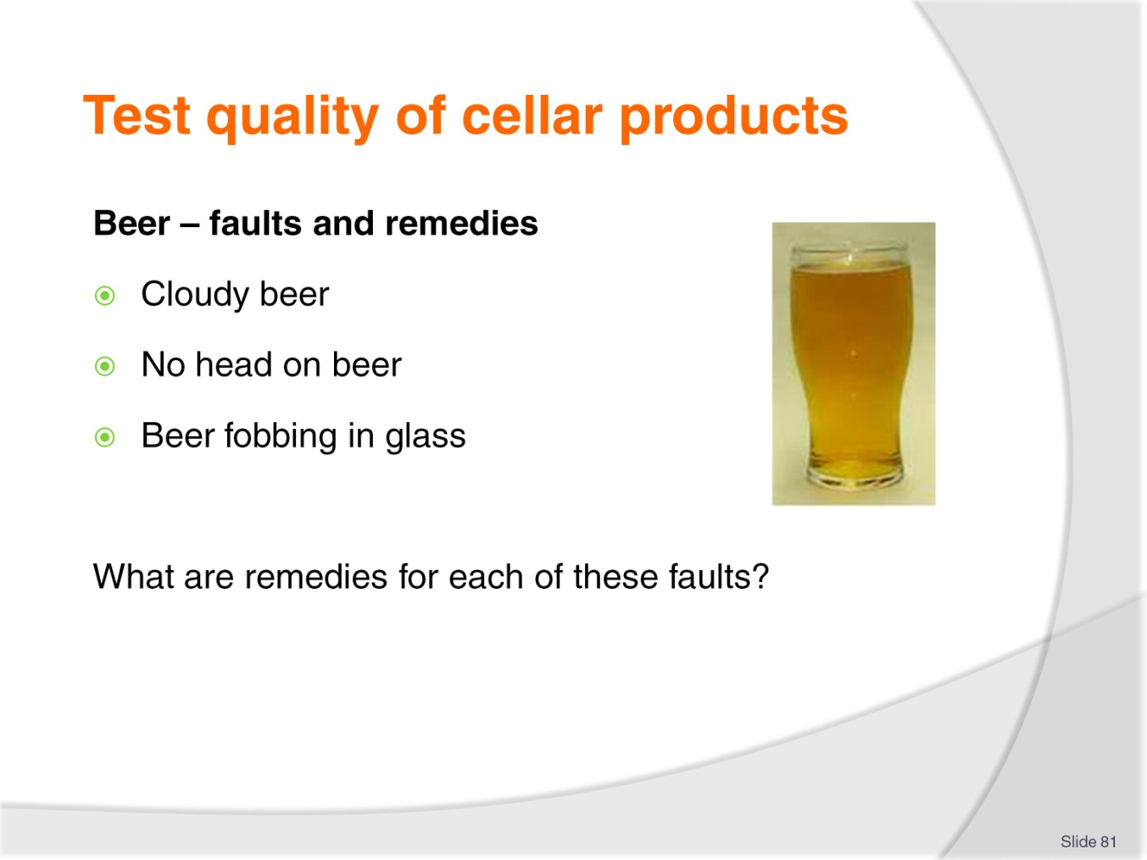
Slide No | Trainer Notes
Class Activity – Discussion
Cloudy beer
Cleaning pipes every week
Ensure key is still within ‘best before date’
Flush through lines with water
Connect to a new keg.
No head on beer
Ensure staff are trained in pouring
Ensure tap sparkler is in place
Ensure beer tap is being used correctly
Ensure correct glass cleaning techniques are used.
Beer fobbing in glass
Ensure beer is poured at correct angle
Ensure beer is at correct temperature.

Slide
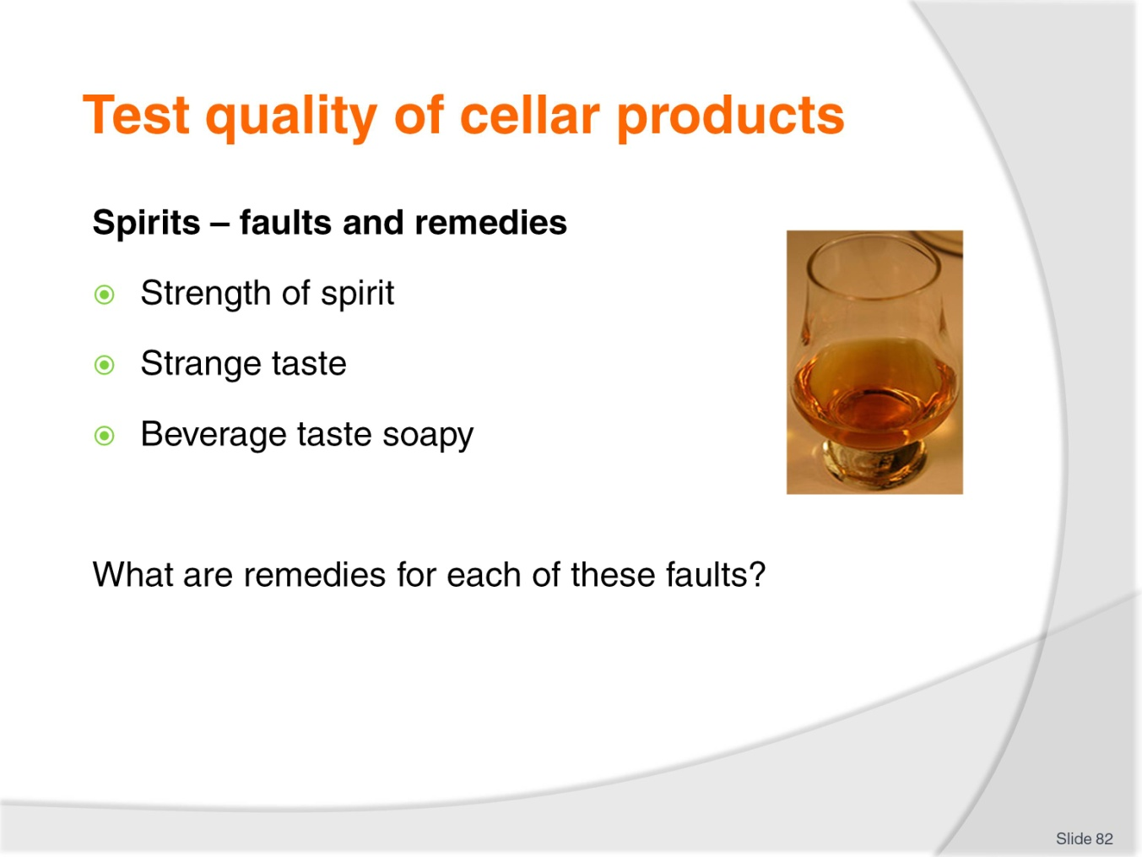
Slide No | Trainer Notes
Class Activity – Discussion
Strength of spirit
At times the amount of spirit being dispensed may be more or less than what is required. Check the equipment.
Strange taste
The dispenser may have been used for another bottle of alcohol. It must be cleaned correctly.
Beverage taste soapy
It is important to ensure that it is cleaned properly.

Slide
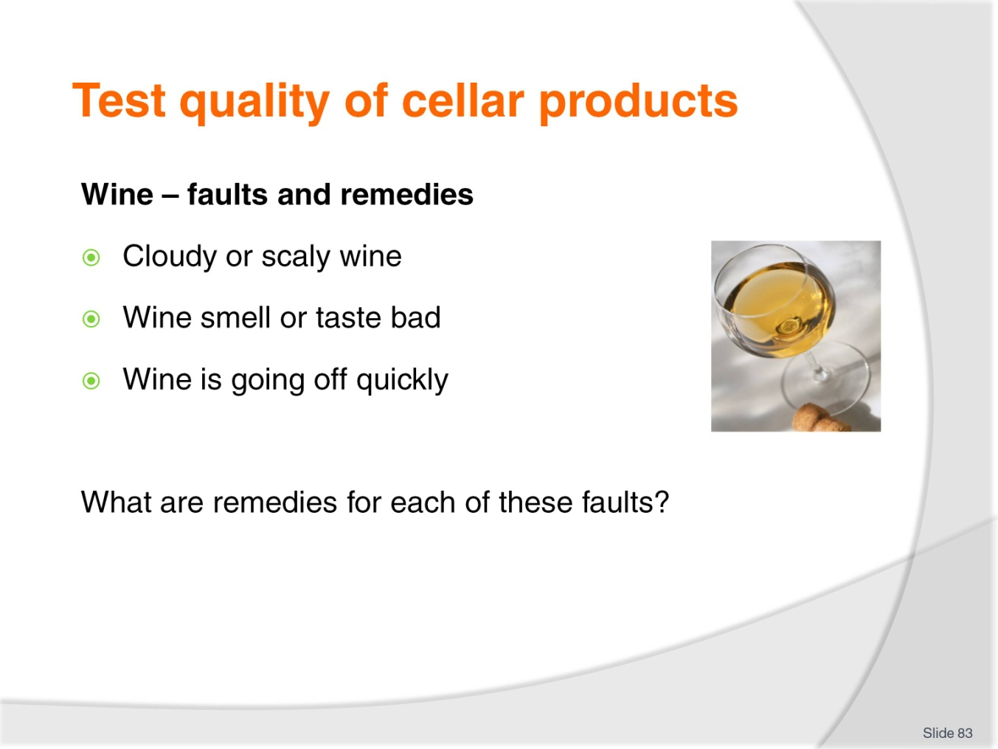
Slide No | Trainer Notes
Class Activity – Discussion
Cloudy or scaly wine
Cloudy or scaly wine is always a symptom of a dirty system and poor maintenance. Incorrect machine use may also contribute to this condition.
Wine smell or taste bad
New units may cause some wines to have a slightly different taste or smell. This is normal and will diminish very rapidly. It should disappear completely within 1-3 days.
Wine is going off quickly
Wines are expected to last approximately one to three weeks. Therefore it if the problem occurs before this time it will vary based on a number of factors being temperature, wine age and wine type, and cleanliness of the machine.

Slide
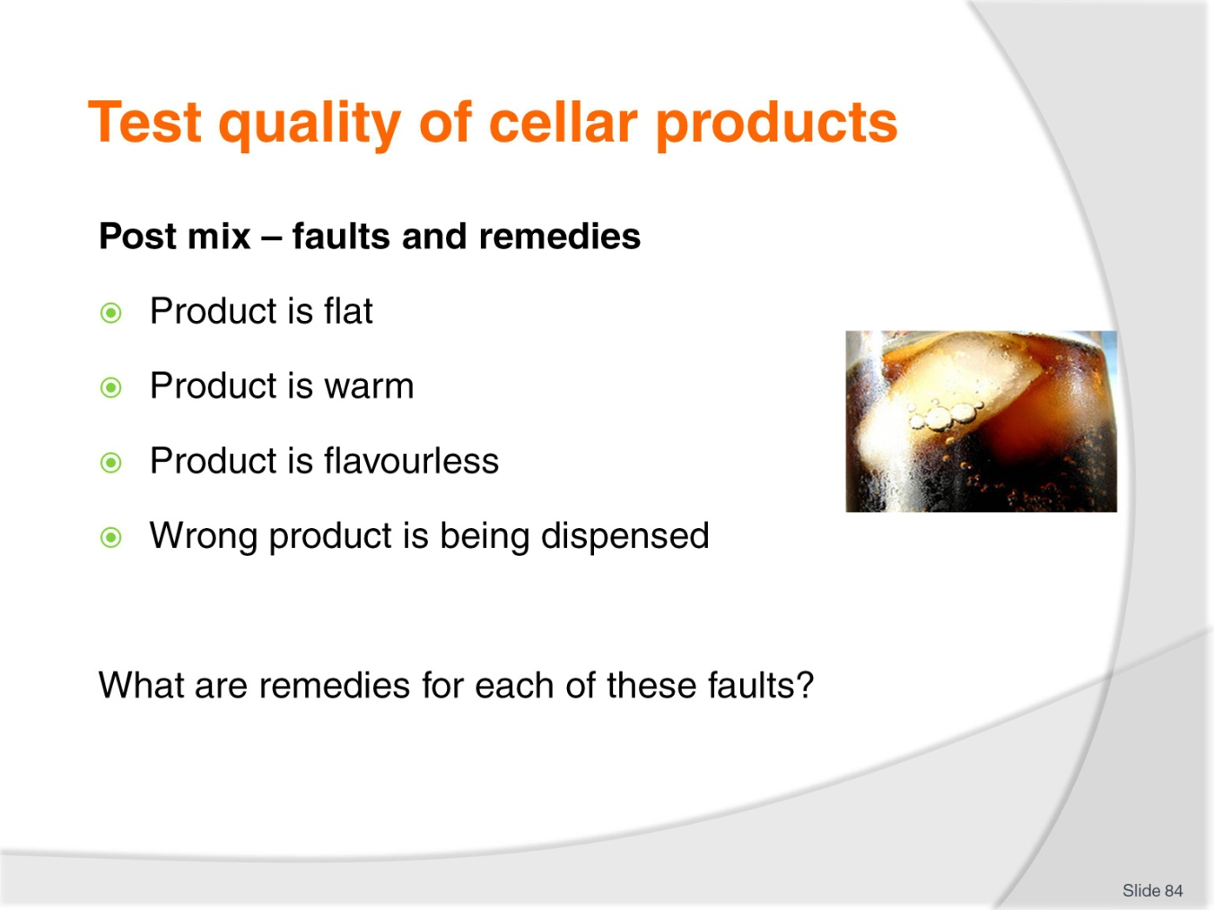
Slide No | Trainer Notes
Class Activity – Discussion
Product is flat
Check CO2 levels to ensure carbonation is taking place.
Product is warm
Check refrigeration system.
Product is flavourless
Ensure they syrup box contains syrup
Ensure syrup is going through lines
Ensure line connections are sealed
Ensure line is connected to syrup box.
Wrong product is being dispensed
Ensure lines are connected to correct syrup box.

Slide
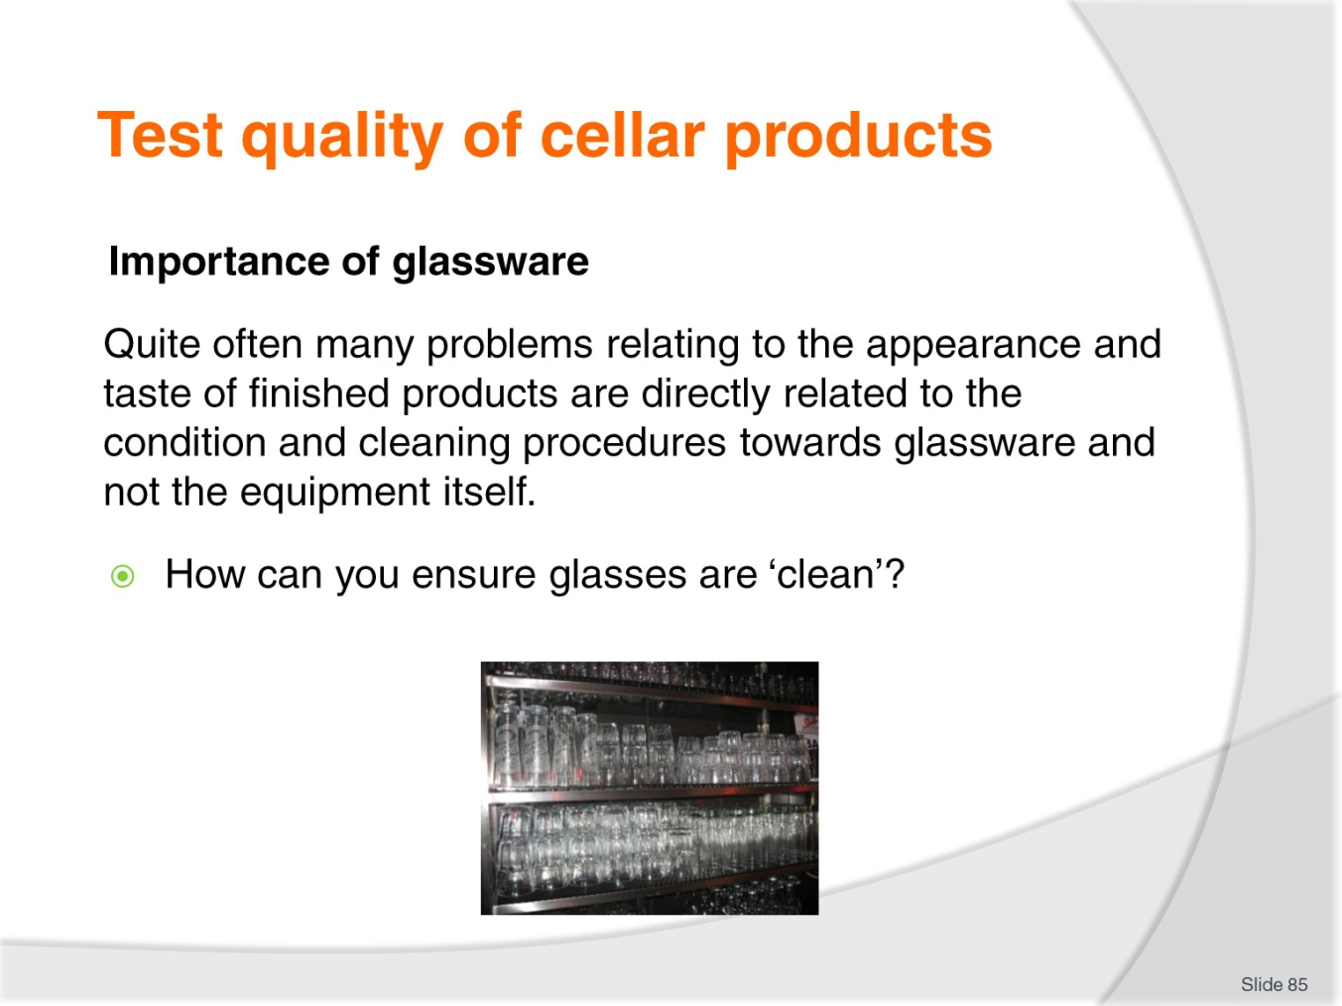
Slide No | Trainer Notes
Class Activity – Discussion
How do you ensure glasses are clean?

Slide
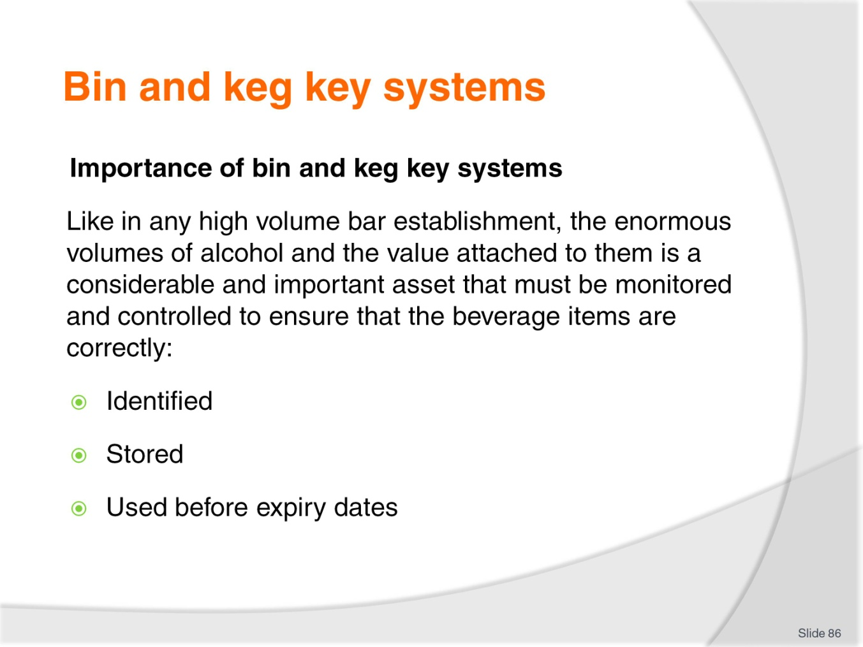
Slide No | Trainer Notes
Class Activity – Discussion
How are these systems used?

Slide
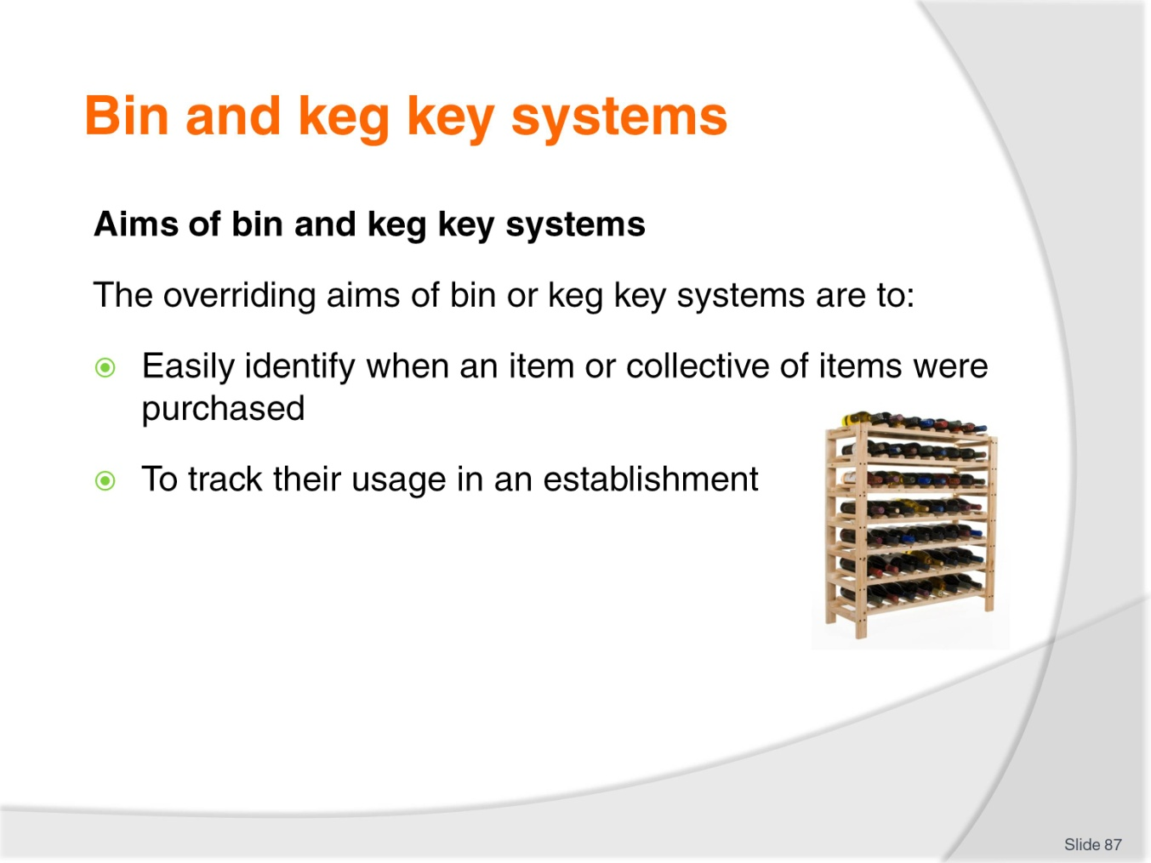
Slide No | Trainer Notes
Class Activity – Discussion
How can this be achieved?

Slide
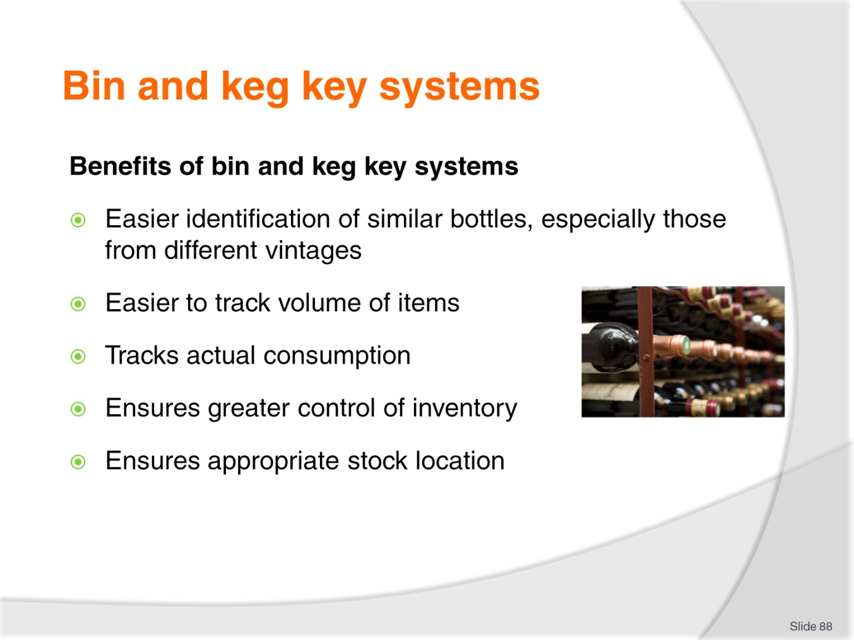
Slide No | Trainer Notes
Class Activity – Discussion
Discuss these benefits.

Slide
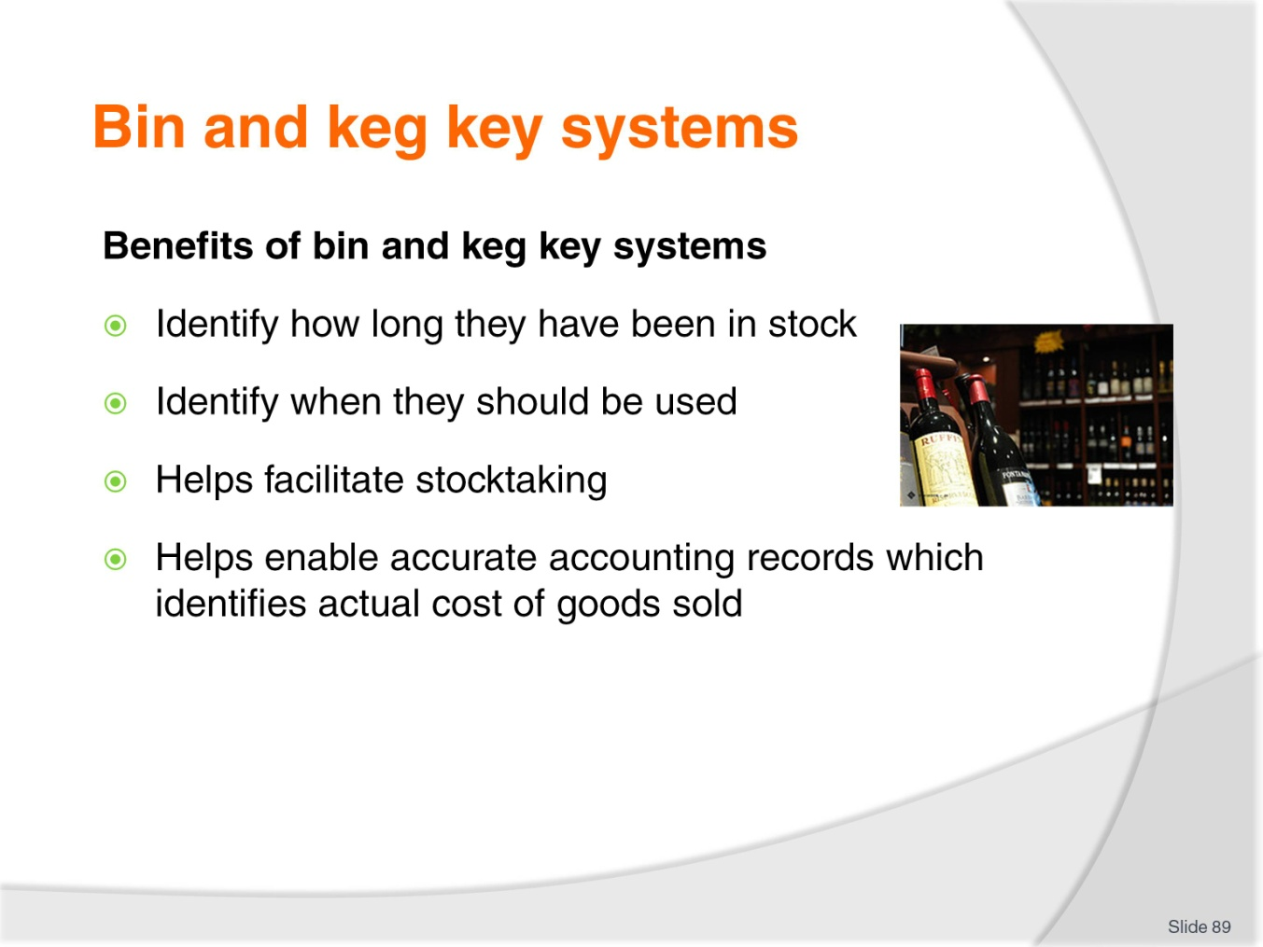
Slide No | Trainer Notes
Class Activity – Discussion
Discuss these benefits.

Slide
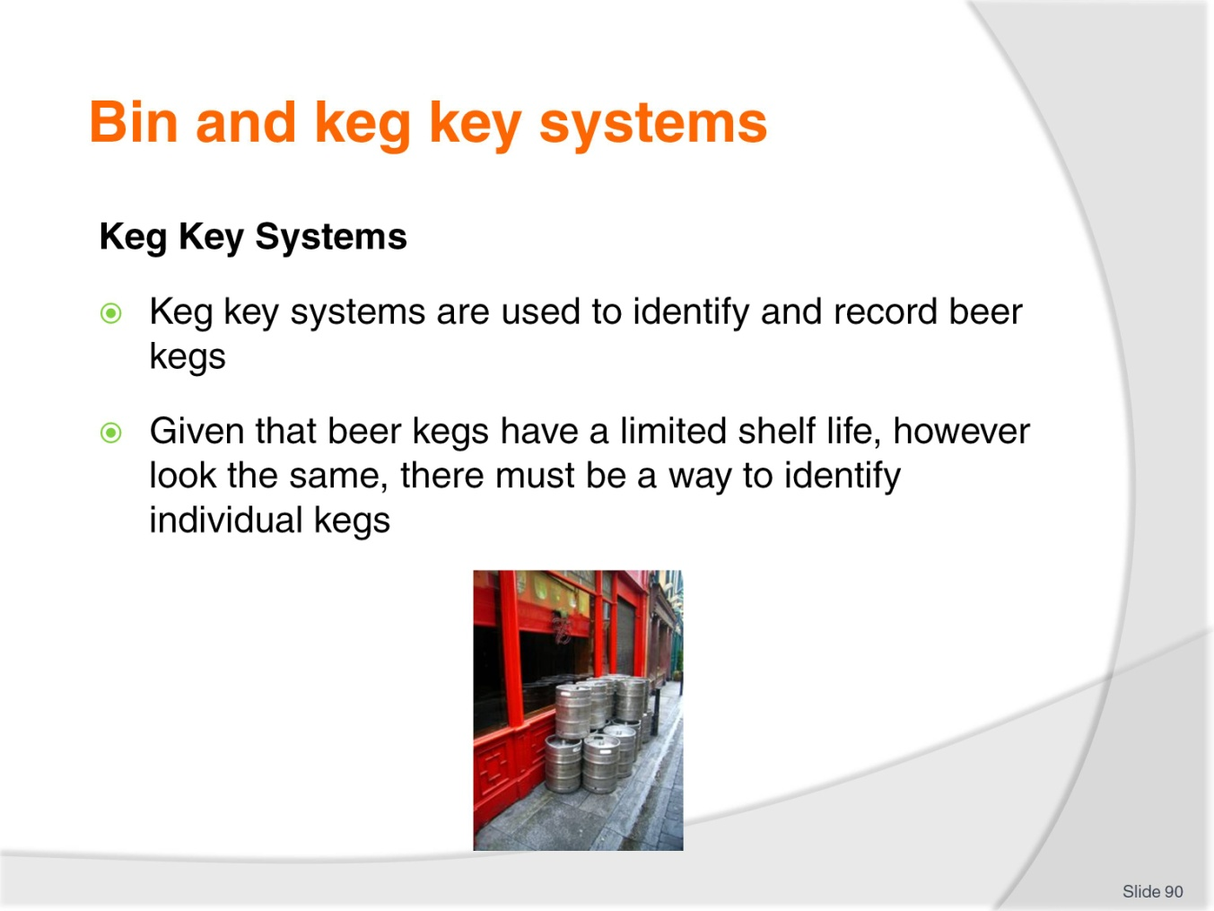
Slide No | Trainer Notes
Class Activity – Discussion
How do keg key systems work?

Slide
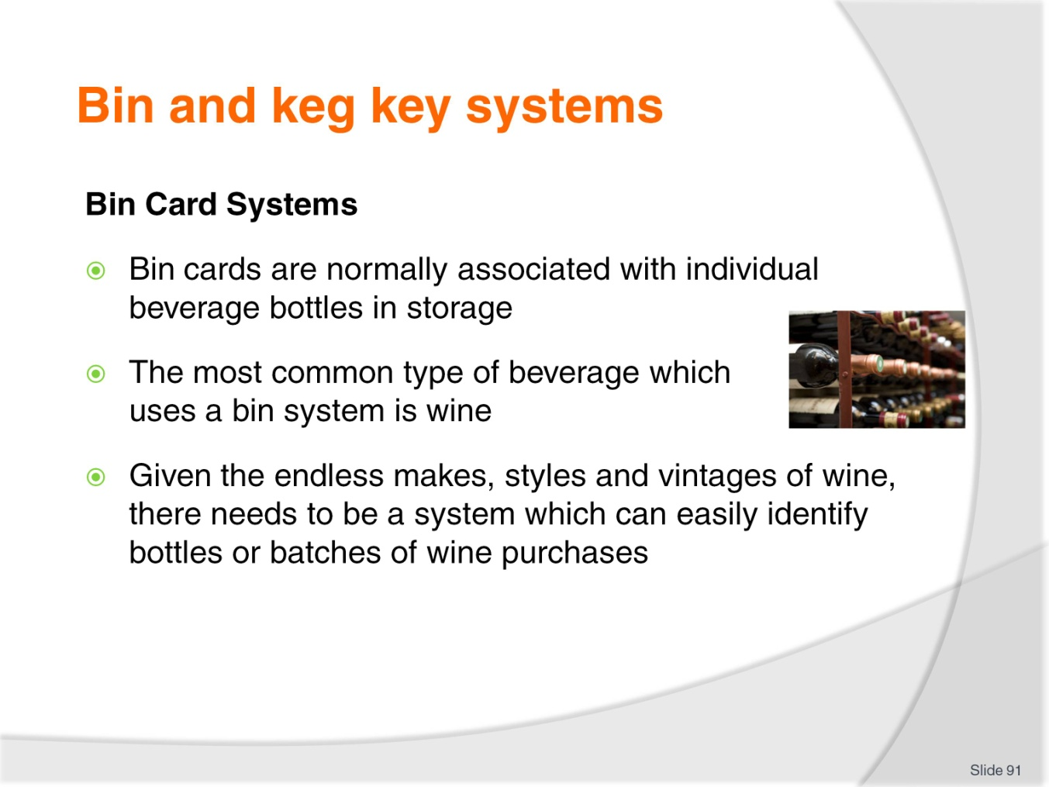
Slide No | Trainer Notes
Class Activity – Discussion
How do bin card systems work?

Slide
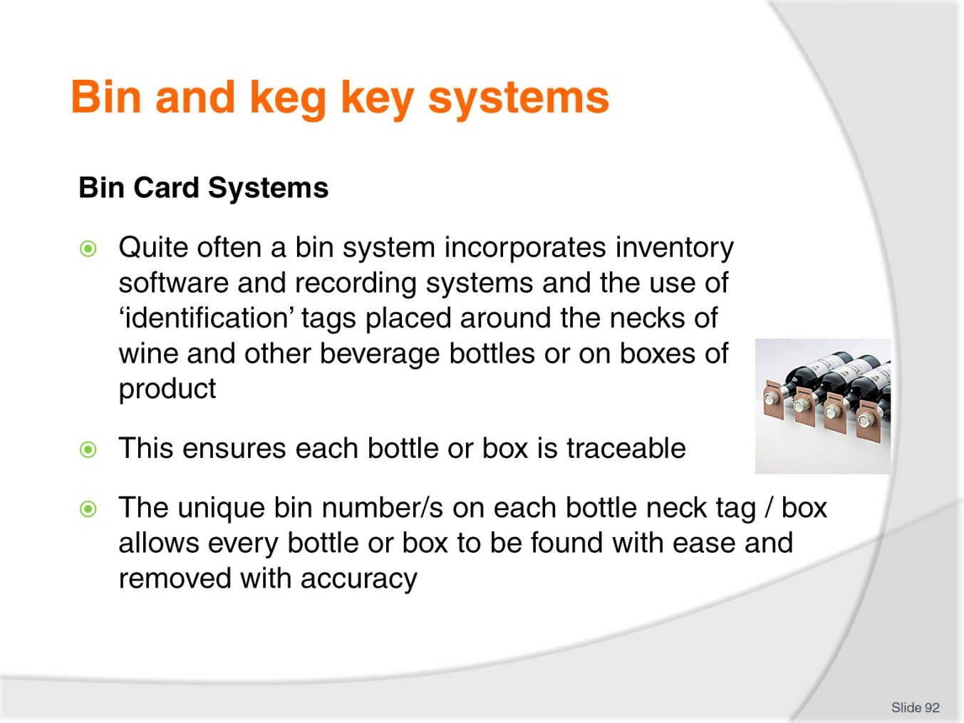
Slide No | Trainer Notes
Class Activity – Discussion
Discuss the operations of these systems.

Slide
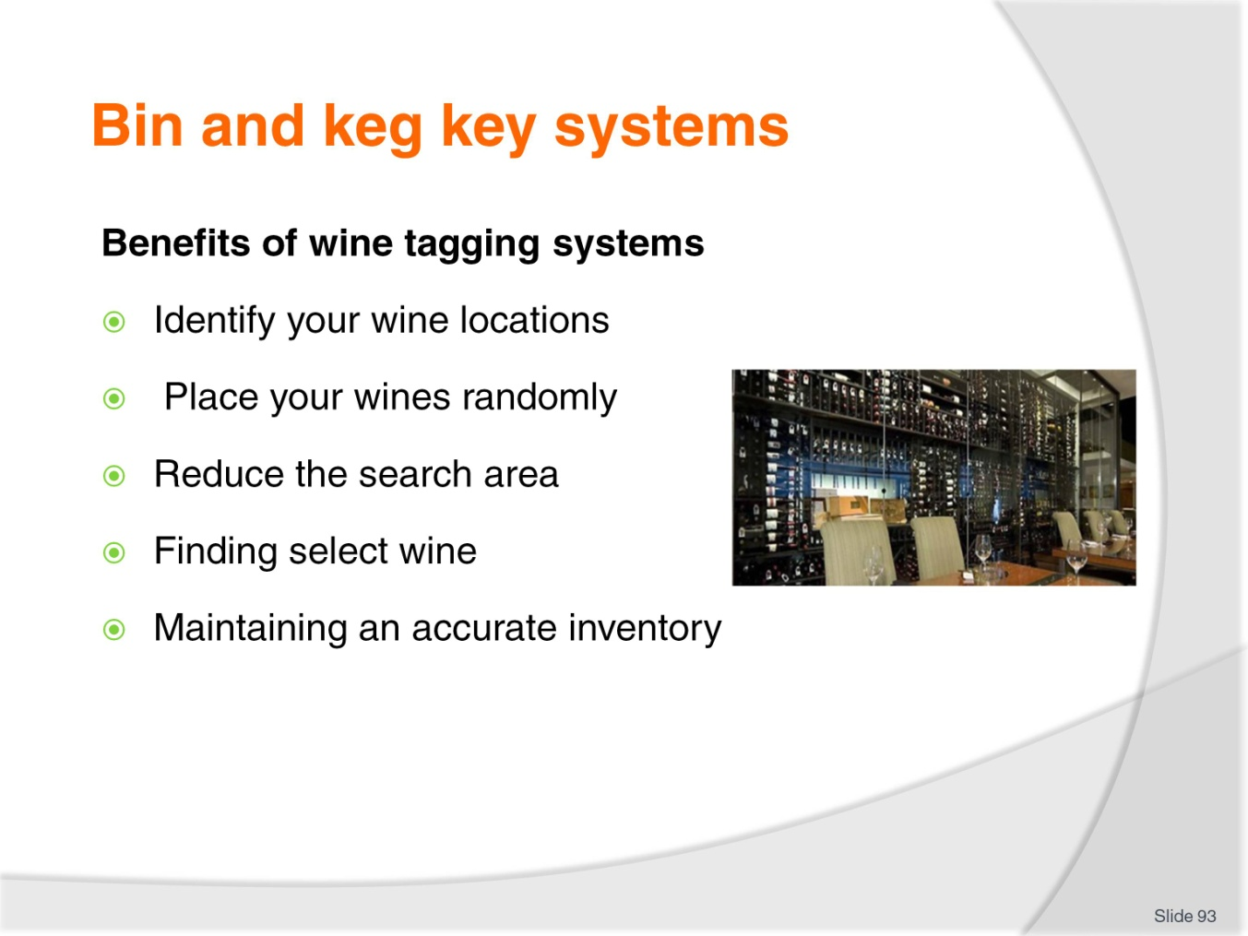
Slide No | Trainer Notes
Class Activity – Discussion
Discuss these benefits.

Slide
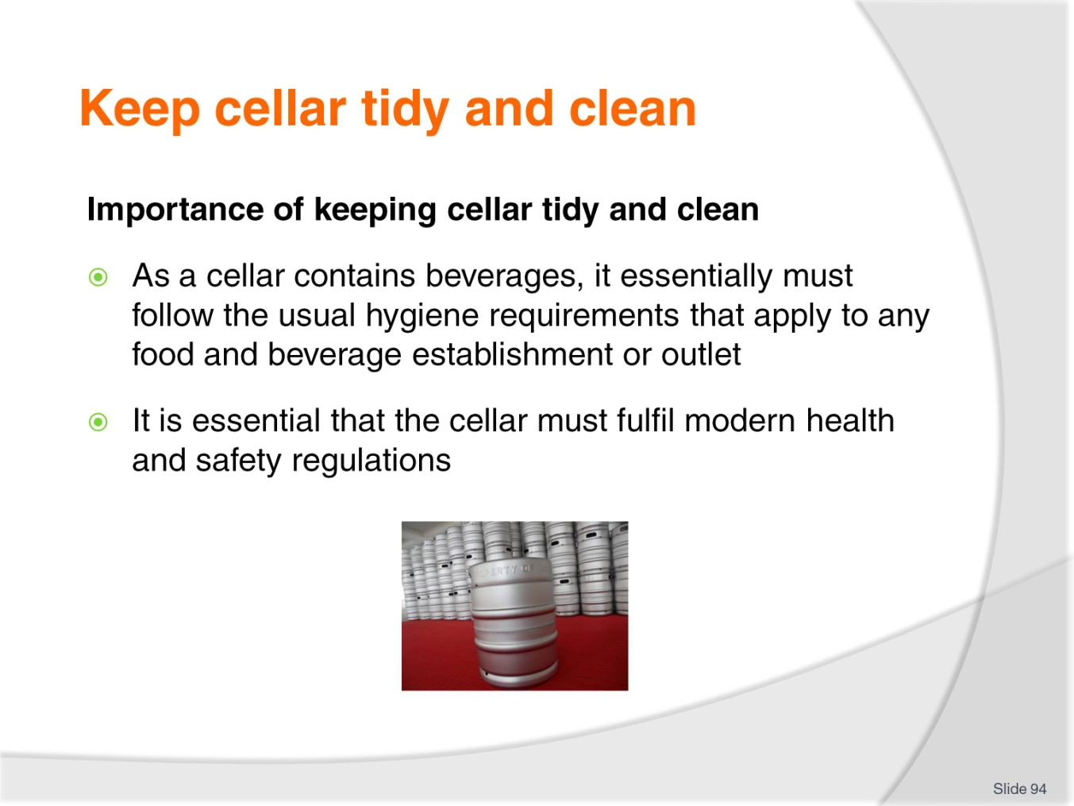
Slide No | Trainer Notes
Class Activity – Discussion
What health regulations must be followed?
What safety regulations must be followed?
How do you maintain a clean and tidy cellar?

Slide
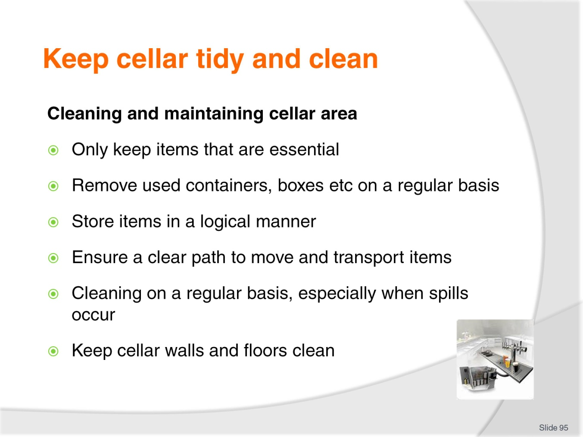
Slide No | Trainer Notes
Class Activity – Discussion
Discuss these steps.

Slide
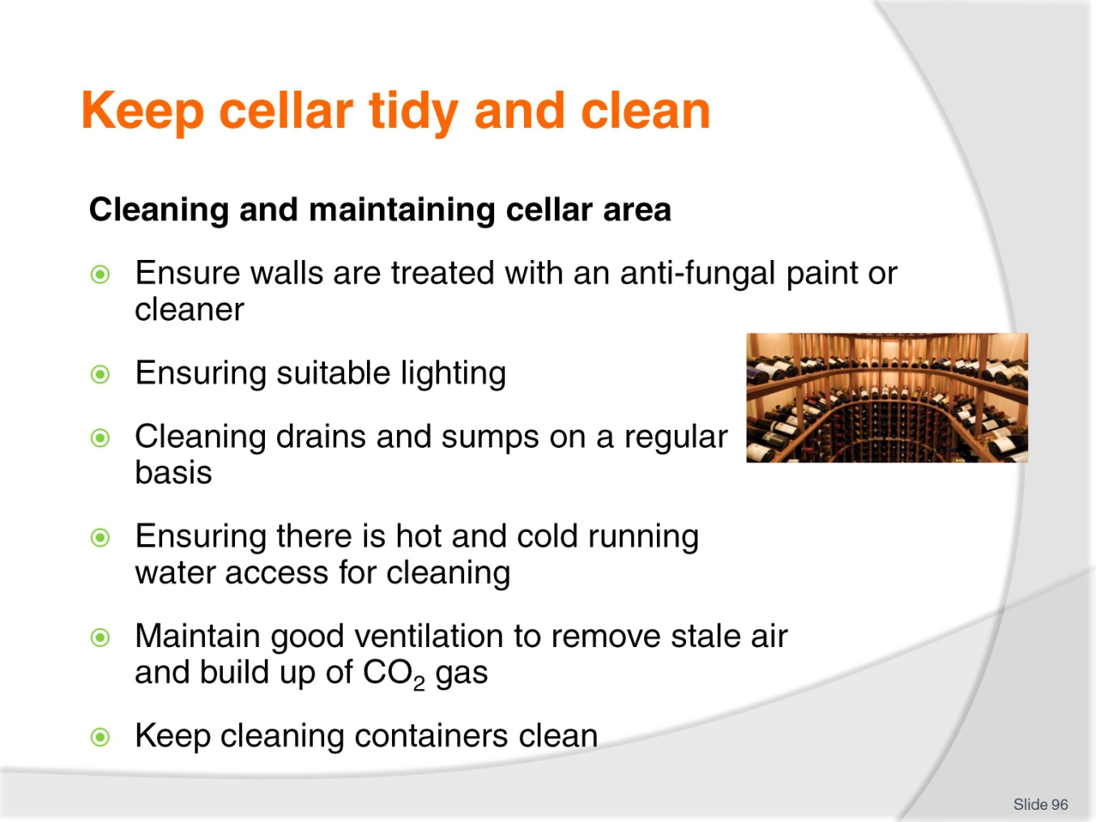
Slide No | Trainer Notes
Class Activity – Discussion
Discuss these steps.

Slide
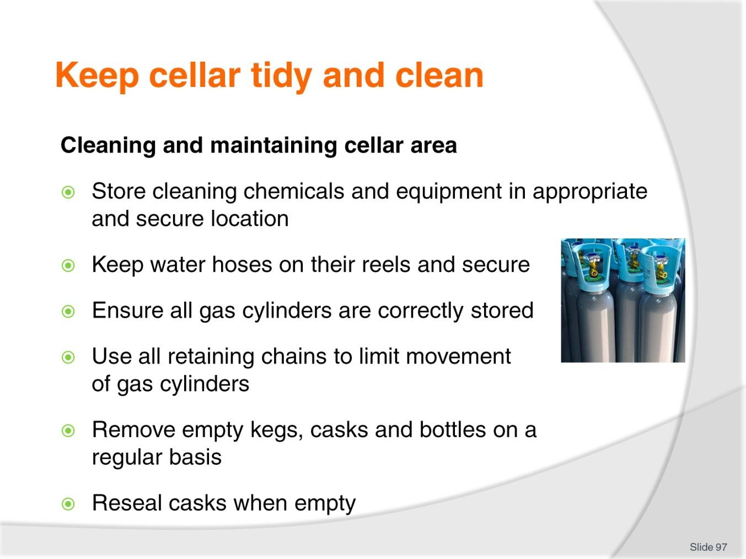
Slide No | Trainer Notes
Class Activity – Discussion
Discuss these steps.

Slide
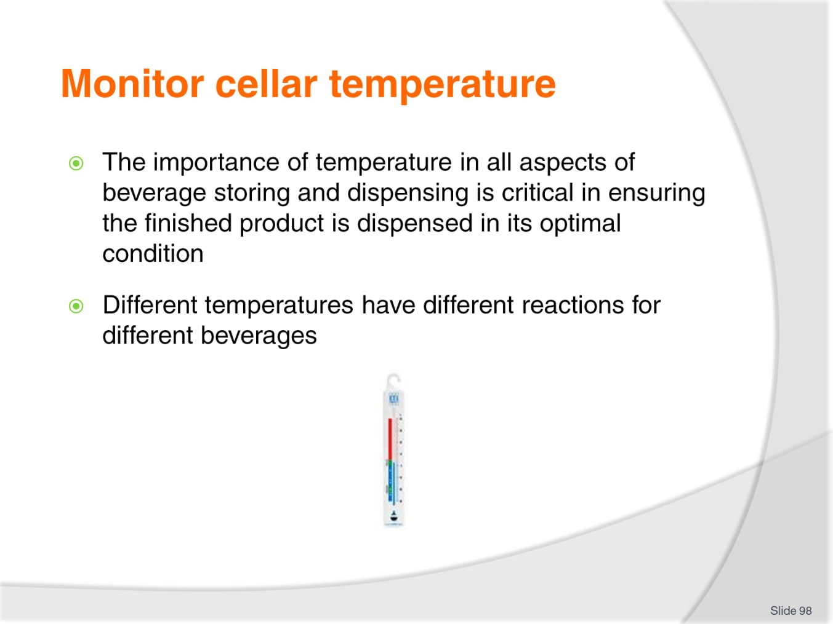
Slide No | Trainer Notes
Class Activity – Discussion
Why is cellar temperature important?

Slide
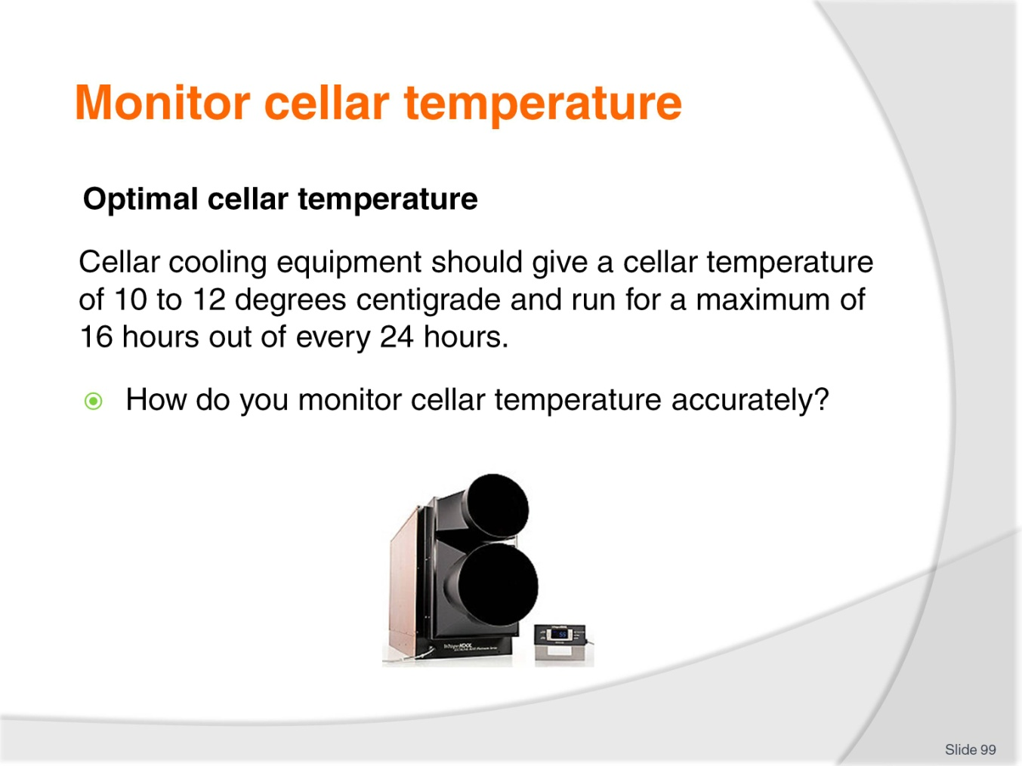
Slide No | Trainer Notes
Class Activity – Discussion
Discuss the question in the slide.

Slide
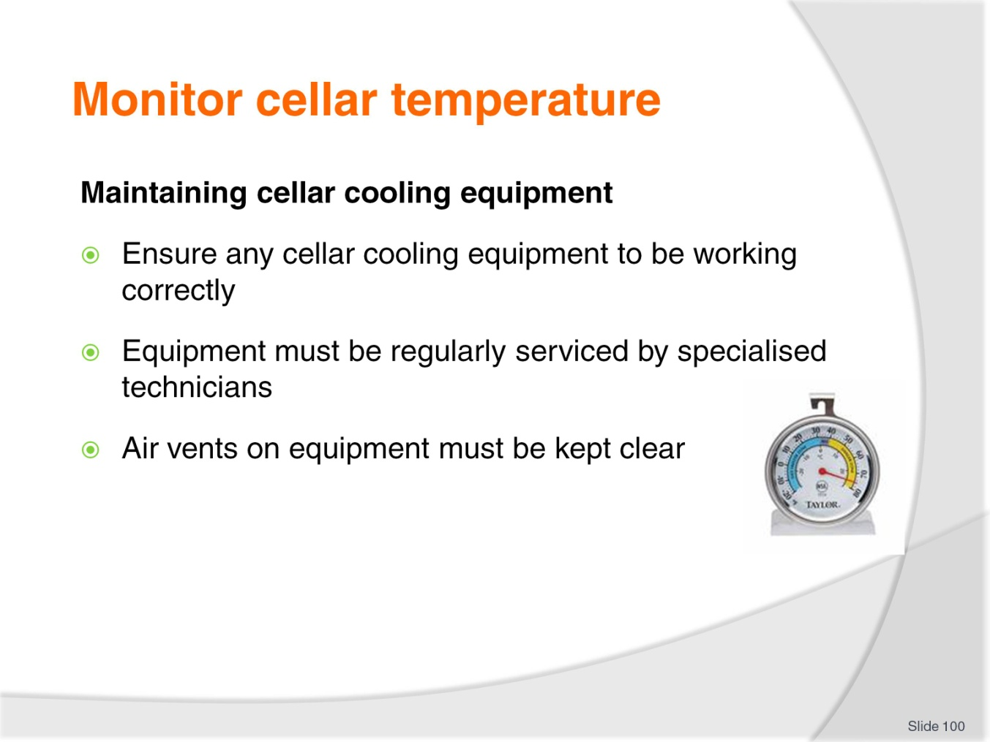
Slide No | Trainer Notes
Class Activity – Discussion
Discuss these points.

Slide
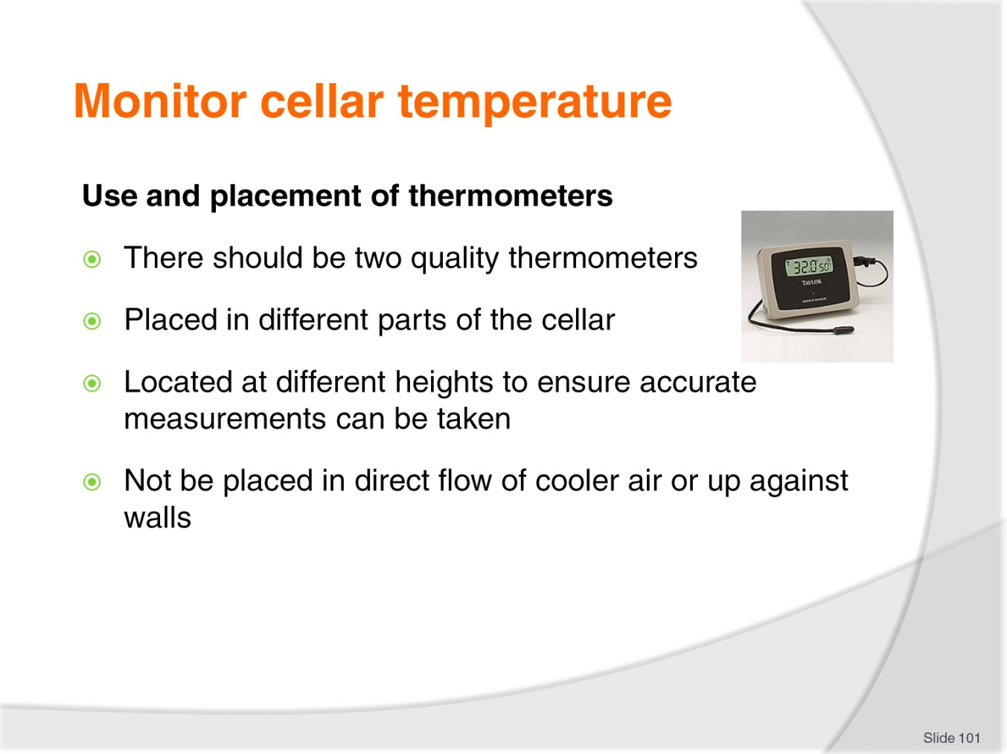
Slide No | Trainer Notes
Class Activity – Discussion
Discuss these points.

Slide
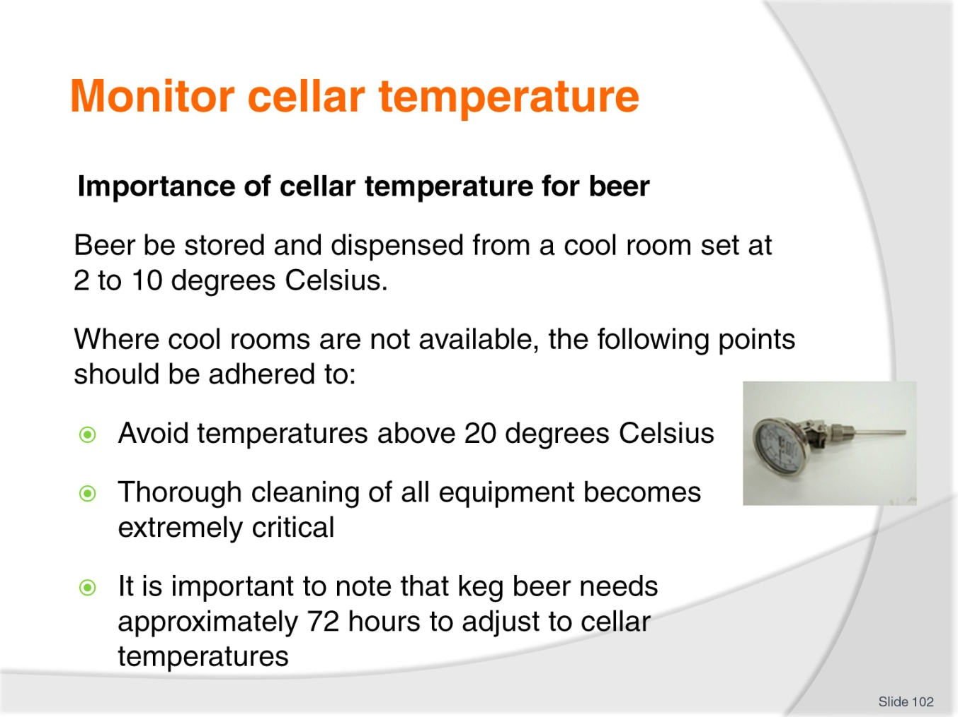
Slide No | Trainer Notes
Class Activity – Discussion
Discuss these points.

Slide
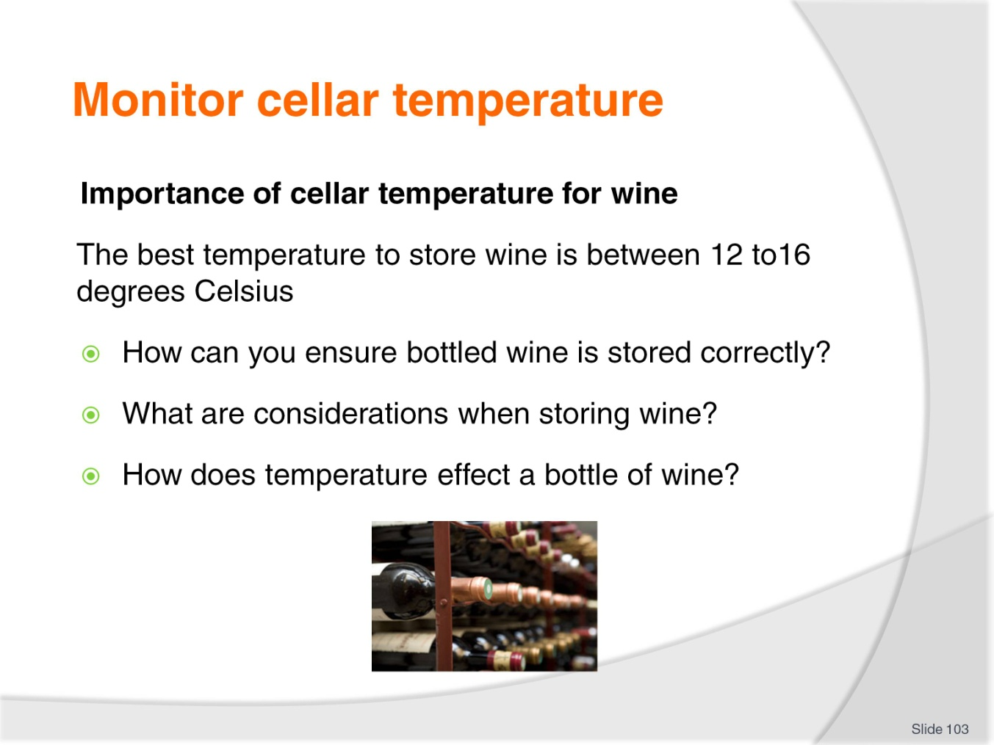
Slide No | Trainer Notes
Class Activity – Discussion
Discuss the questions in the slide.

Recommended training equipment
Access to bulk dispensing systems relating to:
- Beer – kegs, beer lines, taps etc
- Spirits – bottle and bulk dispensers
- Wine – bottles and bulk dispensers
- Post-mix syrups – including syrups, lines and soda guns
- CO2 cylinders.
Access to refrigeration and cooling systems including:
- Glycol system or refrigerated beer line system
- Glycol tanks and pumps
- Compressors
- Chiller plates
- Cold rooms
- Cabinets
- Instantaneous coolers
- Portable coolers
- Ice bank or water chilled system
- Temprite or instantaneous cooler system.
Access to wine cellar
Beverage menu
Chemicals – various for cleaning cellars and equipment
Cleaning Equipment – various including vacuum cleaner, brooms, mops, brushes, sponges
Computer access to visit cellar equipment websites
Equipment manuals
External supplier information
Thermometers
Gas operating SOP’s
Glassware and glassware cleaning equipment
Job descriptions
Layout SOPs for cellar operations
Locations – including access to a bar and cellar
Operational checklists
Refrigerator thermostats
Safety Signs
Standard Operating Procedures (SOP’s)
Wine tagging system

Instructions for Trainers for using
PowerPoint – Presenter View
Connect your laptop or computer to your projector equipment as per manufacturers’ instructions.
In PowerPoint, on the Slide Show menu, click Set up Show.
Under Multiple monitors, select the Show Presenter View check box.
In the Display slide show on list, click the monitor you want the slide show presentation to appear on.
Source: http://office.microsoft.com
Note:
In Presenter View:
You see your notes and have full control of the presentation
Your trainees only see the slide projected on to the screen
More Information
You can obtain more information on how to use PowerPoint from the Microsoft Online Help Centre, available at: http://office.microsoft.com/training/training.aspx?AssetID=RC011298761033
Note Regarding Currency of URLs
Please note that where references have been made to URLs in these training resources trainers will need to verify that the resource or document referred to is still current on the internet. Trainers should endeavour, where possible, to source similar alternative examples of material where it is found that either the website or the document in question is no longer available online.

Appendix – ASEAN acronyms
AADCP | ASEAN – Australia Development Cooperation Program.
ACCSTP | ASEAN Common Competency Standards for Tourism Professionals.
AEC | ASEAN Economic Community.
AMS | ASEAN Member States.
ASEAN | Association of Southeast Asian Nations.
ASEC | ASEAN Secretariat.
ATM | ASEAN Tourism Ministers.
ATPMC | ASEAN Tourism Professionals Monitoring Committee.
ATPRS | ASEAN Tourism Professional Registration System.
ATFTMD | ASEAN Task Force on Tourism Manpower Development.
CATC | Common ASEAN Tourism Curriculum.
MRA | Mutual Recognition Arrangement.
MTCO | Mekong Tourism Coordinating office.
NTO | National Tourism Organisation.
NTPB | National Tourism Professional Board.
RQFSRS | Regional Qualifications Framework and Skills Recognition System.
TPCB | Tourism Professional Certification Board.







